Two x Two Within-Subject ANOVA Interaction = Correlated t on Difference Scores

Petra Schweinhardt at McGill University is planning research involving a 2 x 2 within-subjects ANOVA. Each case has four measurements, PostX1, PreX1, PostX2 and PreX2. X1 and X2 are different experimental treatments, Pre is the dependent variable measured prior to administration of X, and Post is the dependent variable following administration of X. Order effects are controlled by counterbalancing.
Petra wants to determine how many cases she needs to have adequate power to detect the Time (Post versus Pre) by X (1 versus 2) interaction. She is using G*Power 3.1, and it is not obvious to her (or to me) how to do this. She suggested “ANOVA, Repeated Measures, within factors,” but I think some tweaking would be necessary.
My first thought is that the interaction term in such a 2 x 2 ANOVA might be equivalent to a t test between difference scores (I know for sure this is the case with independent samples). To test this hunch, I contrived this data set:

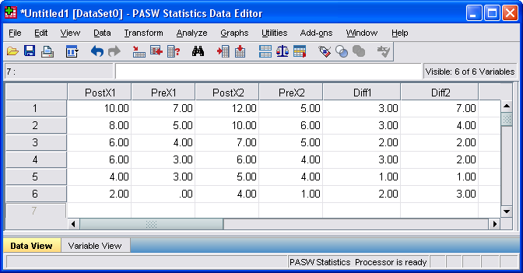

Diff1 and Diff2 are Post-Pre difference scores for X1 and X2. Next I conducted the usual 2 x 2 within-subjects ANOVA with these data:

COMPUTE Diff1=PostX1-PreX1.
EXECUTE.
COMPUTE Diff2=PostX2-PreX2.
EXECUTE.
GLM PostX1 PostX2 PreX1 PreX2
/WSFACTOR=Time 2 Polynomial X 2 Polynomial
/METHOD=SSTYPE(3)
/CRITERIA=ALPHA(.05)
/WSDESIGN=Time X Time*X.
Source |  | Type III Sum of Squares |  | df | Mean Square | F | Sig.
Time |  |  | 45.375 | 1 | 45.375 | 24.200 | .004
Error(Time) |  |  | 9.375 | 5 | 1.875
X |  |  | 5.042 | 1 | 5.042 | 14.756 | .012
Error(X) |  |  | 1.708 | 5 | .342
Time * X |  |  | 1.042 | 1 | 1.042 | 1.404 | .289
Error(Time*X) |  |  | 3.708 | 5 | .742

Next I conducted a correlated t test comparing the difference scores.
T-TEST PAIRS=Diff1 WITH Diff2 (PAIRED)
/CRITERIA=CI(.9500)
/MISSING=ANALYSIS.
Paired Samples Correlations
 |  | N | Correlation | Sig.
Pair 1 | Diff1 & Diff2 | 6 | .650 | .163

Paired Samples Test
 |  | Paired Differences
 |  | Mean | Std. Deviation | Std. Error Mean | 95% Confidence Interval of the Difference
 |  |  |  |  | Lower | Upper
Pair 1 | Diff1 - Diff2 | -.83333 | 1.72240 | .70317 | -2.64088 | .97422

Paired Samples Test
 |  | t | df | Sig. (2-tailed)
Pair 1 | Diff1 - Diff2 | -1.185 | 5 | .289

As you can see, the correlated t test on the difference scores is absolutely equivalent to the interaction test in the ANOVA. The square of the t (-1.185² = 1.404) is equal to the interaction F and the p values are identical.
Having established this equivalence, my suggestion is that the required sample size be determined as if one were simply doing a correlated t test. There are all sorts of issues involving how to define effect sizes for within-subjects effects, but I shall not address those here.
G*Power shows me that Petra would need 54 cases to have a 95% chance of detecting a medium-sized effect using the usual 5% criterion of statistical significance.

t tests - Means: Difference between two dependent means (matched pairs)
Analysis: A priori: Compute required sample size
Input: Tail(s) = Two
Effect size dz = 0.5
α err prob = 0.05
Power (1-β err prob) = 0.95
Output: Noncentrality parameter δ = 3.6742346
Critical t = 2.0057460
Df = 53
Total sample size = 54
Actual power = 0.9502120

We should be able to get this same result using the “ANOVA, Repeated Measures, within factors” analysis in G*Power, as Petra suggested, and, in fact, we do:
F tests - ANOVA: Repeated measures, within factors
Analysis: A priori: Compute required sample size
Input: Effect size f = 0.25
α err prob = 0.05
Power (1-β err prob) = 0.95
Number of groups = 1
Repetitions = 2
Corr among rep measures = 0.5
Nonsphericity correction ε = 1
Output: Noncentrality parameter λ = 13.5000000
Critical F = 4.0230170
Numerator df = 1.0000000
Denominator df = 53.0000000
Total sample size = 54
Actual power = 0.9502120

Karl L. Wuensch, Dept. of Psychology, East Carolina University, Greenville, NC. August, 2009
Return to Wuensch’s Stats Lessons Page

