Using bootstrap.xla to compute the HC4 wild bootstrap estimate’s p-value to assess the statistical significance of a x by group moderation effect.
(The below assumes you have successfully downloaded and added the bootstrap.xla macro into the version of EXCEL on your PC). When this is correctly added in the bootstrap macro will appear ion the top left corner when the add-ins tab is selected.
- Copy the three data columns (corresponding to Y, X and GROUP (the latter coded 0-1) in that order from left to right) into the corresponding green area in Sheet 1. The HC4 estimate should appear at the top of column F of Sheet 1. Repeat for sheet 2 putting these columns into the same cells as you did in sheet 1.

- Click on the blue F2 cell (under T(INT) in sheet 2).

- Go to Add-ins and click bootstrap.
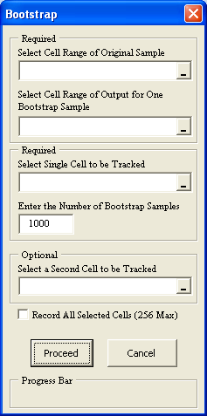
Click

Sheet2!F2
Sheet2!A2:A201
Sheet1!E2:E201
The bootstrap estimates for HC4 from 1000 samples appear in a newly created spreadsheet which will be called BootRawx where x is a number. An example of this is in the BootRaw6 spreadsheet.
- Copy the D5 cell in BootRaw6 and paste into any empty cell in your newly created BootRaw spreadsheet created in the previous step. The value of this cell will represent the 2-sided p-value for the bootstrap version of the HC4 estimate given in Sheet 1.

