# Chapter 3

**CHAPTER 3 Contents:**

3.1 Fuzzy Set Theory and Psychology: Theoretical View 42

3.2. The grey world of mind 42

3.3. The Fuzzy logic under psychological view 45

3.4. Why fuzzy logic theory? 48

3.5. What is the fuzzy map? 53

3.6. Fuzzy Modelling of Psychological Systems 54

3.7. Properties of Fuzzy Sets 55

3.8. Types of Fuzzy Sets (Membership Functions) 58

3.9. Practical Example using R 59

3.10. Fuzzy set composition 64

3.11. Practical example 65

3.12. Mamdani Fuzzy Inference System 66

3.12. Towards Fuzzy Rule Mining 76

3.12. Hierarchical Fuzzy Systems 88



Abstract: Fuzzy set theory and its role in psychology is introduced in this chapter. Fuzzy models accept that the human perception of the world is not black and white but includes a degree of greyness (e.g. in diagnosis where the presence or absence symptoms may or may not lead to a diagnosis of a particular illness and in the use of language where for example a person saying “I am famous” is only their personal subjective opinion). These models attempt to account for this uncertainty in perception when model building by using a fuzzy layer based upon expert perception expressed in language and quantifying these opinions using probabilities in a fuzzy perceptual map. Properties of the set of perceptions are presented and simple mathematical distributions which are used to illustrate the membership of these fuzzy sets of perceptions are defined and illustrated such as cardinality, support, core, height, normalization and crossover points. Finally a worked example with code using procedures in R is given looking at the relationship between depression and multiple sclerosis.

Keywords: Fuzzy sets; Indeterminancy; Language; Expert opinion; Fuzzy inference system; Fuzzy maps; T-norms; S-norms; Mamdani systems

## 3.1 Fuzzy Set Theory and Psychology: Theoretical View

Psychology is the scientific study of mental processes and the behavior of individuals. Fuzzy thinking is an approach for studying the mind. This approach makes the assumption that the brain is a fuzzy inference engine and the mind is a collection of involute fuzzy micro-maps.

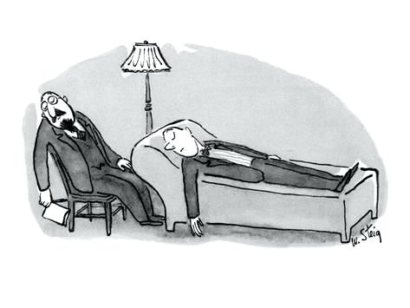Fuzziness, indeterminacy, and overlapping are the main features of this mind which are generally absent or even rare in classical psychology. Psychology is a science and therefore psychologists try to correctly observe real psycho-systems or psychological phenomena, to measure and to assess data, to analyze them using the quantitative and qualitative methods, to interpret results and if the results have the features of replicability and reliability, they establish principles and then introduce an empirical theory.

That is to say that to investigate real-world systems or phenomena, we connect them with a theoretical structure and basis (Seising, 2008).

This is the heart of science since without accepting this assumption we are not able to study the reality. As Wolfgang Blazer (1982) believed, we create this connection between reality and theory and assume that it is possible. Without this vital assumption, it is senseless and meaningless to talk about empirical science. The main goal of this approach is to introduce new concepts and methods for studying the mind and psychological phenomena under the above assumptions.

## 3.2. The grey world of mind

We do not live in the world but the world is living inside us. This kind of statement is not new but dates back many years. Buddha in the 11th century B.C believed that phenomena were not completely black or white, nothing was fixed or permanent and change was always possible. Based on this view, a problem is not a problem rather, our reaction to that problem is our problem.

Uncertainty or vagueness is a wide part of human experience, language, and perception. Human perception is full of inaccuracy. The real world is not an abstraction; it is not perceived, well- defined and precisely calculated (Wierman, 2010). Vagueness and fuzziness as states of uncertainty are generally considered as a realization that our beliefs and representations of the world are unable to accurately predict future events in our environment (Mushtaq, et al., 2011). It is important to note that uncertainty can be present in many forms. Uncertainty is a cost to be paid for living in the real world (Wierman, 2010). Reviewing the related literature revealed that individual differences affect our dealing with uncertainty (Mushtaq, et al., 2011). There are many sources of uncertainty which can impact on the research in this field. This uncertainty is in clinical decision making, disorder diagnosis and in the measurement of psychological constructs. Here it is worthwhile noting that the uncertainty is caused by psycho-researchers and participants contributing to the data gathering for research, because the mind can be regarded as uncertain. Many mathematical methods exist for dealing with uncertainty, which is inherent in psychological research. A more recent class of these methods are called non-probabilistic methods. Among such methods, we focus on those from fuzzy set theory. This approach in psychological research extends the classical view of the mind (Figure.1.3).

**A classical view on psychology**

**A Modern view on psychology**

Probabilistic Methods

Non-Probabilistic Methods

Most of the existing books

**This Book**

Some of the existing books and most of the future ones



Figure 1.3 The niche of this book in psychology

More formally, the theoretical systems are called intendent systems (Blazer, 1997; Sneed, 1971). This means that a researcher gathers data and builds a model as a very simple picture of the real system. Although it is enough in scientific work, this simplification results in a black and white, distorted and static picture of the world. In other words, a researcher is looking for a straightforward and neat picture of a phenomenon, but this view is not able to hook onto a dynamic and elusive psychological process. There is, therefore, a gap between reality and these theoretical systems (Figure.2.3).



Empirical level

Theoretical level

Figure 2.3 From a reality to a model

The main question which arises here is what the gap is and how to bridge this gap with reality? What is missed in this point of view is our perception of reality which is between the empirical level and the theoretical level. In summary, a distinction between real systems and perceptions of these entities leads to a modification of the structuralism approach which pertains to the empirical level. This modification can be attained utilizing fuzzy set theory. This new approach can change the previous model of studying the mental process (Figure 3.3).

Real layer

Fuzzy layer



A fuzzy micro-map

Figure 3.3 From reality to a fuzzy micro-map

In this new perspective, the real layer is maintained, but the former empirical level is replaced by a fuzzy layer. We agree with Seising (2008), who believes that the fuzzy layer is a subjective structure that is imposed by an observer’s perception. This fuzzy layer implies that our perception of reality is vague, ambiguous and uncertain. The fuzzy layer leads to a mind covered by a “fuzzy micro-map”. A fuzzy micro-map is an individual's perception of a psychological event. A fuzzy psychologist tries to capture this map using a detailed interview with the individuals. A fuzzy psychologist draws this map by analyzing the story that has been told by the individuals. The main goal of this field is to introduce methods for gathering the fuzzy micro-maps and then to combine and aggregate them as a fuzzy combined map and make inferences, using fuzzy set theory. In other words, "what we observe is not nature itself, but nature exposed to our method of questioning". This statement by Heisenberg is one of the most important statements in the history of science. Based on this view, the results from research in studying the mind are contaminated by the specified thinking which developed them. Our perception of a phenomenon is imposed by that thinking. This thinking is called the fuzzy layer which is the foundation of this approach. The fuzzy layer yields imprecise and imperfect information but this information is more dynamic, reasonable, and consistent with the real world. The main components of this model are the fuzzy layer and the fuzzy micro-map; the fuzzy inference system is produced from the application of the fuzzy set theory and it leads to some innovative methods for making fuzzy inference based on them. This is a consistent feature of this approach.

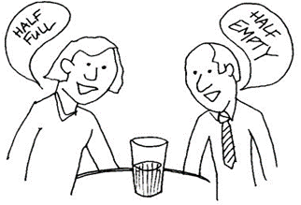

We need an impartial person for the judgment

## 3.3. The Fuzzy logic under psychological view

In a classical view on psychology, we easily see that psychology as a science must describe, explain and predict psychological phenomena. Obtaining this final goal is not always easy. In order to achieve this goal and to preserve the scientific nature of phenomena in psychology, statistical methods or Fisherian statistics are usually employed. Although these methods have influential effects on this science, they do not take into account that the mind is an overlapping, dynamic and integrative map. Simply put, there is no sharp line among latent traits or psychological constructs because, under the assumption of this approach, the mind is a collection of fuzzy integrated overlapping schemas or maps. The boundaries among them are not crisp; they are instead rather fuzzy and ambiguous like a spider’s web. Fuzzy inference systems rely on these assumptions.

In other words, these difficulties are rooted in the nature of a human's mind. Mentality does not consist of distinct parts but is a dynamic, flexible and complicated whole.

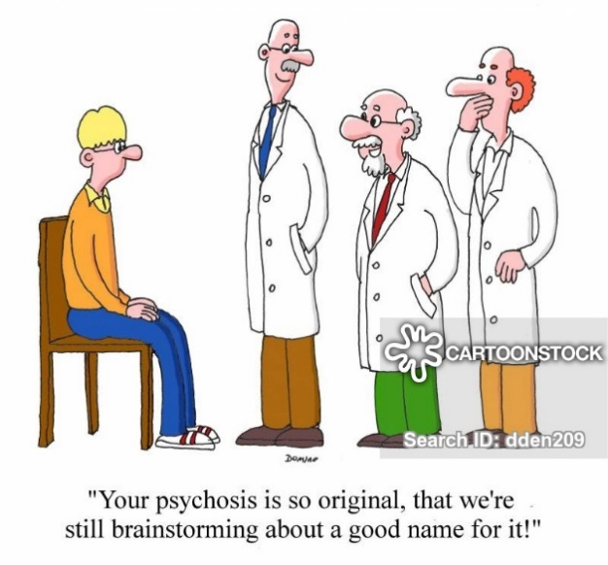Lack of complete information coupled with the imprecise and controversial nature of the mental process and its states leads to challenges in psychology, to diagnosis, research, treatment, prediction and classification and in the construction of theory.

The best and most precise descriptions of the psychological states and traits are made by individuals' linguistic terms. These terms are imprecise and vague. A given disorder may manifest itself quite differently, depending on its intensity and the individual characteristics of the patient. A single symptom may also correspond to different disorders (Torres and Nieto, 2006). On the other hand, some disorders are considered as non-specific with, for example, the need for new theories to be developed to model mixed emotions. For example, some evidence indicates that people can feel happy and sad at the same time (Larsen and McGraw, 2011; see Fang, Sauter, and van Kleef, 2018). Based on the classical view, normality (non-diseased) and abnormality (diseased) are mutually exclusive and even may be opposites. This view originated from Aristotelian logic, which held sway for around 2000 years in human reasoning, knowledge, and science. Everything must either be or not be. A predicate either belongs or does not belong to a given subject in a given respect at a given time. That is either 𝐴 or ¬𝐴. The modern formulation of the above rule is .

Accordance with this emotionless view of classification, every proposition or state is of only two logical values: true or false (1 or 0). In the real world, however, not everything can be classified into either black or white, rather, the real world is colored by our perception, therefore, most of the time our mind’s view of the world is grey. Let us demonstrate this with a simple psychological example using a statement which is an item of The Minnesota Multiphasic Personality Inventory (MMPI). This test and its different versions are one of the most commonly used and important tests in psychological settings and research. The statement "I think many people exaggerate their misfortunes to gain the sympathy and help of others" is part true and part false, depending on the 'states and situations’ of individuals. Consider this statement as another example: “I am a famous person”. If you are the president of a superpower country, this is true but if, however, you are a shepherd in a small marginal village, and then it is false. We are talking here of the relative fame of two sorts of people. Everybody is well-known (W) to some extent and unknown (N) to some extent. If you are famous, W=1, and as each of us has just some degree of reputation, then W<1.

(I) In the W+I+N=1 denoted as “I don’t know”.

Let us pay attention to the diagnostic criteria of the obsessive-compulsive disorder in the fifth edition of the Diagnostic and Statistical Manual of Mental Disorders (DSM-5). Criterion A states that the presence of obsessions, compulsions, or both are defined by the presence of two factors. Firstly, by recurrent and persistent thoughts, or impulses that are experienced, at some time during the disturbance, as intrusive and unwanted, and that in most individuals cause marked anxiety or distress. Secondly by the attempts of the individual to ignore or suppress such thoughts, urges, or images, or to neutralize them with some other thought or action (i.e., by performing a compulsion). Compulsions are defined by:

1. Repetitive behaviors (e.g., hand washing, ordering, checking) or mental acts (e.g., praying, counting, repeating words silently) that make the individual feel driven to perform in response to an obsession or according to rules that must be applied rigidly.

2. Behaviors or mental acts aimed at preventing or reducing anxiety or distress, or preventing some dreaded event or situation, however, these behaviors or mental acts are not connected in a realistic way with what they are designed to neutralize or prevent, or are excessive. Note: Young children may not be able to articulate the aims of these behaviors or mental acts. Criterion B states that the obsessions or compulsions are time-consuming (e.g., take more than 1 hour per day) or cause clinically significant distress or impairment in social, occupational, or other important areas of functioning. Criterion C states that the obsessive-compulsive symptoms are not attributable to the physiological effects of a substance (e.g., a drug of abuse, a medication) or another medical condition. Criterion D states that the disturbance is not better explained by the symptoms of another mental disorder (e.g., excessive worries, as in generalized anxiety disorder, preoccupation with appearance, as in body dysmorphic disorder, difficulty discarding or parting with possessions, as in hoarding disorder, hair pulling, as in trichotillomania (hair-pulling disorder), skin picking, as in excoriation (skinpicking) disorder, stereotypies, as in stereotypic movement disorder, ritualized eating behavior, as in eating disorders, preoccupation with substances or gambling, as in substance-related and addictive disorders, preoccupation with having an illness, as in illness anxiety disorder, sexual urges or fantasies, as in paraphilic disorders, impulses, as in disruptive, impulse-control, and conduct disorders, guilty ruminations, as in major depressive disorder; thought insertion or delusional preoccupations, as in schizophrenia spectrum and other psychotic disorders or repetitive patterns of behaviour, as in autism spectrum disorder. For many years this disorder belonged to a bigger disorder class which was called anxiety disorder but in 2012 it was reclassified. It is obvious that the nature of this disorder has not changed, rather, the definition has been changed and this kind of change may occur in the future as well. This example implies that the boundaries among psychological constructs are not well defined but are instead fuzzy and vague. This means that we face a partial inclusion of the categories (where we have at least two categories). This is a key component in fuzzy thinking according to Wierman (2010). Although fuzzy set theory has been used successfully in many fields of science for more than fifty years, there exist just a few research works, mostly articles, in psychology using this theory. Whilst the existing approaches do not consider any practical aspect or software code that can be easily used by psychologists they can be considered as a theoretical starting point for applying the fuzzy set theory in psychology; for example, Smithson (1982), Zetenyi (1988), Smithson and Oden (1999), Ragin (2000), Smithson and Verkuilen (2006) and Arfi (2010). Some recent examples of fuzzy set theory in psychology include:

* A fuzzy logical model of perception (see Oden and Massaro,1978; Massaro,1989; Massaro & Cohen,2000; Martínez-Jiménez and et al., 2018)
* Fuzzy set-based theory of memory and attention (see Brainerd et al., 1991; Tung and Quek., 2010; Perfilieva,2015; Terziyska1 et al.,2015)
* Fuzzy decision making (see Khefacha & Belkacem,2015)
* Fuzzy psychopathology (see Horowitz & Malle,1993; Mosoiu et al.,2010; Arthi & Amilarasi,2008; Ekong et al. 2013; Reinertsen et al., 2017; Ashish et al.,2018)
* Fuzzy consciousness (see Huette & Spivey, 2012)
* Fuzzy measurement and testing (see Stoklasa & Talasova,2011; Farahani et al.,2018; Farahani & Azadfallah,2019)
* Fuzzy methodology (see Sugeno& Yasukawa,1993; Stoklasa et al., 2014)
* Fuzzy epistemology (see Seising,2008)
* Fuzzy clinical diagnosis (see Baig et al.,2011; Erin,2019)

## 3.4. Why fuzzy logic theory?

According to the literature, it is reasonable to argue that fuzzy logic and its derivatives are helpful to psychologists dealing with ill-structured and ill-defined phenomenon. Many psychological constructs are not well-defined due to their nature. For example, categorizing patients into two distinct groups is often difficult because overlapping and partial inclusion is not possible. Our mind is continuous and full of overlapping fuzzy micro- maps. Thus, it is possible to face many cases, which may belong to at least two categories. Finding a sharp and crisp line among psychological concepts in soft science is very difficult. The nature of continuity of mind implies that our mind is much more similar to overlapping cloud cubes in a rainy sunset than distinct sand particles on a shore. Categorisation is much more difficult when we are too close to a threshold. In reality, many of the psychological traits such as emotion, cognition, and disorder are mixed and of different magnitudes. For example, an extrovert person may have some degrees of introversion and vice versa. Depressed persons may have high scores on only some symptoms, and in the other symptoms, the scores can be in the middle or low. The concept of the stage is important both in the old psychological theories of Piaget or Freud and in new theories that are being built and extended in cognitive psychology and neuroscience. These stages are not distinct and separate from each other, but are instead overlapping. This continuity can be accommodated using a fuzzy psychological view. Psychological data and linguistic data are the same, and the fuzzy logic theory is a powerful tool for quantifying the linguistic data. In psychology information from individuals is collected using standardized tests or interviews therefore information is provided in words. The words are full of imprecise information which needs to be quantified. A concept can mean different things to different people. For example; When two people tick “very high” as a response to the item “I am happy with my life”, they may have different mindsets of very high, although they chose the same answer. “Very high” does not represent a universal standard, but varies depending upon the individual. You may feel like rating it 5 and your friend 10, even though it is very high for both of you.

Quantitative psychological research mostly relies on the classical statistics in which testing the null hypothesis is essential. The null hypotheses are tested directly and the alternative or research hypotheses are tested indirectly. In null hypothesis testing, the p-value is a criterion for making a statistical decision on acceptance (true) or rejection (false) of that null hypothesis. Most psychological researchers analyze their obtained quantitative data until a p-value smaller than 0.05 is observed; this may lead to an inflation of Type 1 error. Many scientists have criticized p-values (e.g., Simmons, Nelson & Simonshon, 2011; Cumming, 2011) and they believe that p-hacking is widespread throughout science (Head et al., 2015) where we increase the significance of “just significant results" (Leggett et al., 2013). This means that psychological researchers, like other researchers, are interested in publishing only the significant results and we observe the surge of p-values and the file drawer effect. This means what is not significant statistically has been ignored and hidden (see Lakens, 2015). These challenging issues threaten the robustness of scientific knowledge. In fuzzy inference systems, the extent of alternative hypotheses is tested directly. That helps us to capture a more realistic picture of a mental event, process, and phenomenon. Fuzzy inference systems aim to rethink the psychological theories and find new results and try to solve what is called a "crisis of confidence" in psychological research. The issue has drawn the attention of Bayesian statisticians (see Marsman,M. & Wagenmakers, 2016; Wagenmakers, 2018). Clinical decision making is a crucial activity in psychology; how do we make decisions in a clinical setting using fuzzy logic? Fuzzy inference systems focus on how a clinical psychologist can build a clinical model and make a fuzzy decision. Based on this method, a psychologist is capable of considering many factors for diagnosing a disorder or determining the efficacy and effectiveness of psychological treatment. In summary, the main goal of a fuzzy inference system is to capture the psychological concepts which are reflected in the linguistic concepts, based on qualitative and quantitative research.

This approach bridges the depth of qualitative research and the precision of quantitative research. This bridge is interesting and of use in psychology. As we have already mentioned two-valued logic cannot adequately model fuzzy systems. The history of developing and paying attention to fuzzy thinking and theory is long and interesting. This journey represents the development of attempts to model “vagueness” in the history of science. What we are aiming to do here is to show the necessity of having this view in studying the mind and the need for fuzzy inference systems.

Is fuzzy inference a reasonable field of psychology? Reviewing the literature indicates that there are many pieces of research in which cognition and emotion have been investigated. Many of them have been done based on classical statistics and, therefore, they could test just simple models. For example, we can find that the cognitive system has an underlying interactive network (Stephen & Mirman, 2010; Spence & Driver, 2004) with meaningful noise conditions which are useful in computation (Kello, Anderson, Holden, & Van Orden,2008; Kello & Van Orden, 2009) and top-down constraints on perceptual processing (Motter,1993; Spivey & Spirn, 2000; Gandhi, Heeger, & Boynton, 1999; Ito & Gilbert, 1999; Lamme & Roelfsema, 2000). Although these research attempts are important and enlightening opening our eyes to many complicated phenomena, it is worthwhile noting that there are still reasons for developing and extending fuzzy inference systems as a major research line. Almost all of this research is based on the linearity assumption, a condition that simplifies the world and may afford a way to reality and yield us a robust model. Huette and Spivey (2012) believe, however, that the most difficult part of transitioning to a descriptive and accurate model of consciousness is to abandon linear causality. The fuzzy inference system uses fuzzy logic to help us more closely represent human thinking and does not make an assumption of linear relationships. Huette and Spivey (2012) have extracted some common points, based on reviewing the research literature about consciousness. They also coined the term “fuzzy consciousness”. These common principles include: a. The everyday experience of consciousness is noisy, imperfect with at best partial information. Most of one’s time is spent by moving through a space of concepts, percepts, and emotions; never quite fully reaching any pure concept in a context-free manner. This means that at any given time, consciousness is defined by the many thousands of environmental inputs in a natural environment, the constraints of many billions of neurons associated with previous learning experiences and a framework equipped with high-dimensional sensation and movement parameters. All of these variables combine to form what is reported as consciousness. b. All relevant variables should be considered. This is based on the linearity assumption and classical statistics. Even considering all variables, at a given time, we may face some thoughts and behaviors, which are unusual. For example, suppose that Shannon is a postgraduate student and she has been informed that her paper submitted to a journal has been rejected yesterday and she must revise it and submit it to another journal soon. She is divorced and alone and her mother is so sick and her father passed away last year. You see her sitting alone and smoking in the door café of your university and you find her feeling depressed. These states of her consciousness are expected, but you may also see Shannon beginning to laugh suddenly. This is not an expected state of her consciousness given she is depressed, but it is possible that she may have remembered a joke just for a millisecond. Under some researchers like Huette and Spivey (2012), we believe that a fuzzy consciousness can account for this surprising behavior. c. Evidence for the fuzzy consciousness should be given. This new theory is a nonlinear and fuzzy system (Huette and Spivey, 2012). The continuity of the mind, which has been argued by Spivey (2015) is a new view for omitting the crisp boundaries of the mind. Simply put, the mind acts continuously, but a given behavior may be taken as a discrete one, in isolation, by an external observer.

There is philosophical evidence for the importance and necessity of the fuzzy view of psychology, for example, Taylor (2019) presents a new philosophical view of perception and argues that perception is a messy cluster which is supported by mechanisms, that don't always work. There is a fuzzy transition between the non-perceptual and the perceptual. This is an entirely new way of thinking about perception, completely unexplored in philosophy. There is some neurological evidence for the necessity of a fuzzy view on psychology. There is not much evidence in neurological research that fuzziness has been considered although Rayan and et al. (2015) indicated that there are shared performance impairments in cognitive control among patients with mood disorders (MDD and BD) relative to healthy controls. They also showed that the neurobiological bases underlying these seemingly shared dimensions of impairment are not as clear cut as we would like due to larger more diverse independent groups.

The nature of fuzzy logic is very close to the real world, due to the capacity of quantifying the linguistic variables, which we use for asserting our emotions and cognitive reasoning, judgment, and decision making. It follows that a fuzzy inference system helps us to solve a “crisis of confidence” in psychological research, which is due to the use of classical statistics overlooking more complex relationships. One important assumption of a fuzzy inference system is the fuzzy layer. We can think of this layer as representing our perception. It is important to note that perception is the core of cognition and emotion. Mao (2018) believes that an entity is not simple but complex and inter-related with other things. In other words, reality is the state of things, past and present, whether or not they are observable or comprehensible. Perception is the interpretation of the stimuli based on experiences which we may have about them. That means that the brain is an active participant in constructing what we perceive. The perceptions that the brain creates are the result of an interaction between the signals received and what it does to them. To understand perception, and the knowledge that we acquire through it, we must, therefore, enquire not only into the nature of the signals that the brain receives but also into the contribution that the brain makes and the limitations that its characteristics impose upon the acquisition of knowledge. (Kant, 1781; Schopenhauer, 1859; as cited in Zeki, 2001). Zeki (2003) believe that the brain has been evolved as a flexible tool for acquiring knowledge about both unambiguous and ambiguous conditions. The ambiguous conditions are not rare, rather, we commonly encounter them. The ambiguous condition is the condition in which two or more interpretations exist, each one of which has equal validity with the others. However, we can only be aware of one interpretation at any given moment (Zeki, 2003). This indicates that our perception is what we call a fuzzy layer. Based on Mao (2018), usually, a thing (T) is multilateral or complex, and so to hold on to its reality is difficult for human beings, where the complexity of the world implies the cognitive system on a thing (T) is itself complex. i.e. a system composed of many components which may interact with each other. Recently, some research has implied that we can experience mixed emotions (see Fang, Sauter, & van Klee, 2018, Keltner, Sauter,Tracy and Cowen, 2019). Van der Heide, Sanchez & Trivno (2011) indicated that a human can experience 1) mixtures of emotions, and /or 2) conflicting emotions and Mao (2018) describes this ambiguity in a mathematical framework. In fuzzy inference, we formulate such a framework by applying fuzzy set theory and its derivatives.

## 3.5. What is the fuzzy map?

Let us take a typical example accounting for the complexity of a cognitive system. It is the well-known fable "the blind men with an elephant".

This is a famous story in Buddhism, which implies the whole is more than its parts but we always tend to focus on the parts. In this story, there are six blind men who were asked to determine what an elephant looked like by feeling different parts of an elephant’s body. The men touched the elephant’s leg, tail, trunk, ear, belly or tusk and they respectively claimed it’s like a pillar, a rope, a tree branch, a hand fan, a wall or a solid pipe.

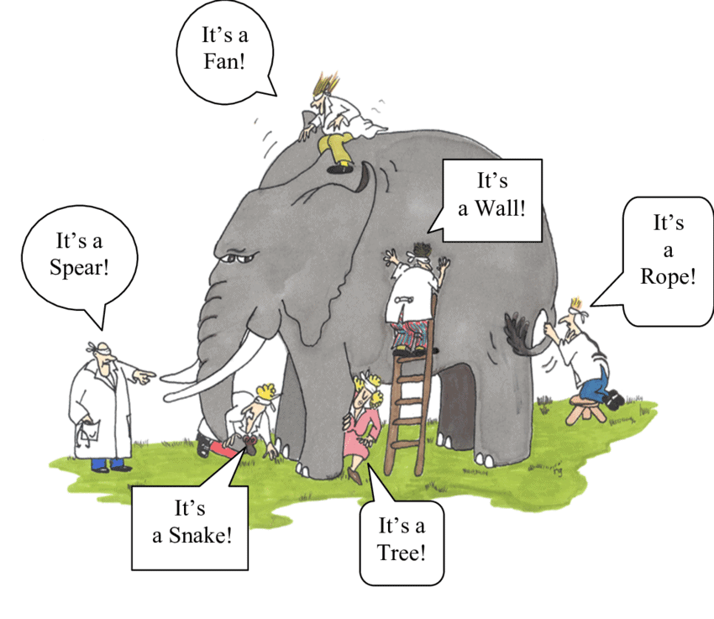

Similarly, Rumi (1207-1273) included it in his approach. In his retelling, "The Elephant in the Darkness", some people bring an elephant to be exhibited in a dark room. Many men touched the elephant in the darkness and, described whatever they happened to touch. This fable is close to the famous statement of Werner Heisenberg (1901-1976). He stated that natural science does not simply describe and explain nature. It is, instead, part of the interplay between nature and ourselves. In this well-known fable, the men's perception of the part of the elephant is akin to a "fuzzy micro-map. Although there is a term which is called a cognitive map in the fuzzy literature, that is a map captured through experts investigating factors influencing a phenomenon. A fuzzy micro-map is a network which is obtained from a cognizant. In a fuzzy inference system, a cognizant is a person who produces a fuzzy micro-map of his or her perception of a phenomenon. His or her perception of a phenomenon is the same fuzzy layer and the theoretical structure as an output of the perception process is the fuzzy micro-map. A fuzzy psychologist tries to collect the fuzzy micro-map using a data-gathering method from the cognizant's point of view. In our elephant example, each fuzzy micro map is the name of the part of the elephant mentioned above, therefore, all of the fuzzy micro-maps need to be combined into a final testable map. It is worth noting that the fuzzy micro map is obtained from the data given by a cognizant. As we have seen a cognizant is a person who has information and experiences of a system (each man touching a part of the elephant). Any human being may be a cognizant. The data are obtained using methods including storytelling by the cognizant, a transcription of the recorded detailed interview with the cognizant, MRI, EEG, QEEG, and EMG. The fuzzy micro-map is a readable mind map of a cognizant. After providing all the fuzzy micro-maps a fuzzy psychologist combines them using an expert panel and provides a final map. This final map will be the basis for the fuzzy inference. Thus fuzzy mapping helps us to find a real model of an elusive phenomenon. The fuzzy map has higher flexibility, an ability to capture more significant complex relationships and more generalizability than traditional approaches.

The main purpose of research in psychology is to model the mind and define normality and abnormality, and these are not usually clearly separated. Most of the samples in psychological research are small and non-random, therefore statistical inference is not a robust method for generalizing the results. The use of the p-value as the heart of null hypothesis testing in psychological research has been strongly criticized. Bayesian statistics require the specification of a prior distribution which is not easy to define. Qualitative research can be an appropriate alternative. Although this methodology can be useful, its precision is somewhat vague. A fuzzy inference system, on the other hand, is a robust method for capturing and explaining the mind and its processes. This approach bridges the depth of qualitative research and the breadth of quantitative research and solves many difficulties by using different sources of information and integrating them to make inference in a way that more closely resembles the reasoning of the mind.

## 3.6. Fuzzy Modelling of Psychological Systems

Neurosis is the inability to tolerate ambiguity (Sigmund Freud)

According to fuzzy logic, a concept is hardly ever completely true or completely false, but it is rather somewhere in between these two extremes.

A simple example of this difference is shown in Figure 4.3, in which instead of a singleton number defining the number x’, as we instinctively use in everyday logic, the concept of degree of similarity (or degree of truth or degree of membership) is introduced, defined by the membership function (mf) A x a: µ (). The interpretation of fuzzy sets () has arisen from the generalization of the classical sets to embrace the vague notions and unclear boundaries. It may not be always clear, if an element x belongs to a set A, or not. Thus, its membership may be measured by a degree, commonly known as the membership degree taking a value from the unit interval by agreement.

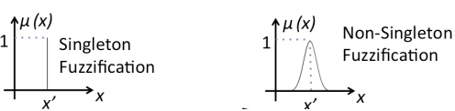

Figure 4.3 A singleton and non-singleton fuzzification

Consequently, a fuzzy set A over the universe of discourse X is defined by function that matches each element of the universe of discourse with its membership degree to the set A

**(3.1)**

where says that an element x definitely does not belong to a fuzzy set A, says that x without any doubt is member of fuzzy set A. Higher value of indicates the higher degree of membership of an element x to a fuzzy set A. Each fuzzy set is defined by one membership function. A membership function maps each element of the universal set X into real numbers from the [0, 1] interval. We should emphasize that the universal set X is always a crisp set (). A fuzzy set can be defined as a set of ordered pairs:

**(3.2)**

When the universal set is finite, fuzzy set constructed on this universal set can be expressed by counting the elements and their respective membership degrees

**(3.3)**

## 3.7. Properties of Fuzzy Sets

In this section properties relevant for the next sections are examined. Firstly we define scalar and relative scalar cardinality. For any fuzzy set A defined on a finite universal set X we define its scalar cardinality by the formula

**(3.4)**

The scalar cardinality of a fuzzy set is a generalization of classical cardinality.

Elements of a universal set belong to fuzzy sets with different likelihoods of membership and therefore we cannot count elements of a set A, but, instead we sum their respective membership of these elements. Some authors refer to as the sigma count of A (Dubois & Prade 2005).

The relative scalar cardinality is defined by the formula:

**(3.5)**

where card(A) is defined in (Dubois & Prade 2005) and card(X) represents the number of elements in X. These cardinalities are broadly used in areas such as linguistic summaries. The third type of cardinality is fuzzy cardinality expressed as an ordered pair defined as the number of elements belonging to a particular α-cut when the universal set is finite. Cardinalities are closely examined e.g. Scalar cardinality of a fuzzy set can be expressed as the area bounded by the membership function of fuzzy set and the x-axis. This approach is demonstrated on the trapezoidal fuzzy set (Dubois & Prade 2005).

* **Support:** The support of a fuzzy set A is the finite set with the following property:

**(3.6)**

* **Core:** The core of a fuzzy set A is the set with the following property:

**(3.7)**

In the fuzzy sets literature, the term kernel is used as a synonym for the core.

* **Height:** The height is the highest value of the degree of membership of all elements in the considered fuzzy set A:

**(3.8)**

* **Normalized fuzzy set:** Fuzzy set A is normalized, if the degree of membership of at least one element is equal to 1, i.e.:

**(3.9)**

* **Crossover point:** The element of a fuzzy set A that has a membership degree equal to 0.5 represents the crossover point, i.e.:

**(3.10)**

One of the important concepts used in fuzzy sets is the α-cut. The α-cut A(α) and its restrictive variant strong α-cut A(α+) are defined in the following way:

**(3.11)**

**(3.12)**

where α ∈ [0, 1]

The α-cut of a fuzzy set A is a set containing all the elements of the set X whose membership degrees in A are greater than or equal to the specified value of α. This property is used in many areas, e.g. working with elements in a fuzzy set associated with a high likelihood of membership. A fuzzy set is convex, if and only if (Pourabdollah, Mendel, & John,2020)

**(3.13)**

for all x and y ∈ X and all λ ∈ [0, 1]. Convex and non-convex fuzzy sets are plotted in Figure.21

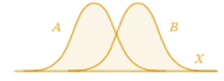

Fuzzy union (OR)

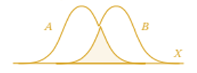

Fuzzy intersection (AND)

Fuzzy union with complement



Fuzzy intersection with complement



Figure 5.3 Logical operations on fuzzy sets. The shaded areas represent the result of the operation (Klir & Yuan,1995)

## 3.8. Types of Fuzzy Sets (Membership Functions)

Membership functions are classified into two main groups [10]: linear and Gaussian or curved. All membership functions explained in this section are normalized fuzzy sets ie with one element having a degree of membership equal to 1 (Hasan& Sobhan2020).

**Triangular fuzzy set** is defined by its lower limit a, its upper limit b and the modal (highest) value m as:

**(3.14)**

**Gaussian fuzzy set** defined by the modal value (centre) m and width k as:

**(3.14)**

The bell of the Gaussian function depends on the value k. If the value k is lower, then the bell is narrower.

**Trapezoidal fuzzy set** is defined by its lower limit a, its upper limit b, and the flat segment [m1, m2] representing the highest value of height (3.16) as

**(3.16)**

## 3.9. Practical Example using R

The R programming language began in 1992 as an effort to create a special-purpose language for use in statistical applications. More than two decades later, the language has evolved into one of the most popular languages used by statisticians, data scientists, and business analysts around the world. R gained rapid traction as a popular language for several reasons. First, it is available to everyone as a free, open source language developed by a community of committed developers. This approach broke the mould of past approaches to analytic tools that relied upon proprietary, commercial software that was often out of the financial reach of many individuals and organizations. R also continues to grow in popularity because of its adoption by the creators of machine learning methods. Almost any new machine learning technique created today quickly becomes available to R users in a redistributable package, offered as open source code on the Comprehensive R Archive Network (CRAN), a worldwide repository of popular R code. Figure 2.1 shows the growth of the number of packages available through CRAN over time. As you can see, the growth took off significantly over the past decade. it’s also important to know that R is an interpreted language, rather than a compiled language. In an interpreted language, the code that you write is stored in a document called a script, and this script is the code that is directly executed by the system processing the code. In a compiled language, the source code written by a developer runs through a specialized program called a compiler, which converts the source code into executable machine language.

Suppose, we need to use fuzzy set for demonstrating degree of depression in a sample of Multiple Sclerosis (MS) ranged between 1 to 10(Table 2). We consider the amount of depression in terms of a triangular fuzzy number for each linguistic terms which may be, for example, responses by clinicians assessing the amount of various aspects of depression (denoted in the table as a,b, and c) in an individual.

Fuzzy set parameters of very low to very high for depression

1. Fuzzy set parameters for linguistic terms

|  |  |  |  |
| --- | --- | --- | --- |
| Linguistic terms  (fuzzy set) | a | b | c |
| Very Low | **0** | **1** | **2** |
| Low | **2** | **3** | **4** |
| Middle | **3** | **5** | **6** |
| High | **6** | **8** | **9** |
| Very High | **9** | **10** | **11** |

Based on table 2, we are going to define a triangular distribution for each fuzzy set element (ranging from very low to very high) and determine membership degree for various numbers. You can see the R codes as below in RStudio, an add-on interface to R.

**Listing1** R codes for defining a triangular number for each fuzzy set elements

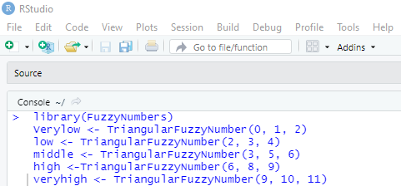

Using plot (Verylow, xlim=c (0,2)) the plot of the triangular distribution is provided for the very low fuzzy set (Figure 6.3).

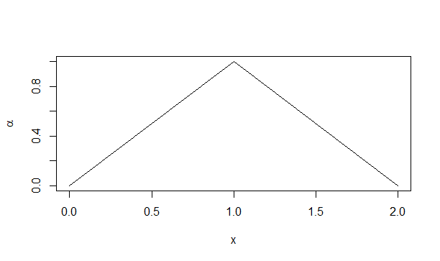

Figure 6.3 R results for plotting of each fuzzy set elements

Using the following codes, we can show the distributions of membership degree of all elements of the fuzzy set in the same plot.

**Listing2** R codes for plotting all of the fuzzy set

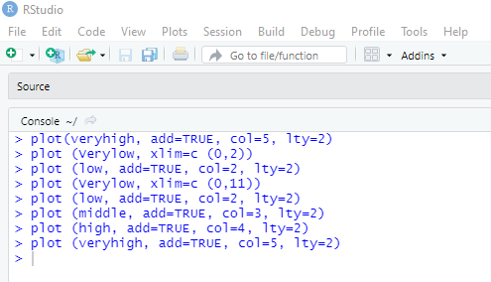

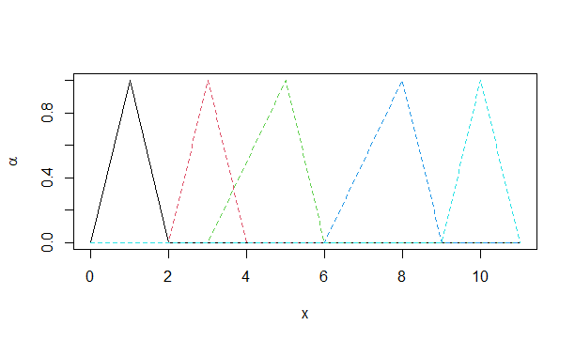

**Figure 7.3** R results of plotting of all elements of the fuzzy set

With a simple code the support and core values can be accessed. The supports for very high are 9 and 11 and there are cores which are 10 and 10.



[1] 9 11



[1] 10 10

For determining the α-cuts, we just need to use , for every fuzzy set A. You can see the result of the code for middle.

*cuts <- alphacut(middle, c(0, 0.5, 0.8)*

*cuts*



**Figure 8.3** the result of the code for middle

Suppose, there is a patient suffering from MS who as a score of 7 on a depression scale. We wish to determine the degree to which this patient belongs to each fuzzy set element. Let us determine the membership degree for all scores from 1 to 10 including 7. To do this we write a simple code using the function, evaluate()

**Listing 3** R codes for evaluation of the fuzzy membership function

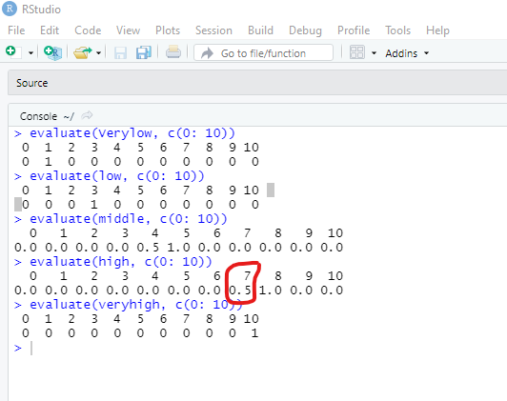

As you can see for a score of 7, membership degree is 0.5 only for high and 0 for the rest. This shows that there is a 50% chance of someone with a score of 7 on the depression scale being given a ‘high’ rating by the clinicians. We can calculate membership degree for each of the depression scores between 1 and 10 for people rated by the clinicians as highly likely to be depressed.

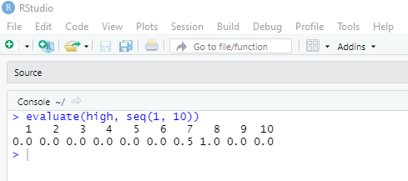

## 3.10. Fuzzy set composition

A suitable tool for interpretation of the “AND” or connective (conjunction) in fuzzy logic are triangular norms (or short t-norms) (Nguyen, Walker,1977). Relevant mathematical aspects of t-norms are discussed in depth in [20]. Theoretically, there are an unlimited number of t-norms. The four basic and commonly used t-norms are given below (Wanga , Yanga, &Li,2022).

.

* **Minimum:**

**(3.17)**

* **Product:**

**(3.18)**

* **Łukasiewicz t-norm:**

**(3.19)**

* **drastic product**

**(3.20)**

where , i = 1, 2 denotes the degree of membership of the element x in the i-th fuzzy set, Ai. An interesting t-norm is the nilpotent minimum t-norm defined as:

**(3.21)**

The s-norm or t-conorm functions define a general class of disjunction operators. The following s-norm functions are correspondingly dual to the aforementioned t-norms (3.22)– (3.25):

* **maximum:**

**(3.22)**

* **algebraic sum:**

**(3.23)**

* **Łukasiewicz s-norm:**

**(3.24)**

* **drastic s-norm**

**(3.25)**

where , i = 1, 2 denotes the degree of membership of the element x to the fuzzy sets Ai .

### 3.10.1. Practical example using R

We can illustrate these fuzzy set terms with an example. Let us suppose 2 experts interviewed one MS patient and evaluated him/ her as high and very high. If we want to quantify these linguistic terms and combine them based on fuzzy logic, we can use the following codes using the FuzzyR library(listing3)

**Listing 3**. R codes for linguistic terms and composite them based on fuzzy logic



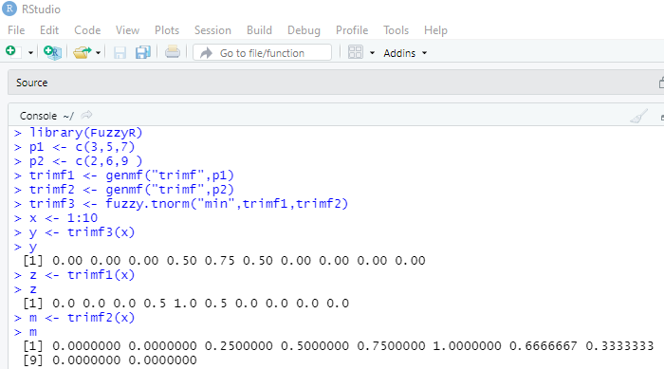

 We can use the code below for defuzzification .

This code defuzzifies scores between 1 and 10 based on a triangular fuzzy number using a "centroid". For aggregating the opinions of the experts in terms of a t-conorm, we write the codes as follows.

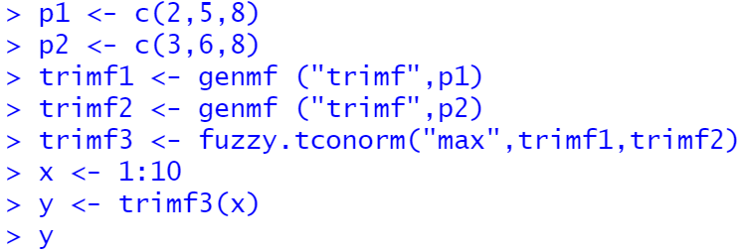

[1] 0.0000000 0.0000000 0.3333333 0.6666667 1.0000000 1.0000000 0.5000000 0.0000000

[9] 0.0000000 0.0000000

We conclude that the most prevalent scores are between 3 and 7.

## 3.12. Mamdani Fuzzy Inference System

Mamdani systems have proven to be a very useful tool for function approximation and control (Cao et al. 2001) – an aspect that has interesting potential applications in the social sciences too which we will not discuss here. In this section we analyze their potential usefulness as a tool for logical deductive inference to study, via simulation, the consequences and behavior of a model defined by means of IF-THEN rules.

Mamdani systems are most often classified as a form of Approximate Reasoning, which has been defined as “the process or processes by which a possible imprecise conclusion is deduced from a collection of imprecise premises” (Pal & Mandal 1991). This categorization, together with the fact that the core component of a Mamdani system is a set of IF-THEN rules, can easily mislead one to believe that Mamdani systems can provide the logical implications of the set of rules used to build them, even if only approximately. Without pointing at any particular example, it is not difficult to find cases in the literature that seem to be taking this assumption for granted, either implicitly or explicitly. Specifically, one might be tempted to believe that in a Mamdani system the joint truth of the premises guarantees the truth of the conclusions. In logics that admit degrees of partial truth, this expectation would read that if the inputs of the system are true to some degree (i.e., they satisfy the antecedents of the rules to some extent), then the outputs of the system should also be true to at least the same degree (i.e., they should satisfy the consequents of the rules to at least the same extent). This fallacious interpretation of Mamdani systems as truth-preserving inference machines is certainly – and fortunately – not shared by everyone, but is reasonably widespread and does permeate many simulation applications of the technique.

To be clear, Mamdani systems are not truth-preserving in the sense stated above; they can lead to very different results from those obtained if the IF-THEN rules embedded within are interpreted as proper logical implications. This fact has already been well established in the specialized literature of fuzzy logic – as the quote below shows – but, arguably, it does not seem to be so conspicuous in many practical applications of the technique.

[The inference rule used by Mamdani systems] “is not a logical inference, i.e., a procedure aiming at the derivation of new facts from some other known ones using formal deduction rules. No logical implication is inside and thus, no modus ponens proceeds.” (Klawonna & Novák 1996).

This section illustrates through several examples why the Mamdani method is not appropriate to explore the logical deductive consequences of a set of IF-THEN implication premises. More technical discussions of some of the aspects that we illustrate in this paper can also be found in the literature (Bodenhofer et al. 2007; Dubois & Prade 1996; Hájek 1998; Klawonna & Novák 1996; Novák 1994).

Mamdani fuzzy systems were originally designed to imitate the performance of human operators in charge of controlling certain industrial processes (Mamdani 1974, 1976, 1977; Mamdani & Assilian 1975). The aim was to summarize the operator’s experience into a set of (linguistic) IF-THEN rules that could be used by a machine to automatically control the process. Specifically, using such a set of IF-THEN rules.

A Mamdani fuzzy system defines a function which generates numerical outputs from (usually numerical) input values x. Here we present a reduced and simplified exposition of the method. For a more complete and detailed presentation, the reader is referred to Sections 11.4.1 and 11.4.2 in Zimmermann (2001) or Section 11.4 and Chapter 12 in Klir & Yuan (1995).

Mamdani systems are composed of IF-THEN rules of the form “IF X is A THEN Y is B”, such as “IF PRESSURE is HIGH THEN VOLUME is LOW”. The IF part “X is A” is called the antecedent of the rule, and the THEN part “Y is B” is called the consequent of the rule. For simplicity in the exposition of the method and the examples, let us assume that X and Y (PRESSURE and VOLUME respectively in the example above) are numerical variables defined on real intervals. The examples we provide can be easily adapted to other input and output spaces, multiple inputs, or fuzzy inputs. Thus, henceforth variable X is assumed to be defined in a real interval that we call the input interval, whilst variable Y is assumed to be defined in a real interval that we call the output interval. Let us use lower-case letters x and y to denote specific values of the variables X and Y respectively.

The symbols A and B (HIGH and LOW respectively in the example above) denote linguistic terms that are modeled as fuzzy sets defined on the input and output intervals respectively. Fuzzy set A is defined by a membership function that assigns a real value between 0 and 1 to each element x in the input interval. The value is called the degree of membership of element x in fuzzy set A, and can be interpreted as the extent to which element x belongs to fuzzy set A. If the fuzzy set A represents a certain concept (i.e. “HIGH”), can also be interpreted as the truth value of the proposition “X is A” whenever X = x (e.g. the truth value of “PRESSURE is HIGH” whenever PRESSURE= x), represented as Truth Value (). Likewise, fuzzy set B is defined by a membership function µB that assigns a real value µB(y) between 0 and 1 to each real value y in the output interval.

Most often Mamdani systems are composed of several IF-THEN rules. Naturally, each of the rules (which we index with subscript k) may use different fuzzy sets Ak and Bk. The antecedents and consequents can also be combined propositions that include the logical connectives AND or OR. A standard Mamdani system uses the following operations to compute the truth value of combined propositions:

,

,

**(3.26)**

The logical negation is implemented in a standard Mamdani system as follows:

**(3.27)**

Leaving aside a possible fuzzification step, which is not relevant for our discussion, the algorithm that a Mamdani system uses to compute a numerical output y from a numerical input X=x , given a set of rules "IF X is Ak THEN Y is Bk", consists of the following steps:

1. Compute the degrees of consistency between observations (inputs) and antecedents of each rule. In this step we evaluate the extent to which the antecedent of each IF-THEN rule is satisfied for a given input. The degree of consistency between an input or observation X = x and an antecedent “X is A” is simply the degree of membership of x in the fuzzy set A, i.e. µA(x). The result of this step is a number for each rule “IF X is Ak THEN Y is Bk” (i.e. the degree of consistency between the input and each rule’s antecedent). If the corresponding rule k is said to be “fired”.
2. Truncate the fuzzy set in the consequent of each rule. The result of this step for each rule “IF X is Ak THEN Y is Bk” is the fuzzy set Bk truncated at the level, i.e., a set such that

**(3.28)**

1. Aggregate all the truncated fuzzy sets. In this step the truncated fuzzy sets corresponding to each fired rule are aggregated to provide one single fuzzy set defined by the membership function

**(3.29)**

The equation above clearly shows why Mamdani fuzzy systems are sometimes called max-min fuzzy systems.

1. Defuzzify the aggregated fuzzy set. The defuzzification step transforms the aggregated fuzzy set into one single crisp number. Standard Mamdani systems use the Centre of Gravity (COG) defuzzification method. This method returns the projection (on the horizontal axis) of the centre of gravity of the area under the membership function . If some input value is such that no rule is fired, the centre of gravity for cannot be calculated. In that case, some default output value can be considered, or the system can be readjusted to avoid that situation (e.g. by modifying the fuzzy sets Ak, or by including new rules).

Given that the defuzzification step has a large influence on the final function that the system provides, we will also consider here two other alternative defuzzification methods (Van Leekwijck & Kerre 1999):

1. First of Maxima. This method returns the smallest value of y for which the membership function attains its maximum value.
2. Last of Maxima. This method returns the greatest value of y for which the membership function attains its maximum value (Izquierdo, S., & Izquierdo, L. R., 2017)

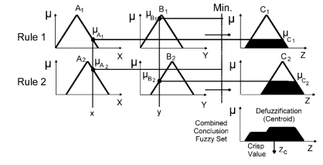

Figure 9.3 Mamdani Fuzzy Inference System

### 3.12.1. Mamdani Fuzzy system steps

A Mamdani fuzzy system consists of different steps which are explained below.

1. Determining the case variables based on the research background and theoretical foundations of the researcher.
2. Determining the fuzzy sets, through interviews with experts, theoretical logic, or the background of the conducted researches. Fuzzy sets such as high, medium, low, or very high, high, medium, low, very low, or any fuzzy set that is suitable for the desired variables according to the researcher's opinion. are determined. Fuzzy sets are Linguistic terms.
3. Determining the fuzzy membership functions, according to the previous step, the fuzzy membership function is determined for each fuzzy set. In this field, you can get help from experts again, fuzzy membership functions are different functions that have been discussed in the previous sections. Triangular, trapezoidal, Gaussian functions are among these functions. Each function is specified with parameters; which parameters are determined based on the range of variable measurement scores according to the researcher's opinion.
4. Define IF-Then rules. These are the rules of the antecedent relationship. and they specify the consequent. There are two solutions to determine the rules, one solution is based on the opinion of experts who actually formulate rules based on their experience in their work, for example, a health psychologist derives this rule based on his studies and professional experience. "If depression is high, stress sensitivity is average and life expectancy is average, then the quality of life is close to average". The linguistic terms "high", "average" and "close to average" are the same fuzzy sets, based on their type, the fuzzy membership functions are determined. The second solution is to explain the rules based on the data set in an exploratory manner. In this situation, Adaptive Neuro Fuzzy Inference System (ANFIS) or other algorithms such as Genetic Cooperative Classification Learning (GCCL) can be used. This issue is explained in detail below.
5. Weighting the fuzzy rules, the researcher may be interested in assigning weights to the fuzzy rules. Weights indicate the degree of importance of those rules. It is standard to give all the rules the same weight, i.e. 1. According to the importance of each rule in the fuzzy system, different weights, however, can be determined and attributed to those rules. Weights can be obtained in different ways. One method is given in the example related to the fuzzy cognitive map (see FCM example section).
6. In this step, all the truncated fuzzy sets obtained in the previous steps are aggregated. In fact, in this step, the shortened fuzzy sets related to the rules are aggregated with each other to provide a single fuzzy set. For this purpose, various methods are used. Max and Min operators are routinely used, that is why Mamdani type fuzzy inference systems are sometimes called max-min fuzzy systems.
7. The last step is defuzzification of the aggregated fuzzy set. In this step, Defuzzification, the aggregated fuzzy set is converted into a single crisp number one. There are different methods for defuzzification, the Center of Gravity (COG) method is routinely used. Different defuzzification methods affect the final function that the system provides. Therefore, the opinion of the researcher is important and he must decide on this matter.

### 3.12.1. Practical example using R

**Example 1.**

The artificial psychologist attempts to identify cyber shame based on mental security and hopelessness, self-assertiveness, and mental flexibility using the Mamdani-type fuzzy inference system (FIS). The psychologist first forms the parameter matrix of the fuzzy membership function based on expert opinion. The variable, fuzzy set, membership functions, and parameters are demonstrated in Table 3.

Table3

The variable, fuzzy set, membership functions, and parameters to identify cyber shame

|  |  |  |  |
| --- | --- | --- | --- |
| Variable | Fuzzy set | Membership functions | Parameter |
| Mental Security (MS) | Low | Triangular | (0, 10, 20) |
| Medium | Trapezoidal | (10, 20, 30, 40) |
| High | Triangular | (30, 40, 50) |
| Hopelessness (HL) | Yes | Triangular | (0, 18, 20) |
| No | Triangular | (20, 40, 50) |
| Self-assertiveness (SA) | Low | Triangular | (0, 10, 20) |
| Medium | Triangular | (10, 25, 40) |
| High | Triangular | (30, 40, 50) |
| Cyber shame (CS) | Low | Triangular | (0, 10, 20) |
| Medium | Trapezoidal | (10, 25, 30, 40) |
| High | Triangular | (30, 40, 50) |

**Listing4** R codes for Mamdani Fuzzy Inference System

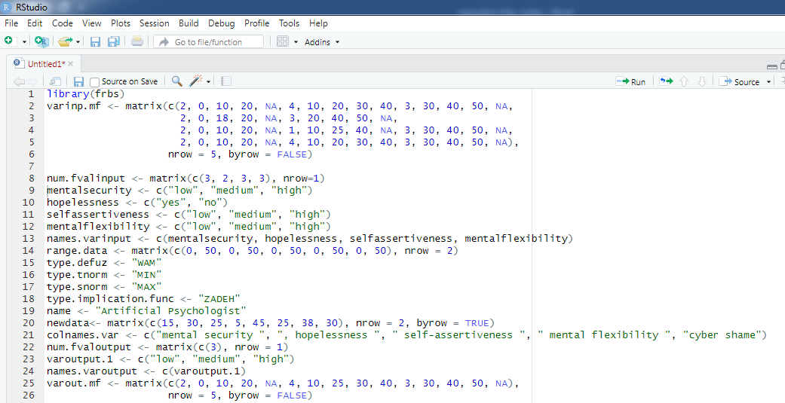

(continued) **Listing 4**.R codes Mamdani Fuzzy Inference System

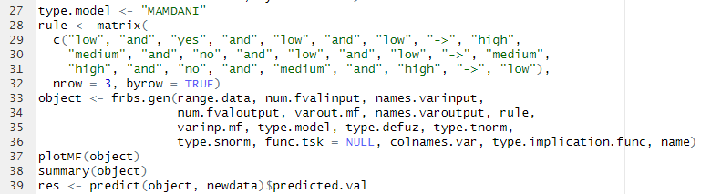

Figure 10.3 illustrates the rules between the variables in the R output. For instance, the first rule is as follows:

*“If mental security is low and hopelessness is yes and self-assertiveness is low and mental flexibility is low, then cyber shame is high*”.

Figure 11.3 shows the form of the membership functions.

**Figure 10.3** R plot for Mamdani Fuzzy Inference System

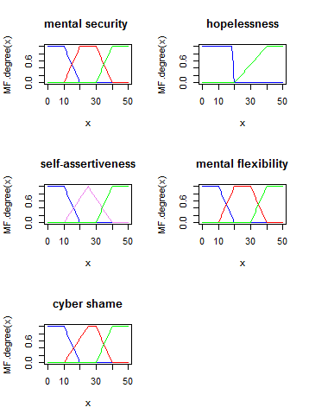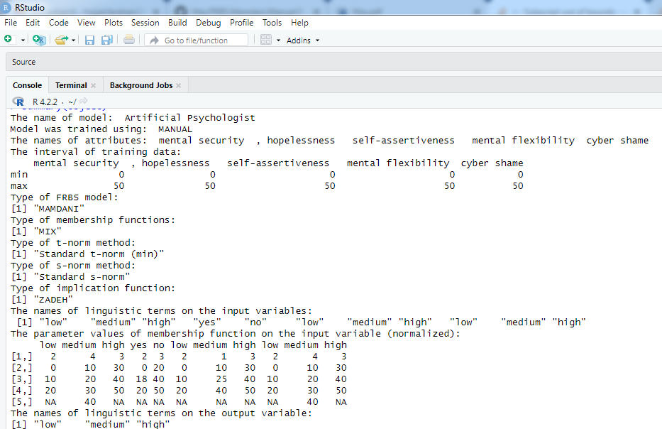

**Figure 11.3** R results of Mamdani Fuzzy Inference System(continued)

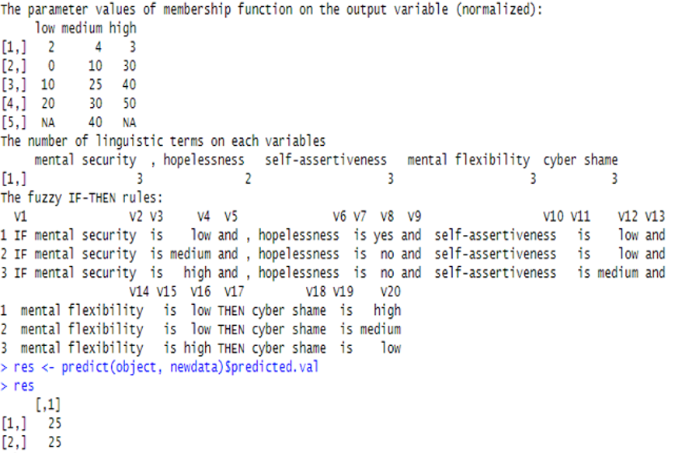

**Figure 12.3** R results of Mamdani Fuzzy Inference System

**Example 2.**

An Artificial psychologist aims to model pain feeling (PF) based on childhood trauma (CT) experience and alexithymia (ALX) using the fuzzy inference system (FIS) (Figure. 13.3).

CT

ALX

FIS

PF

Figure 13.3 Hypothetical Model

After a careful review of the literature different variables are evaluated and CT and ALX are selected. The artificial psychologist interviewed PF experts and added other variables. In fact, a careful literature review and interviews with experts and the target population (people with physical pain) are the three primary sources for designing and developing the hypothetical model (Figure.14.3).

Theoretical foundations

Interviews with experts

Interviews with the target group

Necessary content for model design

Content analysis

Thematic and content analysis

Hypothetical model

Figure 14.3 Flow work for developing a hypothetical model

Here, the researcher can use sample data from the target or expert groups to obtain the values of variables. In this study, artificial psychologists prepare the CT and ALX questionnaires with sufficient validity and reliability.

PF is measured within 0-30. Assuming that the range of the CT and ALX scales is within 0-10 and PF is within 0-30, the range for the first two cases is determined by the scores, and skeletal PF is determined by the opinions of relevant researchers. Having determined these ranges, a artificial psychologist determines fuzzy sets based on researcher and expert opinion (Table 4).

Artificial psychologists then determine the suitable fuzzy membership function for the fuzzy set. Selecting and using one of the numerous fuzzy membership functions requires practical and theoretical insight. The triangular fuzzy membership function is typically appropriate for psychology studies employing 1, 3, and 5-point Likert scales. As mentioned earlier, the triangular function has three parameters, namely a, b, c; and the trapezoidal function is also used due to its similarity to the triangular function, but instead of only one value from the x axis having a membership degree of 1, a range of numbers has the membership function of 1, giving the trapezoidal function four parameters, namely a, b, c, and d. Table1 shows the variables, range of scores, fuzzy set, and membership function parameters.

Table 4 Variables, range of scores, fuzzy set, and membership function parameters

|  |  |  |  |  |
| --- | --- | --- | --- | --- |
| Variables | Range of scores | Fuzzy sets | Membership function | Parameters |
| CT | 0-10 | Low/middle/high | Triangular/triangular/triangular | (0,1,2)  (2,3,7)  (4,6,10) |
| ALX | 0-10 | Mild/moderate/severe | trapezoidal/trapezoidal/ trapezoidal | (0,1,2,2)  (2,3,3,4)  (5,8,10,10) |
| Skeletal Pain Feelings | 0-30 | Little/tolerate/much | Triangular/Triangular/triangular | (0,3,8)  (8,13,18)  (18,23,30) |

Figure 16.3,17.3 and 18.3 demonstrates the membership function after running the R codes. After specifying fuzzy sets, membership functions, and their parameters, the next step is the fuzzy rule-based inference system (FRBIS). This example uses a Mamdani-type fuzzy inference system. Since the number of rules could be large, the fuzzy inference system can be implemented in several stages, which is also known as the hierarchical fuzzy model.

In this example, an artificial psychologist designs the rules using their own logic and assembling a panel of experts. These rules could be considered composite hypotheses and are presented in the following example (Table 5). Table 5 indicates the rules of the Mamdani-type fuzzy inference system.

**Table 5** Fuzzy Inference Rules

|  |  |  |  |
| --- | --- | --- | --- |
| Rule |  | Average importance | Weight |
| 1 |  | 4 | 0.75 |
| 2 |  | 5 | 1 |
| 3 |  | 2.5 | 0.4 |

**Rule 1.** If CT is low and ALX is mild, then PF is little (0.75)

**Rule 2**. If CT is middle, then PF is tolerable (1)

**Rule 3**. If CT is high or ALX is moderate, then PF is much (0.4)

Importance weights can also be determined for rules. With a group of 5 experts on a 5-point Likert scale ((very low: 1), (low: 2), (average: 3), (high: 4), (very high: 5)), the artificial psychologist aiming to determine the importance of each rule takes their average (Table 2) and normalizes them into a standard weight.

There are different ways to normalize the resulting averages, and the following equation is a simple solution:

The expert survey to determine the importance and ultimately the weight of each rule is as follows:

Table 6 survey of Experts to Determine the Relative Importance of Each Rule

|  |  |  |  |  |  |  |
| --- | --- | --- | --- | --- | --- | --- |
| No. | Rules | Importance | | | | |
|  |  | Very low (1) | Low (2) | Moderate (3) | High (4) | Very high (5) |

After determining the rules, the artificial psychologist is required to specify the defuzzification method of the study. As mentioned earlier, there are various defuzzification methods. Here, the artificial psychologist employs the centroid method to convert the obtained fuzzy number into a crisp number. Listing.6 depicts the R codes of all stages.

Figure 15 shows the output, including the fuzzy system’s specifications. To evaluate the model, suppose a person who has experienced skeletal pain responds to emotional dyslexia and childhood experience scales with scores of 4 and 5, respectively. According to the Mamdani-type fuzzy inference model, the muscle pain score will be 12.997 For a depressed individual with scores of 5 and 7 in ALX and CT, muscle pain will be 16.979.

**Listing 6** R codes for Mamdani Fuzzy Inference System(continued)

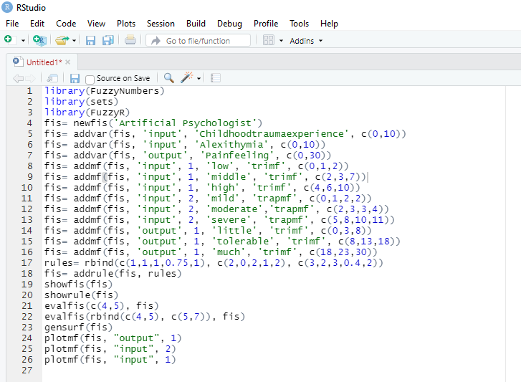

Surface Plot suggests that higher CT and ALX increase the probability of skeletal PF. This graph shows that the rules are designed properly.

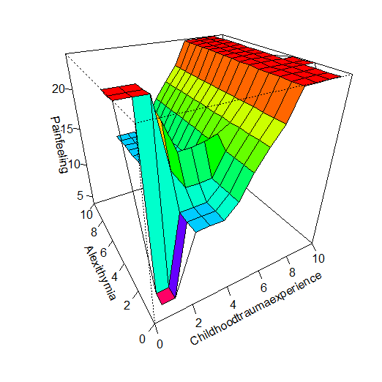

**Figure 15.3** R surface plot for Mamdani Fuzzy Inference System

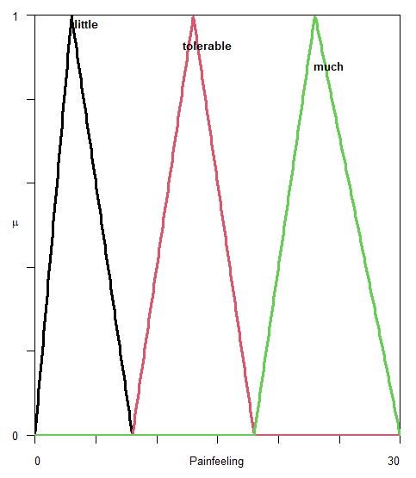

**Figure 16.3** Triangular fuzzy membership of Pain feeling

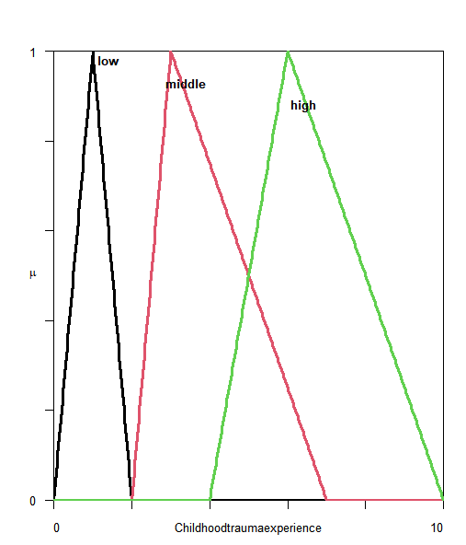

**Figure 17.3** Triangular fuzzy membership of Childhood Trauma Experience

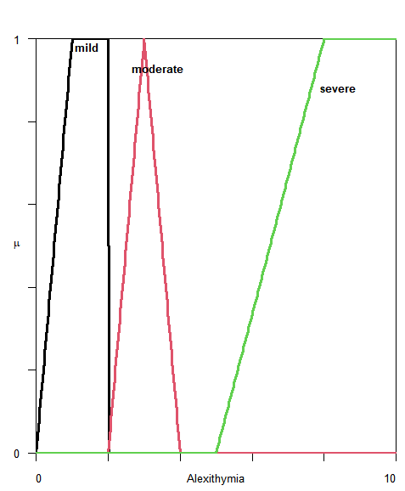

**Figure 18.3** Triangular fuzzy membership of Alexithymia





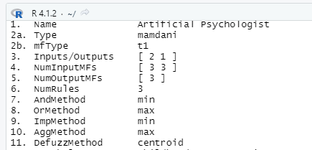

**Figure 19.3** R outputs of Mamdani Fuzzy Inference System

## 3.13. Towards Fuzzy Rule Mining

Basically, there are two different methods to construct Fuzzy Rule-Based systems (FRBSs), including Classification (FRBCSs) and Regression systems (FRBRSs) depending on the information (Wang 1994). One method or strategy is to obtain information from human experts in the field. In this strategy knowledge is defined by artificial psychologists who interview experts in the field to extract and represent their knowledge. Although, this method is most commonly used, sometimes it is not feasible because of the lack of knowledge. The second strategy is to apply learning methods for extracting knowledge from data in FRBSs. Some of the strategies are used for FRBRSs and some others are used in FRBCSs. In this section, we try to discuss some of both.

A fuzzy rule-based classification system (FRBCS) or Fuzzy Rule-Based Regression system consists of two main conceptual elements: a) the fuzzy rule base (FRB) and b) the fuzzy reasoning method (FRM). The first element provides an association between the space of pattern features and the space of consequent classes or target. The second element provides a mechanism to classify or predict a given pattern or values based on the first part (Jiao, et all, 2015).

While in classification the outputs are categorized. As a result, in this model the antecedent part is linguistic variables, and the consequent part is a class from a prespecified class set, in regression task the target outputs are quantitative as values (Riza, Bergmeir, Herrera & Ben´ıtez,2015).

### 3.12.1. Adaptive Network-Based Fuzzy Inference System (ANFIS)

Neuro-Fuzzy Inference Systems were developed in 1993 by J.S. Roger Jang. This method can be considered as an exploratory fuzzy inference system, if we can name Mamdani and Takagi-Sugeno-Kang or Sugeno –type(TSK) fuzzy inference systems as a confirmatory one. This system will be discussed below. An Adaptive Network-Based Fuzzy Inference System (ANFIS) consists of a Takagi-Sugeno-Kang or TSK- FRBS model which is built out of a five-layered network architecture. Both artificial neural network and fuzzy logic are used in ANFIS’ architecture (Avcı, 2008; Avcı & Akpolat, 2006; Avcı, Turkoglu, & Poyraz, 2005). The "ANFIS" is a learning algorithm which consists of two forward and backward processes. The forward stage includes the layers as follows (Figure 20.3).

L1:

Input Layer

;

**L2: Multiples fuzzy signals**

**L3:**

**Rule layer**

**L4:**

**Inference Layer**

Figure 20.3 ANFIS layers

1. The fuzzification process in which crisp values are transformed into linguistic values using the Gaussian function (or the other fuzzy membership functions) as the shape of the membership function.
2. The inference stage using the t-norm operator (the AND operator).
3. Calculating the ratio of the strengths of the rules.
4. Calculating the parameters for the consequent parts.
5. Computing the overall output as the sum of all incoming inputs.

Layer 1 receives the inputs and transforms them into the fuzzy value using membership functions. Layer 2 multiplies the fuzzy signals obtained from layer 1 and provides the firing strength of the rule. Layer 3 is the rules layer where all outputs from layer 2 are normalized. Layer 4 provides the inference of rules, and all signals are transformed to crisp values. The final layer summarizes all the signals and provides the outputted crisp value (Cvetković et al.,2019).

The backward stage is a process in which the database is estimated. This database includes the parameters of the membership functions in the antecedent part and the coefficients of the linear equations in the consequent part (the output is not a value like Mamdani Inference system). Since the Gaussian function is a membership function in this method, therefore, it is expected that mean and variance are optimized as two parameters of this function. In this step, the least squares method is used to perform the parameter learning. For the prediction phase, the method performs normal fuzzy reasoning of the TSK model (Lala Septem Riza, et al.2015)

The Takagi-Sugeno Fuzzy model is a Type 3 Fuzzy Inference System, where the rule outputs are a linear combination of inputs along with a constant like a regression, and the final output is the weighted average of every rule’s output. For a first order of TSK fuzzy model, a typical rule set with base fuzzy if–then rules can be expressed as If x is A1 and y is then (Avcı, 2008; Avcı, Hanbay, & Varol, 2007; Avcı et al., 2005).

IF-THEN rules for a 2-input Takagi-Sugeno(TSK) system are described as follows:



where x, y are the inputs in the crisp values set, Ai, Bi are the linguistic terms, pi ,qi are the consequent parameters, and are the linear combination of inputs along with a constant (ci).

In summary, ANFIS consists of IF-THEN rules and pairs of input–output and learning algorithms from a neural network (Avcı, 2008; Avcı, Hanbay, & Varol, 2007; Avcı et al., 2005; Avcı, Turkoglu, & Poyraz, 2006; Jang, 1993; Turkoglu & Avcı, 2008). During the forward stage, when the inputs are provided to the model, the consequent parameters are updated, and the initial parameters are kept fixed, using Least squares Estimation, the consequent parameters are updated in Layer 4, and the final output is calculated accordingly. The backward stage starts immediately after calculating the final output. In this stage the error is propagated back to Layer 1, and the initial parameters are updated. The consequent parameters are kept fixed (Chopra, et al., 2021).

A standard ANFIS has some assumptions. The system is zero-order or a first order Sugeno type inference system. Membership functions of output are the same whether they be constant or linear. Each rule is of a specific membership function for each output variable and all rule weights are 1 (Cvetković, et al., 2020).

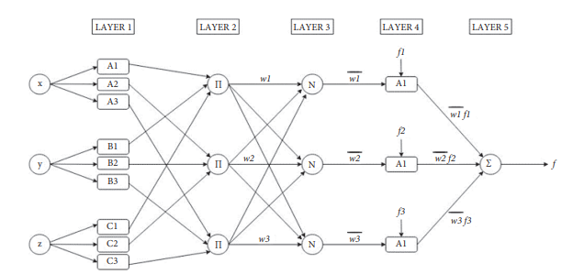

Figure 21.3 Standard structure of ANFIS. w1, w2, and w3 are the weights of the neurons and w1, w2, w3 are the normalized weights of the neuron (Chopra, et al., 2021)

As mentioned, ANFIS is based on a TSK system. In this section, we further discuss the Sugeno method. A Sugeno-type method (or Takagi-Sugeno-Kang) consists of fuzzy inputs and a crisp output (linear combination of the inputs). It is computationally efficient and suitable for optimization and adaptive techniques (Sugeno & Kang, 1988). The Sugeno method provides fuzzy rules from a given input-output database. It changes the consequent (then part) of the Mamdani rule with a function (Equation) of the input variables. The T-S style fuzzy rule is: IF x is A AND y is B THEN z is f (x, y) where x, y and z are linguistic variables, A and B are fuzzy sets on a universe of discourses X and Y and f (x, y) is a mathematical function (Du, Zhang, 2008). Sugeno-type FIS uses a weighted average to compute the crisp output while Mamdani-type FIS uses the technique of defuzzification of a fuzzy output. The first two parts of the fuzzy inference process, fuzzifying the inputs and applying the fuzzy operator, are the same (Du, Zhang, 2008). The main difference is that the Sugeno output membership functions are either linear or constant (Du, Zhang, 2008). In Figure 7 different types of fuzzy systems are shown. Type two is Mamdani FIS with output function based on overall fuzzy output, while type three is the Takagi-Sugeno fuzzy inference.

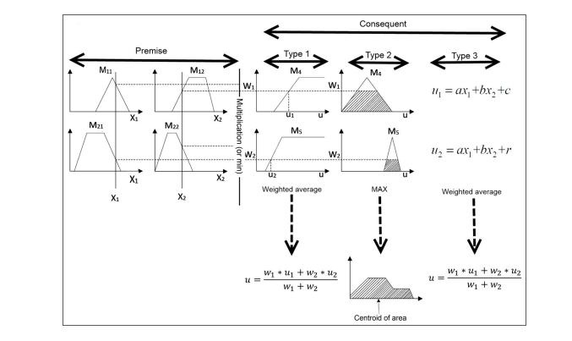

Figure 22.3 Different types of Fuzzy inference system (Mehran, K. 2008)

#### 3.12.1.1 Practical example using R

An artificial social psychologist aims to examine anxiety based on conscientiousness and extroversion with fuzzy modeling. There are two goals: 1) to measure the predictive power of the fuzzy model and 2) to extract the fuzzy rules. They wonder about the possible fuzzy rules between anxiety, conscientiousness, and extroversion. In a heuristic fuzzy model, the psychologist actually seeks to extract the rules based on the data from a large sample of high school students. To this end, the Beck Anxiety Inventory and NEO_AC are calculated for a sample of 861 students (ANFF file) and the model's accuracy is measured using ANFIS while also extracting the fuzzy rules of the three variables.

Listing.7 depicts the R codes for ANFIS implementation. In this study, the artificial social psychologist trains the model with 500 people and 361 people as the test sample. The fuzzy set has 5 degrees (very small, small, medium, large, and very large) in 5 iterations, the fuzzy membership is Gaussian, and the implication function is ZADEH.

According to **Figure 23.3**, the membership function reveals the two variables of conscientiousness and extroversion.

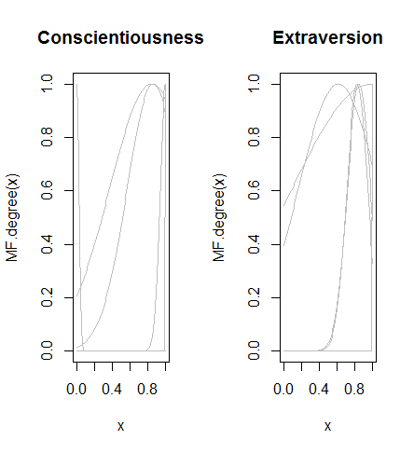

**Figure 23.3** The membership functions of conscientiousness and extroversion.

**Figure 24 .3** illustrates the evaluation of the trained model versus the test data, and the test model with real data covering a sample of 361 people. Since the MSE, RMSE, and SMAPE values of 202.4, 14.22, and 1.91, respectively, may not satisfy the researcher, the number of fuzzy sets and the sample size can be increased, or even the fuzzy membership function can be altered. **Figure 25. 3** indicates R outputs of ANFIS implementation. **Figure 26.3** demonstrates the extracted fuzzy rules.

**Listing 7** R codes for ANFIS implementation



R code for ANFIS, section 2

(Continued)**Listing 7** R codes for ANFIS implementation

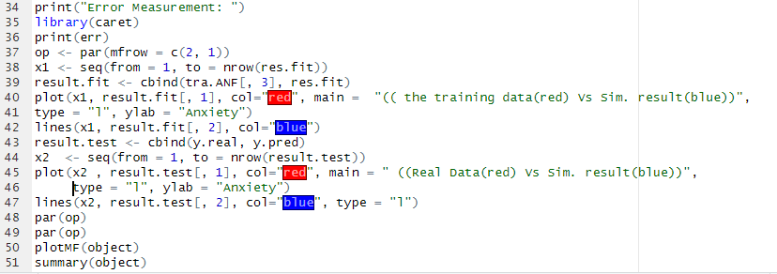

R result for ANFIS, section 1

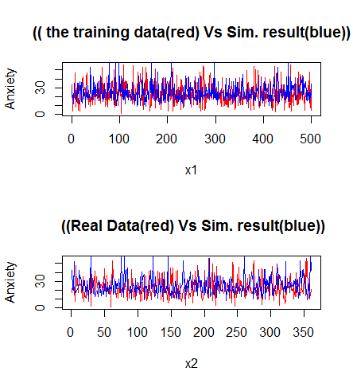

**Figure 24 .3** The result of the evaluation of the trained model

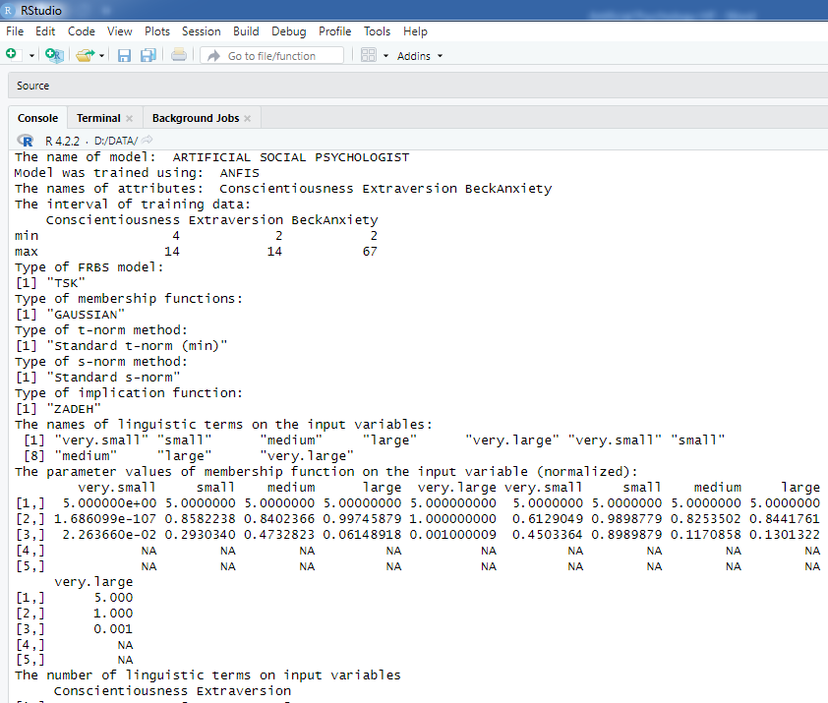

**Figure 25. 3** R outputs of ANFIS implementation



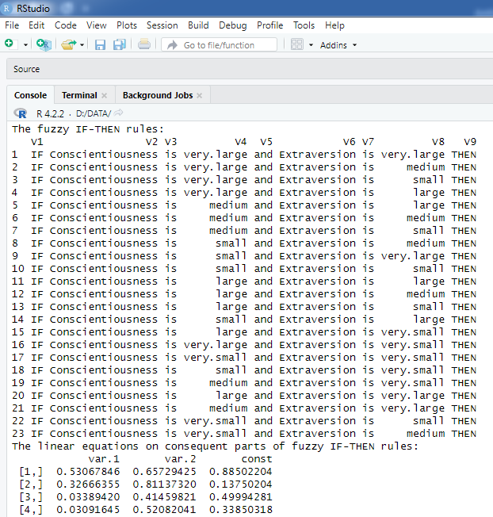

**Figure 26.3** The extracted fuzzy rules.

### 3.12.2. Genetic Cooperative-Competitive Learning (GCCL)

This method is based on Ishibuchi, Nakashima, and Murata (1999) using genetic cooperative competitive learning (GCCL) to handle classification problems. In this method, a chromosome describes each linguistic IF-THEN rule using integers as its representation of the antecedent part. In the consequent part of the fuzzy rules, the heuristic method is carried out to automatically generate the class. The evaluation is calculated for each rule, which means that the performance is not based on the entire rule set. The method works as follows: Step 1: Generate an initial population of fuzzy rules. Step 2: Evaluate each fuzzy rule in the current population. Step 3: Generate new fuzzy rules by genetic operators. Step 4: Replace a part of the current population with the newly generated rules. Step 5: Terminate the algorithm if the stopping condition is satisfied, otherwise return to Step 2 (Lala Septem Riza, et al.2015).

The genetic cooperative-competitive learning (GCCL) algorithm (Ishibuchi, H, et al.1999) employs a GA to optimize the rule base while the data base is fixed. Thus, a computationally effective classifier with an interpretable rule base can be obtained using Genetic Fuzzy Systems for Rule Induction Processes. Fuzzy systems have shown their usefulness in solving a wide range of problems in different application domains. The use of Evolutionary Algorithms (EAs), and particularly Genetic Algorithms (GAs), in the design of fuzzy systems allows us to equip them with the learning and adaptation capabilities. The result of this hybridization between Fuzzy Logic and GAs leads to Genetic Fuzzy Systems (GFSs) (Throckmorton, C. S., et al. 2015). The most influential aspect of any GFS is the genetic representation of the solutions. In this sense, the proposals in the specialized literature follow two approaches in order to encode rules within a population of individuals (Throckmorton et al. 2015). The” Chromosome = Set of rules”, also called the Pittsburgh approach, in which each individual represents a whole rule set. Thrift proposes in (Chen, Y. J., et al. 2017) a method that follows this approach. In turn, within the” Chromosome = Rule” approach, there are three generic proposals. The Michigan approach, The IRL (Iterative Rule Learning) and The GCCL (Genetic Cooperative-Competitive Learning) approach, in which the complete population or a subset of it, codifies the rule base. This approach makes it necessary to introduce a mechanism to maintain the diversity of the population in order to avoid all individuals in the population converging to the same area of search space.

#### 3.12.2.1 Practical example using R

The artificial cognitive psychologist seeks to explore fuzzy rules to predict a class (duty-oriented, utility-oriented) based on three variables: neuroticism, extroversion, and lie. Rules were obtained using GFS-GCC and SLAVE algorithms.

The different forms of this fuzzy rule-mining are shown in the following figures.

Listing 8,9 depict the R codes for running the two algorithms.

As the output from R software reveals, the artificial cognitive psychologist divides people into two categories based on a task: People in direct dilemma preferring duty-orientation and the group preferring utility-orientation (utility-oriented: class 1, duty-oriented: class 2). Then, they are all measured in terms of extroversion, lie, and neuroticism with valid and reliable scales.

Then, GFS_GCCL is used for the soft triangular fuzzy membership function +- (product), standard s-norm, and implication function equal to ZADEH and a fuzzy set of 5 (very small, small, medium, large, and very large). The population created in each generation has 5 members with a cross-over probability of 0.9 and a mutation probability of 0.3. In this study, the maximum number of generations for the genetic algorithm is 2 for ease of running. According to the procedure, 80% of the sample size (100 out of 125 people) is the training sample, and 20% (25 people) is the test sample.

Figure 27.3 shows the fuzzy classification rules. For example, in rule 5:

*“If neuroticism is very large and extroversion is small and the lie is large, then the direct dilemma is utility-oriented (class 1)”.*

According to Figure 27.3, the certainty factor for the rules indicates that certainty is 85% for rule 1 and 67% for rule 5. The certainty factor indicates trust in rules in rule-based systems.

**Listing 8** R Codes for GCCL implement

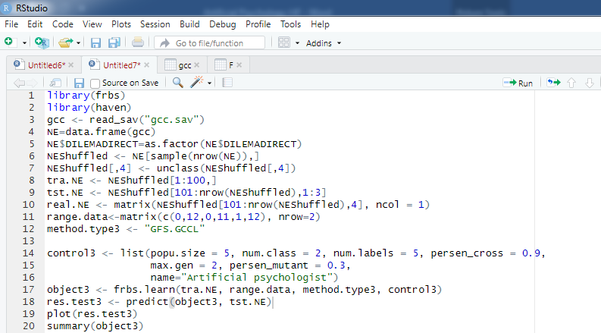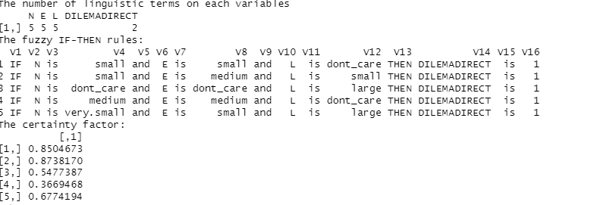

**Figure 27.3** Thefuzzy classification rules and the certainty factor

### 3.12.3. Structural learning algorithm on indefinite environment (SLAVE)

SLAVE (Structural Learning Algorithms in Vague Environments) is an inductive learning algorithm, that was initially proposed in González, A, et all, 1994 and later developed in Gonzalez, Perez, 1999. The basic element of the SLAVE learning algorithm is its rule. , where each variable Xi has a referential set Ui and takes values in a finite domain (term set) Di, i = 1, . . ., n. The referential set for Y is V and its domain is F. The value of the variable Y is B, where B ∈ F and the value of the variable Xi is Ai, where Afi ∈ P(Di) and P(Di) denotes the set of subsets of Di.

Slave algorithms have used iterative approaches to discover fuzzy association rules. The SLAVE algorithm is one of the fuzzy rules learning algorithms which were developed after 1994. It is used as a benchmark new algorithm (Ishibuchi, H, et al, 1999). Since implementation in 1996, this algorithm has been altered many times. When the SLAVE algorithm was first executed in 1994, there were very few algorithms for fuzzy rule learning. Significant recommendations were proposed by Wang et al. Both algorithms were centered on control rule learning (a regression problem). For working with a noise influenced framework, the SLAVE approach has been discovered where the existing learning approach does not distribute expected outputs in some situations (Tsai, C. F., & Chen, M. Y, 2010). The algorithm can define the rules which describe the system from all the variables proposed (feature selection). The SLAVE algorithm mainly uses iterative approaches. Gonzalez and Perez proposed a modified initial iterative approach used in SLAVE (Blake, C. 1998). In this process, their thought was to incorporate more data to learn one single rule. This data is merged into the iterative methodology over an alternate proposition of calculus to determine the positive and negative guide to a rule. A new function and extra genetic operators are also proposed that can decrease the time required for learning and develop the understanding of the rules that are obtained. Gonzalez and Perez further worked on the SLAVE algorithm. Later they reduced the time needed for learning processing obtaining a complete rule in each iteration (Wang, L, et al, 2015).

#### 3.12.3.1 Practical example using R

The artificial cognitive psychologist repeats the study using the SLAVE algorithm. This algorithm, which is very similar to GFS_GCCL, has a probability of cross-over of 0.9, 5 fuzzy sets, 5 iterations, a maximum of 3 generations, a mutation probability of 0.3, an interval of 0.25-0.75 for the threshold of noise, and an epsilon of 0.1. Epsilon is a number between 0 and 1 that indicates the covering factor.

**Listing.9** illustrates the R codes for implementing this method**. Figure 28.3** shows the R output for this method, which was used to extract 10 rules. Rule 10 states that:

*“If neuroticism is very large, extroversion is not care, and the lie is small, then the direct dilemma is duty-oriented (class 2)”.*

Therefore, these two methods can be used for classification-fuzzy rule mining.

**Listing 9** R codes of SLAVE implement

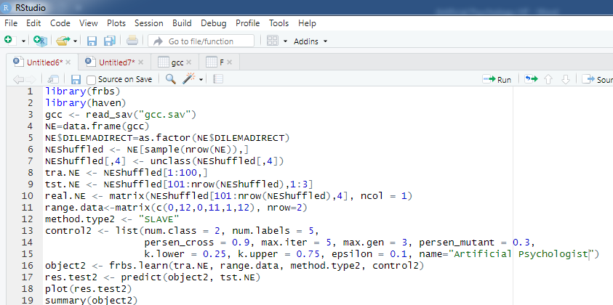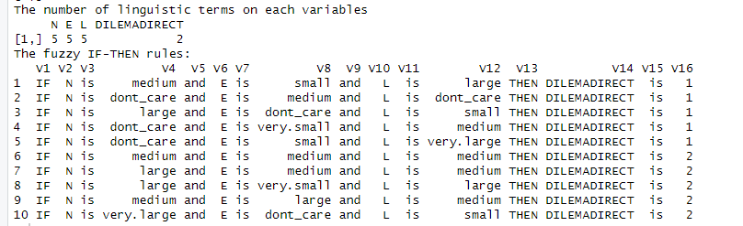

**Figure28.3** The R output of SLAVE and the extracted rules

**References**

Barker, R., & Schofield, M. (2008). Inference about magnitudes of effects. International Journal of Sports Physiology and Performance, 3, 547-557. doi:10.1123/ijspp.3.4.547

Harrison, Andrew J ,Stuart A. McErlain-Naylor, Elizabeth J. Bradshaw, Boyi Dai, Hiroyuki Nunome, Gerwyn T.G. Hughes, Pui W. Kong, Benedicte Vanwanseele, J. Paulo VilasBoas & Daniel T. P. Fong (2020) Recommendations for statistical analysis involving null hypothesis significance testing, Sports Biomechanics, 19:5, 561-568, DOI: 10.1080/14763141.2020.1782555

Chang, M., Balser, J., Roach, J., & Bliss, R. (2019). Innovative strategies, statistical solutions and simulations for modern clinical trials. CRC Press, Taylor & Francis Group.

Indrayan A. (2019).The Conundrum of P-Values: Statistical Significance Is Unavoidable but Need Medical Significance Too. J Biostat Epidemiol,5(4): 259-267

Lyu, X-K, Xu ,Y, Zhao,X-F,  Zuo, X-N and  Hu,C-P(2020). Beyond psychology: prevalence of p value and confidence interval misinterpretation across different fields. Journal of Pacific Rim sychologyVolume 14. <https://doi.org/10.1017/prp.2019.28>

Greenland S., Senn S.J., Rothman K.J., Carlin J.B., Poole C., Goodman S.N., Altman D.G. (2016). Statistical tests, P values, confidence intervals, and power: A guide to misinterpretations. *European Journal of Epidemiology*, 31, 337-350. [Crossref](https://doi.org/10.1007/s10654-016-0149-3).

Cumming G. (2013). The New Statistics: Why and How. *Psychological Science*, 25, 7-29. [Crossref](https://doi.org/10.1177/0956797613504966).

Lyu Z., Peng K., Hu C.-P. (2018). P-value, confidence intervals, and statistical inference: A new dataset of misinterpretation. *Frontiers in Psychology*, 9, 868 [Crossref](https://doi.org/10.3389/fpsyg.2018.00868).

Morey R.D., Hoekstra R., Rouder J.N., Wagenmakers E.-J. (2016). Continued misinterpretation of confidence intervals: Response to Miller and Ulrich. *Psychonomic Bulletin & Review*, 23, 131-140. [Crossref](https://doi.org/10.3758/s13423-015-0955-8).

Xin Y, Kong L, Liu Z, Chen Y, Li Y, Zhu H, Gao M, Hou H, Wang C.(2018). Machine learning and deep learning methods for cybersecurity. IEEE Access. 2018;6:35365–81.

Borsboom, D., van der Maas, H. L., Dalege, J., Kievit, R. A. & Haig, B. D.(2021). Theory construction methodology: a practical framework for building theories in psychology. Perspect. Psychol. Sci. 16, 756–766 .

Zhou, J.; Gandomi, A.H.; Chen, F.; Holzinger. (2021). A. Evaluating the Quality of Machine Learning Explanations: A Survey on Methods and Metrics. Electronics, 10, 593. https://doi.org/10.3390/ electronics10050593

Rudin, S.(2019). Stop Explaining Black Box Machine Learning Models for High Stakes Decisions and Use Interpretable Models Instead. Nat. Mach. Intell, 1, 206–215. [CrossRef]

Zhou, J.; Chen, F. (2018). Human and Machine Learning: Visible, Explainable, Trustworthy and Transparent; Human–Computer Interaction Series; Springer: Berlin/Heidelberg, Germany,; ISBN 978-3-319-90402-3.

Aslam, N.; Khan, I.U.; Mirza, S.; AlOwayed, A.; Anis, F.M.; Aljuaid, R.M.; Baageel, R.(2022). Interpretable Machine Learning Models for Malicious Domains Detection Using Explainable Artificial Intelligence (XAI). Sustainability 14, 7375. https:// doi.org/10.3390/su14127375

Vélez, J. I. (2021). Machine Learning Psychology: Advocating for a Data-Driven Approach. International Journal of Psychological Research, 14(1), 6–11. <https://doi.org/10.21500/20112084.5365>

Zhou, B., Sun, Y., Bau, D. and Torralba, A. (2018). Interpretable basis decomposition for visual explanation. In Proceedings of the European Conference on Computer Vision (ECCV) 119–134.

Jaganathan, K.; Rehman, M.U.; Tayara, H.; Chong, K.T. XML-CIMT: Explainable Machine Learning (XML) Model for Predicting Chemical-Induced Mitochondrial Toxicity. Int. J. Mol. Sci. 2022, 23, 15655. https://doi.org/10.3390/ ijms232415655

Crabbe, & Schaar.(2022). Proceedings of the 39 th International Conference on Machine Learning, Baltimore, Maryland, USA, PMLR 162, 2022.

Eronen, M, I,&Bringmann, L, F.(2021). Perspectives on Psychological ScienceVolume 16, 4,  779-788. <https://doi.org/10.1177/1745691620970586>

Shrestha, Yash Raj; He, Vivianna Fang; Puranam, Phanish & von Krogh, Georg (2021) Algorithm supported induction for building theory: How can we use prediction models to theorize? Organization Science, 32 (3). 856-880.

Dua, D. ,& Graff, C. (2017) UCI Machine Learning Repository. <https://archive.ics.uci.edu/ml/index.php>

Dubois, D.,& Prade,H.(2005). Fuzzy elements in a fuzzy set. International Fuzzy Systems Association World Congress, Jul 2005, Beijing, China. pp.55–60. ffhal-03367408f

Dhar,M.(2013). On Cardinality of Fuzzy Sets. Intelligent Systems and Applications, 2013, 06, 47-52. DOI: <https://doi.org/10.5815/ijisa.2013.06.06>

G.J. Klir and B. Yuan. (1995). Fuzzy Sets and Fuzzy Logic: Theory and Application. Upper-Saddle River, Prentice-Hall, NJ.

Hasan, M.F. and Sobhan, M.A. (2020). Describing Fuzzy Membership Function and Detecting the Outlier by Using Five Number Summary of Data. *American Journal of Computational Mathematics*, **10**, 410-424. doi: [10.4236/ajcm.2020.103022](https://doi.org/10.4236/ajcm.2020.103022).

|  |
| --- |
| Wanga , Yanga,& Li.(2022).Some properties of fuzzy t-norm and vague t-norm.<https://doi.org/10.48550/arXiv.2205.09231>  Klir, Yuan. (1995). Fuzzy sets and fuzzy logic: theory and applications. Prentice Hall PTR, New Jersey |

Nguyen, T H., Walker,E.(1977)., A First Course in Fuzzy Logic, CRC Press, Boca Raton, FL.

Gonzalez, A., P ´ erez, R.(1999).SLAVE: A genetic learning ´ system based on an iterative approach. IEEE Trans. on Fuzzy Systems, 7 (2), 176–191 .

Oliveira, C,R ,Werlan, T.(2007). Ergodic hypothesis in classical statistical mechanics.

Aguinis,H & Solarin,A.(2019). Transparency and replicability in qualitative research: The case of interviews with elite informants. Strategic Management,40,8,1291-1315.

<https://doi.org/10.1002/smj.3015>

Pratt M. G., Lepisto D., Dane E. 2019 “The hidden side of trust: Supporting and sustaining leaps of faith among firefighters.” Administrative Science Quarterly, 64: 398–434. [Crossref](https://doi.org/10.1177/0001839218769252). [ISI](http://gateway.webofknowledge.com/gateway/Gateway.cgi?GWVersion=2&DestApp=WOS_CPL&UsrCustomerID=5e3815c904498985e796fc91436abd9a&SrcAuth=atyponcel&SrcApp=literatum&DestLinkType=FullRecord&KeyUT=000470852300009).

Pourabdollah,A, Mendel,J,M & John,R,I.(2020). Alpha-cut representation used for defuzzification in rule-based systems, Fuzzy Set System,399,15,110-132. <https://doi.org/10.1016/j.fss.2020.05.008>

Sugeno ,M& Kang,G.(1988). Structure identification of fuzzy model, Fuzzy Sets and Systems,(28), (Oct.1988)15-33

Du, H., Zhang,N.(2008). Application of evolving Takagi–Sugeno fuzzy model to nonlinear system identification, Applied Soft Computing, 8( 1)( January 2008) 676-686.

Gigerenzer, G., Swijtink, Z., Porter, T., Daston, L., & Kruger, L. (1990). *The empire of chance: How probability changed science and everyday life*. Cambridge University Press.

Head, M. L., Holman, L., Lanfear, R., Kahn, A. T., & Jennions, M. D. (2015)v. The extent and consequences of p-hacking in science. *PLoS biology*, *13*(3), e1002106.

Lyu, X. K., Xu, Y., Zhao, X. F., Zuo, X. N., & Hu, C. P. (2020). Beyond psychology: prevalence of p value and confidence interval misinterpretation across different fields. *Journal of Pacific Rim Psychology*, *14*.

Head, M. L., Holman, L., Lanfear, R., Kahn, A. T., & Jennions, M. D. (2015). The extent and consequences of p-hacking in science. *PLoS biology*, *13*(3), e1002106.

Francis, G. (2014). The frequency of excess success for articles in Psychological Science. *Psychonomic bulletin & review*, *21*(5), 1180-1187.

Schmidt, F. L., & Oh, I. S. (2016). The crisis of confidence in research findings in psychology: Is lack of replication the real problem? Or is it something else?. *Archives of Scientific Psychology*, *4*(1), 32.

Cohen, J. (1962). The statistical power of abnormal-social psychological research: a review. *The Journal of Abnormal and Social Psychology*, *65*(3), 145.

Maxwell, J. A. (2004). Causal explanation, qualitative research, and scientific inquiry in education. *Educational researcher*, *33*(2), 3-11.

Farahani, H., Azadfallah, P., Chesli, R. R., Pourmohamadreza-Tajrishi, M., Esrafilian, F., Lavasani, F. F., & Chiniforoushan, F. (2021). Methodology of Inquiring “Therapy Failure” in Psychotherapy Research: Practical Guide for Clinical Practitioners and Researchers. *Psychotherapy*, *7*, 01.

Crowder, J. A., & Friess, S. (2012). Artificial psychology: The psychology of AI. *People*, *2*(3), 4-5.

Crowder, J., & Friess, S. (2010). Artificial Neural Emotions and Emotional Memory. In *Ic-Ai* (pp. 373-378).

Lipkova, J., Chen, R. J., Chen, B., Lu, M. Y., Barbieri, M., Shao, D., ... & Mahmood, F. (2022). Artificial intelligence for multimodal data integration in oncology. *Cancer Cell*, *40*(10), 1095-1110.

Buchanan, B. G. (2005). A (very) brief history of artificial intelligence. *Ai Magazine*, *26*(4), 53-53.

Yarkoni, T., & Westfall, J. (2017). Choosing prediction over explanation in psychology: Lessons from machine learning. *Perspectives on Psychological Science*, *12*(6), 1100-1122.

Samuel, A. L. (1967). Some Studies in Machine Learning Using the Game of Checkers. *IBM J. Res. Dev.*, *44*, 206-227.

Adadi, A., & Berrada, M. (2018). Peeking inside the black-box: a survey on explainable artificial intelligence (XAI). *IEEE access*, *6*, 52138-52160.

Gilpin, L. H., Bau, D., Yuan, B. Z., Bajwa, A., Specter, M., & Kagal, L. (2018, October). Explaining explanations: An overview of interpretability of machine learning. In *2018 IEEE 5th International Conference on data science and advanced analytics (DSAA)* (pp. 80-89). IEEE.

Markus, A. F., Kors, J. A., & Rijnbeek, P. R. (2021). The role of explainability in creating trustworthy artificial intelligence for health care: a comprehensive survey of the terminology, design choices, and evaluation strategies. *Journal of Biomedical Informatics*, *113*, 103655.

Doshi-Velez, F., & Kim, B. (2017). Towards a rigorous science of interpretable machine learning. *arXiv preprint arXiv:1702.08608*.

Gianfagna, L., & Di Cecco, A. (2021). Model-agnostic methods for XAI. In *Explainable AI with Python* (pp. 81-113). Springer, Cham.

Gianfagna, L., & Di Cecco, A. (2021). *Explainable AI with Python* (pp. 1-202). Berlin/Heidelberg, Germany: Springer.

Farahani, H. A., Kazemi, Z., Aghamohamadi, S., Bakhtiarvand, F., & Ansari, M. (2011). Examining mental health indices in students using Facebook in Iran. *Procedia-Social and Behavioral Sciences*, *28*, 811-814.

Mohammadipour Rik, N., Roshan, R., Farahani, H., & Abolghasemi, A. (2022). Psychometric properties of the Persian Non-Suicidal Self-Injury Expectancies Questionnaire in high school students. *Rooyesh-e-Ravanshenasi Journal (RRJ)*, *11*(2), 105-116.

Grazioli, S., Rosi, E., Mauri, M., Crippa, A., Tizzoni, F., Tarabelloni, A., ... & Nobile, M. (2021). Patterns of Response to Methylphenidate Administration in Children with ADHD: A Personalized Medicine Approach through Clustering Analysis. *Children*, *8*(11), 1008.

Nayebi, A., Tipirneni, S., Foreman, B., Reddy, C. K., & Subbian, V. (2022). An Empirical Comparison of Explainable Artificial Intelligence Methods for Clinical Data: A Case Study on Traumatic Brain Injury. *arXiv preprint arXiv:2208.06717*.

Team, R. C. (2013). R: A language and environment for statistical computing. R Foundation for Statistical Computing, Vienna, Austria. *http://www. R-project. org/*.

Vélez, J. I. (2021). Machine Learning based Psychology: Advocating for A Data-Driven Approach. *International Journal of Psychological Research*, *14*(1), 6-11.

Fielder, E., Von Zglinicki, T., & Jurk, D. (2017). The DNA damage response in neurons: die by apoptosis or survive in a senescence-like state?. *Journal of Alzheimer's Disease*, *60*(s1), S107-S131.

Meehl, P. E. (1990). Appraising and amending theories: The strategy of Lakatosian defense and two principles that warrant it. *Psychological inquiry*, *1*(2), 108-141.

Mischel, W. (2008). The toothbrush problem. *APS Observer*, *21*.

Shrestha, Y. R., He, V. F., Puranam, P., & von Krogh, G. (2021). Algorithm supported induction for building theory: How can we use prediction models to theorize?. *Organization Science*, *32*(3), 856-880.

Seising, R. (2008). On the absence of strict boundaries—Vagueness, haziness, and fuzziness in philosophy, science, and medicine. *Applied soft computing*, *8*(3), 1232-1242.

Blazer, D. G. (1982). Social support and mortality in an elderly community population. *American journal of epidemiology*, *115*(5), 684-694.

Wierman, M. J. (2010). An introduction to the mathematics of uncertainty. *Creighton University*, 149-150.

Mushtaq, F., Bland, A. R., & Schaefer, A. (2011). Uncertainty and cognitive control. *Frontiers in psychology*, *2*, 249.

Balzer, W., Moulines, C. U., & Sneed, J. D. (2012). *An architectonic for science: The structuralist program* (Vol. 186). Springer Science & Business Media.

Torres, A., & Nieto, J. J. (2006). Fuzzy logic in medicine and bioinformatics. *Journal of Biomedicine and biotechnology*, *2006*.

Larsen, J. T., & McGraw, A. P. (2011). Further evidence for mixed emotions. *Journal of personality and social psychology*, *100*(6), 1095.

Fang, X., Van Kleef, G. A., & Sauter, D. A. (2018). Person perception from changing emotional expressions: primacy, recency, or averaging effect?. *Cognition and Emotion*, *32*(8), 1597-1610.

Smithson, M. (1982). Applications of fuzzy set concepts to behavioral sciences. *Mathematical Social Sciences*, *2*(3), 257-274.

Zétényi, T. (Ed.). (1988). *Fuzzy sets in psychology*. Elsevier.

Smithson, M., & Oden, G. C. (1999). Fuzzy set theory and applications in psychology. *Practical Applications of fuzzy technologies*, 557-585.

Ragin, C. C. (2000). *Fuzzy-set social science*. University of Chicago Press.

Smithson, M., & Verkuilen, J. (2006). *Fuzzy set theory: Applications in the social sciences* (No. 147). Sage.

Arfi, B. (2010). *Linguistic fuzzy logic methods in social sciences* (Vol. 253). Berlin: Springer.

Oden, G. C., & Massaro, D. W. (1978). Integration of featural information in speech perception. *Psychological review*, *85*(3), 172.

Massaro, D. W. (1989). Testing between the TRACE model and the fuzzy logical model of speech perception. *Cognitive psychology*, *21*(3), 398-421.

Massaro, D. W., & Cohen, M. M. (2000). Tests of auditory–visual integration efficiency within the framework of the fuzzy logical model of perception. *The Journal of the Acoustical Society of America*, *108*(2), 784-789.

Martínez-Jiménez, M. A., Ramirez-GarciaLuna, J. L., Kolosovas-Machuca, E. S., Drager, J., & González, F. J. (2018). Development and validation of an algorithm to predict the treatment modality of burn wounds using thermographic scans: Prospective cohort study. *PloS one*, *13*(11), e0206477.

Brainerd, C. J., & Reyna, V. F. (1996). Mere memory testing creates false memories in children. *Developmental Psychology*, *32*(3), 467.

Ho, W. L., Tung, W. L., & Quek, C. (2010, July). An evolving mamdani-takagi-sugeno based neural-fuzzy inference system with improved interpretability-accuracy. In *International Conference on Fuzzy Systems* (pp. 1-8). IEEE.

Perfilieva, I., & Vajgl, M. (2015, June). Autoassociative fuzzy implicative memory on the platform of fuzzy preorder. In *2015 Conference of the International Fuzzy Systems Association and the European Society for Fuzzy Logic and Technology (IFSA-EUSFLAT-15)* (pp. 1598-1603). Atlantis Press.

Terziyska, M., Doukovska, L., & Petrov, M. (2015). Implicit GPC based on semi fuzzy neural network model. In *Intelligent Systems' 2014* (pp. 695-706). Springer, Cham.

Khefacha, I., & Belkacem, L. (2015). Modeling entrepreneurial decision-making process using concepts from fuzzy set theory. *Journal of Global Entrepreneurship Research*, *5*, 1-21.

Horowitz, L., & Malle, B. (1993). Fuzzy concepts in psychotherapy research. *Psychotherapy research*, *3*(2), 131-148.

Mosoiu, C., Sumedrea, A. G., Burtea, V., & Ifteni, P. (2010, June). Fuzzy system approach to symptoms in schizophrenia. In *Proceedings of the 11th WSEAS international conference on nural networks and 11th WSEAS international conference on evolutionary computing and 11th WSEAS international conference on Fuzzy systems* (pp. 268-272).

Ekong, V. E., EKONG, U. O., Uwadiae, E. E., Abasiubong, F., & Onibere, E. A. (2013). A fuzzy inference system for predicting depression risk levels. *African Journal of Mathematics and Computer Science Research*, *6*(10), 197-204.

Reinertsen, K. V., Engebraaten, O., Loge, J. H., Cvancarova, M., Naume, B., Wist, E., ... & Kiserud, C. E. (2017). Fatigue during and after breast cancer therapy—a prospective study. *Journal of pain and symptom management*, *53*(3), 551-560.

Ashish, K., Dasari, A., Chattopadhyay, S., & Hui, N. B. (2018). Genetic-neuro-fuzzy system for grading depression. *Applied computing and informatics*, *14*(1), 98-105.

Huette, S., & Spivey, M. (2012). Fuzzy consciousness. *Being in time: Dynamical theories of phenomenal experience*, 149-164.

Stoklasa, J., Talašová, J., & Holeček, P. (2011). Academic staff performance evaluation–variants of models. *Acta Polytechnica Hungarica*, *8*(3), 91-111.

Poursamar, S. L., Azadfallah, P., & Farahani, H. (2019). Conceptualizing emotion regulation in Iranian women: qualitative research based on grounded theory approche. *Journal of psychological achievements*, *26*(1), 59-78.

Hojjatollah Farahani, Lihshing LeighPiotr, OlesPiotr (2018)Fuzzy Matrix Model as a New Method to Find Optimal Diagnostic Accuracy Points of Psychological Tests, European Mathematical Psychology Group

Sugeno, M., & Yasukawa, T. (1993). A fuzzy-logic-based approach to qualitative modeling. *IEEE Transactions on fuzzy systems*, *1*(1), 7-31.

Stoklasa, J., Talášek, T., & Musilová, J. (2014). Fuzzy approach-a new chapter in the methodology of psychology?. *Human affairs*, *24*(2), 189-203.

Baig, F., Khan, M. S., Noor, Y., Imran, M., & Baig, F. (2011). Design model of fuzzy logic medical diagnosis control system. *International Journal on Computer Science and Engineering*, *3*(5), 2093-2108.

Erin, B., & Abiyev, R. H. (2019, January). Diagnosis of Common Diseases Using Type-2 Fuzzy System. In *Proceedings of the 3rd International Conference on Machine Learning and Soft Computing* (pp. 239-243).

Simmons, J. P., Nelson, L. D., & Simonsohn, U. (2016). False-positive psychology: undisclosed flexibility in data collection and analysis allows presenting anything as significant.

Cumming, G. S. (2011). *Spatial resilience in social-ecological systems*. Springer Science & Business Media.

Leggett, D. J. (Ed.). (2013). *Computational methods for the determination of formation constants*. Springer Science & Business Media.

Lakens, D. (2015). On the challenges of drawing conclusions from p-values just below 0.05. *PeerJ*, *3*, e1142.

Marsman, M., & Wagenmakers, E. J. (2017). Bayesian benefits with JASP. *European Journal of Developmental Psychology*, *14*(5), 545-555.

Wagenmakers, E. J., Marsman, M., Jamil, T., Ly, A., Verhagen, J., Love, J., ... & Morey, R. D. (2018). Bayesian inference for psychology. Part I: Theoretical advantages and practical ramifications. *Psychonomic bulletin & review*, *25*(1), 35-57.

Stephen, D. G., & Mirman, D. (2010). Interactions dominate the dynamics of visual cognition. *Cognition*, *115*(1), 154-165.

Spence, C., Driver, J., & Driver, J. C. (Eds.). (2004). *Crossmodal space and crossmodal attention*. Oxford University Press.

Kello, C. T., Anderson, G. G., Holden, J. G., & Van Orden, G. C. (2008). The pervasiveness of 1/f scaling in speech reflects the metastable basis of cognition. *Cognitive Science*, *32*(7), 1217-1231.

Kello, C. T., & Van Orden, G. C. (2009). Soft-assembly of sensorimotor function. *Nonlinear dynamics, psychology, and life sciences*, *13*(1), 57.

Motter, B. C. (1993). Focal attention produces spatially selective processing in visual cortical areas V1, V2, and V4 in the presence of competing stimuli. *Journal of neurophysiology*, *70*(3), 909-919.

Spivey, M. J., & Spirn, M. J. (2000). Selective visual attention modulates the direct tilt aftereffect. *Perception & Psychophysics*, *62*(8), 1525-1533.

Gandhi, S. P., Heeger, D. J., & Boynton, G. M. (1999). Spatial attention affects brain activity in human primary visual cortex. *Proceedings of the National Academy of Sciences*, *96*(6), 3314-3319.

Ito, M., & Gilbert, C. D. (1999). Attention modulates contextual influences in the primary visual cortex of alert monkeys. *Neuron*, *22*(3), 593-604.

Lamme, V. A., & Roelfsema, P. R. (2000). The distinct modes of vision offered by feedforward and recurrent processing. *Trends in neurosciences*, *23*(11), 571-579.

Huette, S., Winter, B., Matlock, T., & Spivey, M. (2012). Processing motion implied in language: eye-movement differences during aspect comprehension. *Cognitive Processing*, *13*(1), 193-197.

Spivey, B., & Echeverria, J. (2015). *Hadoop Security: Protecting your big data platform*. " O'Reilly Media, Inc.".

Taylor, S. (2022). The psychology of pandemics. *Annual review of clinical psychology*, *18*, 581-609.

Rayan, F., Nanjayan, S. K., Quah, C., Ramoutar, D., Konan, S., & Haddad, F. S. (2015). Review of evolution of tunnel position in anterior cruciate ligament reconstruction. *World journal of orthopedics*, *6*(2), 252.

Mao, Y., Wong, C. S., Tao, X., & Jiang, C. (2018). The impact of affect on organizational justice perceptions: A test of the affect infusion model. *Journal of Management & Organization*, *24*(6), 893-916.

Kant, I. (1908). Critique of pure reason. 1781. *Modern Classical Philosophers, Cambridge, MA: Houghton Mifflin*, 370-456.

Schopenhauer, A., Frauenstädt, J., & Hübscher, A. (1859). *Die welt als wille und vorstellung* (Vol. 2). Leipzig: Brockhaus.

Zeki, S. (2001). Localization and globalization in conscious vision. *Annual review of neuroscience*, *24*(1), 57-86.

Zeki, S. (2003). The disunity of consciousness. *Trends in cognitive sciences*, *7*(5), 214-218.

Fang, X., Sauter, D. A., & Van Kleef, G. A. (2018). Seeing mixed emotions: The specificity of emotion perception from static and dynamic facial expressions across cultures. *Journal of Cross-Cultural Psychology*, *49*(1), 130-148.

Keltner, D., Sauter, D., Tracy, J., & Cowen, A. (2019). Emotional expression: Advances in basic emotion theory. *Journal of nonverbal behavior*, *43*(2), 133-160.

Van Der Heide, A., Sánchez, D., & Trivino, G. (2011, August). Computational models of affect and fuzzy logic. In *Proceedings of the 7th conference of the European Society for Fuzzy Logic and Technology* (pp. 620-627). Atlantis Press.

Cao, S. G., Rees, N. W., & Feng, G. (2001). Mamdani-type fuzzy controllers are universal fuzzy controllers. *Fuzzy sets and systems*, *123*(3), 359-367.

Pal, S. K., & Mandal, D. P. (1991). Fuzzy logic and approximate reasoning: an overview. *IETE Journal of Research*, *37*(5-6), 548-560.

Klawonna, F., & Novák, V. (1996). The relation between inference and interpolation in the framework of fuzzy systems. *Fuzzy sets and systems*, *81*(3), 331-354.

Bodenhofer, U., De Baets, B., & Fodor, J. (2007). A compendium of fuzzy weak orders: Representations and constructions. *Fuzzy Sets and Systems*, *158*(8), 811-829.

Dubois, D., & Prade, H. (1996). What are fuzzy rules and how to use them. *Fuzzy sets and systems*, *84*(2), 169-185.

Hájek, P. (2013). *Metamathematics of fuzzy logic* (Vol. 4). Springer Science & Business Media.

Novák, V. (1994). Fuzzy control from the logical point of view. *Fuzzy Sets and Systems*, *66*(2), 159-173.

Mamdani, E. H. (1974). Applications of fuzzy algorithms for control of simple dynamic plant. *Proc. Iee*, *121*, 1585-1588.

Mamdani, E. H., & Assilian, S. (1975). An experiment in linguistic synthesis with a fuzzy logic controller. *International journal of man-machine studies*, *7*(1), 1-13.

Zimmermann, H. J. (2011). *Fuzzy set theory—and its applications*. Springer Science & Business Media.

Klir, G., & Yuan, B. (1995). *Fuzzy sets and fuzzy logic* (Vol. 4, pp. 1-12). New Jersey: Prentice hall.

Van Leekwijck, W., & Kerre, E. E. (1999). Defuzzification: criteria and classification. *Fuzzy sets and systems*, *108*(2), 159-178.

Izquierdo, S., & Izquierdo, L. R. (2017). Mamdani fuzzy systems for modelling and simulation: A critical assessment. *Available at SSRN 2900827*.

Riza, L. S., Bergmeir, C., Herrera, F., & Benítez, J. M. (2015). frbs: Fuzzy rule-based systems for classification and regression in R. *Journal of statistical software*, *65*, 1-30.

Jang, J. S. (1993). ANFIS: adaptive-network-based fuzzy inference system. *IEEE transactions on systems, man, and cybernetics*, *23*(3), 665-685.

Avci, E. (2008). Comparison of wavelet families for texture classification by using wavelet packet entropy adaptive network based fuzzy inference system. *Applied Soft Computing*, *8*(1), 225-231.

Avci, E., & Akpolat, Z. H. (2006). Speech recognition using a wavelet packet adaptive network based fuzzy inference system. *Expert Systems with Applications*, *31*(3), 495-503.

Avci, E., Turkoglu, I., & Poyraz, M. (2005, June). Intelligent target recognition based on wavelet adaptive network based fuzzy inference system. In *Iberian Conference on Pattern Recognition and Image Analysis* (pp. 594-603). Springer, Berlin, Heidelberg.

Cvetkovic, S. (2020). Analysis of Correlations Between Joint Physical Parameters and Laser Welding with Filer Wire by the Adaptive-network-based Fuzzy Inference Systems Technique. *Lasers in Engineering (Old City Publishing)*, *47*.

Riza, L. S., Bergmeir, C., Herrera, F., & Benítez, J. M. (2015). frbs: Fuzzy rule-based systems for classification and regression in R. *Journal of statistical software*, *65*, 1-30.

Avci, E., Hanbay, D., & Varol, A. (2007). An expert discrete wavelet adaptive network based fuzzy inference system for digital modulation recognition. *Expert Systems with Applications*, *33*(3), 582-589.

Avci, E., Turkoglu, I., & Poyraz, M. (2005, June). Intelligent target recognition based on wavelet adaptive network based fuzzy inference system. In *Iberian Conference on Pattern Recognition and Image Analysis* (pp. 594-603). Springer, Berlin, Heidelberg.

Jang, J. S. (1993). ANFIS: adaptive-network-based fuzzy inference system. *IEEE transactions on systems, man, and cybernetics*, *23*(3), 665-685.

Turkoglu, I., & Avci, E. (2008). Comparison of wavelet-SVM and wavelet-adaptive network based fuzzy inference system for texture classification. *Digital Signal Processing*, *18*(1), 15-24.

Chopra, S., Dhiman, G., Sharma, A., Shabaz, M., Shukla, P., & Arora, M. (2021). Taxonomy of adaptive neuro-fuzzy inference system in modern engineering sciences. *Computational Intelligence and Neuroscience*, *2021*.

Cvetković, J., Ivanović Kovačevic, S., Cvetkovic, M., & Cvetkovic, S. (2020). Evaluation of the role of stress in patients with breast cancer and depression by paykel's life event and adaptive neuro‐fuzzy approach. *Brain and Behavior*, *10*(4), e01570.

Ishibuchi, H., Nakashima, T., & Murata, T. (1999). Performance evaluation of fuzzy classifier systems for multidimensional pattern classification problems. *IEEE Transactions on Systems, Man, and Cybernetics, Part B (Cybernetics)*, *29*(5), 601-618.

Riza, L. S., Bergmeir, C., Herrera, F., & Benítez, J. M. (2015). frbs: Fuzzy rule-based systems for classification and regression in R. *Journal of statistical software*, *65*, 1-30.

Throckmorton, C. S., Mayew, W. J., Venkatachalam, M., & Collins, L. M. (2015). Financial fraud detection using vocal, linguistic and financial cues. *Decision Support Systems*, *74*, 78-87.

Chen, Y. J., Wu, C. H., Chen, Y. M., Li, H. Y., & Chen, H. K. (2017). Enhancement of fraud detection for narratives in annual reports. *International Journal of Accounting Information Systems*, *26*, 32-45.

Jiao, L., Pan, Q., Denoeux, T., Liang, Y., & Feng, X. (2015). Belief rule-based classification system: Extension of FRBCS in belief functions framework. *Information Sciences*, *309*, 26-49.

Mehran, K. (2008). Takagi-sugeno fuzzy modeling for process control. *Industrial Automation, Robotics and Artificial Intelligence (EEE8005)*, *262*, 1-31.

Takagi, T., & Sugeno, M. (1985). Fuzzy identification of systems and its applications to modeling and control. *IEEE transactions on systems, man, and cybernetics*, (1), 116-132.

Cavallaro, F., & Ciraolo, L. (2015). Design and implementation of a fuzzy inference model for mapping the sustainability of energy crops. In *Soft Computing Applications for Renewable Energy and Energy Efficiency* (pp. 47-68). IGI Global.

González, A., Pérez, R., & Verdegay, J. L. (1994). Learning the structure of a fuzzy rule: a genetic approach. *Fuzzy Systems and Artificial Intelligence*, *3*(1), 57-70.

Wang, L., Dong, J. Y., & Li, S. L. (2015). Fuzzy inference algorithm based on quantitative association rules. *Procedia Computer Science*, *61*, 388-394.

Tsai, C. F., & Chen, M. Y. (2010). Variable selection by association rules for customer churn prediction of multimedia on demand. *Expert Systems with Applications*, *37*(3), 2006-2015.

Blake, C. (1998). UCI repository of machine learning databases. *http://www. ics. uci. edu/~ mlearn/MLRepository. html*.