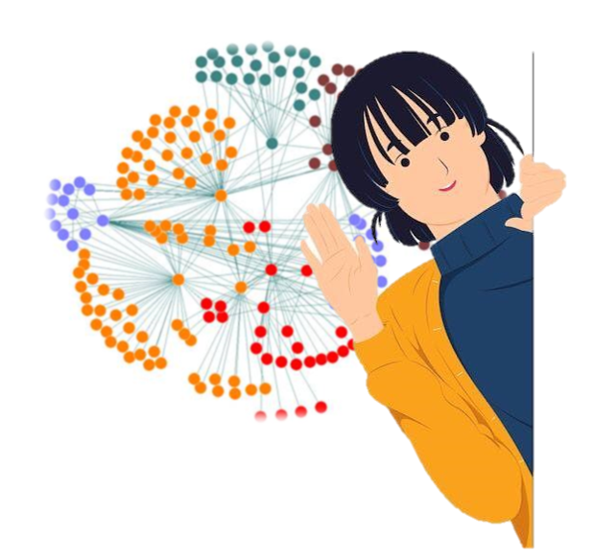

Chapter 5:

Network analysis in AP

CHAPTER 5 Contents:

5.1. Network Analysis in AP 109
5.2. Structural analysis of psychological network 110
5.3. Steps in Network Analysis 111
5.4. Descriptive Statistics of Networks 113
5.5. Network Accuracy 115
5.6. Accuracy of Centrality Indices 115
5.7. Network science in Psychology 116
5.7. Network science in cognitive psychology and neuroscience 116
5.8. Designing Conceptual Networks 134
5.9. Sample Size in Network Analysis 136
5.10. Moderated Psychological Network Analysis 137

Abstract: Further examples of network analysis using the directed graphs introduced in chapter 4 are given. These networks are graphs showing the degree of relationship between variables. Given the complexity of relationships between concepts network models are multivariate and often highly dimensional so there is often a need to reduce the number of variables using techniques such as exploratory factor analysis and LASSO which uses a tuning parameter specifying the threshold for the degree of removal of variables. New aspects of networks introduced in this chapter include Markov random fields which are used to estimate the networks, the betweenness index to show the location of ‘hubs’ in the network, clustering of nodes and assessment of model fit and robustness using unbiased methods such as bootstrapping. One application using the connectome measuring the degree of connectivity between neurons and regions in an individual’s brain is introduced together with the size of such systems (microscopic, macroscopic) and types of connectivity. Independent component analysis can look at changes in brain networks over time. A worked example fitting and using the aspects of networks discussed earlier in the chapter to interpret the results is presented using R functions at the end of the chapter.
Keywords: Network analysis; Nodes; Edges; LASSO; Betweenness; Bootstrap; Centrality index; Neural network; Brain connectome

5.1. Network Analysis in AP
AP is introduced to improve the quality of analyzing psychological models. Psychological phenomena are not independent from each other as consciousness is a dynamic and continuous phenomenon. Human behaviors, however, might seem to be discrete and singular but are not. Therefore, in order to understand a phenomenon one should study it as a series of complex and interrelated features, viewing them as a psychological network. AP, in this sense, could be called the science of psychological networks, networks of complex and interrelated variables. These networks are small or big, simple or complex, visible or invisible and dynamic or static. Psychological features in a network could comprise of different types of factors: factors showing cause and effect, environmental factors, character-related factors, psychological or physical factors. The relation among the features could be negative or positive, directional, unidirectional or reciprocal.

Borgatti, Mehra, Brass and Labianca (2009) believe that networks have influenced all aspects of human psychology. In the last decade, network analysis has been viewed as a significant analytical approach in psychological research (Hevey, 2018). Network analysis has a long history in the field, and in recent years there has been a shift from a latent-based approach to a network approach, in order to explain the correlation among variables. In this approach, the observed pattern in the form of correlation can be explained by a mutualism model, in which features have reinforcing and mutual relations (Kayla et al,2020). In the network analysis model, the relationship between variables represents the psychological phenomenon (De Schryver, et al., 2015).
Therefore, conceptually, network is an acceptable model of psychological phenomena, enabling precise analysis, and statistically it is a method to study the relations among variables simultaneously.
Psychological constructs are inherently complex and therefore the researchers have for some years focused on restricting the phenomena studied to that of significant variables. Such a reductionism leads to a limiting of our knowledge of the phenomena as a whole (Barabasi, 2011).
Network approaches in AP focus on multi-variate data to advance several goals. Borsboom et al. (2021) elaborated on these goals. First, they can be used to explore the structure of high-dimensional data in the absence of strong prior theory on how variables are related. Second, in these analyses, psychometric network analysis complements existing techniques for the exploratory analysis of psychological data, such as exploratory factor analysis (which aims to represent shared variance due to a small number of latent variables) and multidimensional scaling (which aims to represent similarity relations between objects in a low-dimensional metric space). The unique focus of psychometric network analysis is on the patterns of pairwise conditional dependencies that are present in the data. Network representations can be used to communicate multivariate patterns of dependency effectively, because they offer powerful visualizations of patterns of statistical association. In other words, it enables the discovery of a communal structure. Third, network models can be used to generate causal hypotheses, as they represent statistical structures that may offer clues to causal dynamics. As stated by Pearl (2000), Spirtes et al, (2000) and Haslbeck et al. (2021), networks that represent conditional independence relationships form a gateway that connects correlations to causal relationships.
Many still believe that causality is derived from the theory and not data. To illustrate network analysis, the following figure could be used.
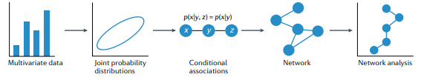
- Structure of psychometric network analysis (derived from Borsboom, etal.,2021, P.2)

5.2. Structural analysis of psychological network
At an abstract level, a network refers to various structures, consisting of variables. These variables are called nodes and the relationships between these nodes are called edges. Despite social networks, in which associations between people are directly observable, (for example friends and enemies), edges in psychological networks depend on statistical analyses and partial correlations among nodes, which represent the power of associations among them. In visual representation of a network, green (or blue) edges represent positive associations and red edges represent negative associations. The thickness of each edge shows the power of association (Jones, Mair, Mcnally, 2018). Edges can be either weighted or unweighted. Weighted edges reflect the direction and strength among nodes. Alternatively, the edge may be unweighted and simply represent the presence vs. absence of a relationship.
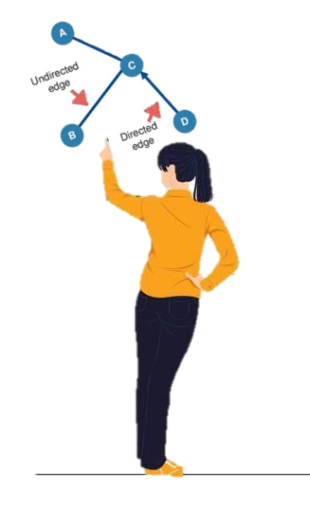
A node can represent a single item from a scale, a sub-scale, or a composite scale. The choice of node depends upon the type of data that provide the most appropriate and useful understanding of the questions to be addressed. This is along with explainabilty and interpretability which are the bases of AP. Edges can represent different types of relationships, for example co-morbidity of psychological symptoms or correlations between attitudes (Hevey, 2018). Farahani, Azadfallah, Watson, & Blagojević (2021) investigated the application of network analysis for capturing comorbidity structure in mental disorders .
Generally, two types of edges can be present in a network: (1) a directed/directional edge: the nodes are connected in a one-way effect, or (2) an undirected/undirectional edge: the nodes have a mutual relationship.
A directed network can be cyclic i.e. we can follow the directed edges from a given node to end up back at that node or acyclic i.e. you cannot start at a node and end up back at that node again by following the directed edges.
Pearl (2000) believe that directed networks can represent causal structures and therefore cannot be cyclic and are surely acyclic (Epskamp, S., Borsboom, D., & Fried, 2018). However, in the real world the cyclic assumption is untenable. In addition, directed networks suffer from the problem that many equivalent models can account for the pattern of relationships found in the data (Bentler & Satorra, 2010).
Despite the plausibility of many causal psychopathological symptom pathways in networks, there is a need to build a stronger rationale to motivate the causal nature of these relationships (Fried and Cramer, 2017).
Regarding time, networks can be cross sectional data or time-series data.

5.3. Steps in Network Analysis
Estimating a network
For a network to be formed, first the edges should be determined. In classical statistics there are several methods to study the relationships between variables such as correlations, covariance, partial correlations, regression coefficients, odds ratios and factor loadings. However, in network analysis, the estimation method depends on the type of network. Undirected networks occur frequently in psychology and a frequently used model in estimating such undirected networks is the pairwise Markov Random Field (PMRF), which is a broad class of statistical models. A PMRF model is characterized by undirected edges between nodes that indicate conditional dependence relations between nodes. An absent edge means that two nodes are conditionally independent given all other nodes in the network. An edge indicates conditional dependence given all other nodes in the network.
Edges are estimated depending upon the type of data. If continuous data are multivariate normally distributed, analyzing the partial correlations using the Gaussian graphical model (GGM) is appropriate (Costantini, & Perugini,2016). If the continuous data are not normally distributed then a transformation can be applied prior to analysis (Liu, Lafferty, & Wasserman, 2009). For ordinal data, polychoric correlations are used (Epskamp, 2018).
If all the data are binary, the Ising Model can be used (van Borkulo, 2014). All of these models can be coded in R. When the data comprise a mixture of categorical and continuous variables, the Mixed Graphical Model can be used to estimate the PMRF (Haslbeck, J. M., & Waldorp, 2018).
The network complexity requires consideration. The Parsimony principle is of great importance here. The higher the number of nodes being examined, then the higher the number of edges that have to be estimated and so the network is more complex. For example, in a network with 10 nodes, 45 edges are estimated. In addition, in the case of an Ising model, the number of estimations is more. Moreover, due to confounding variables, some of these correlations might be fabricated and an increase in the number of nodes can lead to over-fitting and very unstable estimates (Babyak, 2004).
It should be born in mind that correlations and partial correlations are the bases of estimation in undirected weighted networks, and these like all statistical techniques are influenced by sample variation and therefore exact zeros will be rarely observed. However, weak and spurious correlations may occur. In order to limit the number of such spurious relationships, along with benefiting from theoretical backgrounds, a statistical regularization technique is frequently used. A ‘least absolute shrinkage and selection operator’ (LASSO is such a regularization technique, introduced by Friedman, Hastie, & Tibshirani in 2008. The estimation of the partial correlation networks is done with a tuning parameter set by the researcher. Studies (Wu, Fan & Feng, 2009) show that LASSO performs well in the estimation of partial correlation networks. LASSO reduces some small weak edge estimates to exactly zero, resulting in a sparse network (Tibshirani, 1996). In other words, LASSO yields a more parsimonious model by reducing the number of connections between nodes, that reflects only the most important empirical relationships in the data. Therefore, the absence of an edge does not present evidence that the edge is in fact exactly zero (Epskamp, Kruis, Marsman, & Marinazzo, 2017). Note that there is also the threat of omitting actual relationships when using LASSO.
Among many variants of the LASSO, the graphical LASSO (Friedman, et al, 2008) is generally used in network analysis, as it is easily implemented in software and also it is flexible in terms of data type (Epskamp & Fried,2018).

The use of the LASSO requires tuning parameter $λ$. The higher the λ value, the more edges are removed from the network more directly influencing the structure of the network. A common method involves estimating a number of networks under different λ. These different networks range from a completely full network to a network with no edges. The LASSO estimates produce a collection of networks and one needs to select the optimal network model. Optimizing is typically achieved by minimizing the Extended Bayesian Information Criterion (EBIC) (Chen & Chen, 2008). EBIC works well for both the Ising model and GGM (Foygel & Drton, 2010). EBIC has been used in psychology networks and it enhances the accuracy of networks (Tibshirani, 1996; Isvoranu et al, 2017).
λ in EBIC is a hyperparameter, which is determined by the researcher and is typically set between 0 and 0.5. Its default value is 0.5 in almost all cases. The explanability and interpretability is of great importance here. The researcher should determine which produced networks are more aligned to theoretical bases. After estimating the network, the important questions to be answered are: which node is the most important one? Is the global structure of the network dense or sparse? Is the network stable? Do nodes consist of communities or are they singular?

5.4. Descriptive Statistics of Networks
Centrality indices are used to study network descriptions. Centrality indices (CI) represent the relative importance of a node in the context of the other nodes in the network (Borgatti, 2005).
One of the indices of centrality is node strength. How strongly a node is directly connected to other nodes is based on the sum of the weighted number and strength of all connections of a specific node relative to all other nodes.


Another index is closeness which quantifies the node’s relationship to all other nodes in the network by taking into account the indirect connections from that node. A node with high closeness will be affected by changes in any part of the network and can affect changes in other parts of the network quickly (Borgatti,2005).
In addition, there is an index of Betweenness. The betweenness index is defined by the frequency in which a node lies on the shortest path between two other nodes. In other words, this index shows which nodes are bridges.
Clustering is used to interpret psychological networks. The overall network might comprise communities. Each community is a clustering of nodes that are highly interconnected among themselves and poorly connected with nodes outside that cluster (Havey, 2018). Detecting communities, helps researchers to interpret the network. Discovering clusters of nodes (communities) helps in interpreting the multiplicity of nodes.
Fried (2016) introduces a number of approaches to identify communities. The familiar approaches of Latent variable models and “Exploratory factor analysis” do this. Communities are in fact factors. There are also more sophisticated approaches, including the spinglass algorithm. The problem with this algorithm is that it often produces different results every time you run it, and it only allows nodes to be part of one community. Another approach is the walktrap algorithm. This algorithm provides more consistent results but only allows nodes to be part of one community. Lastly we have the Clique Percolation Method (CPM), which allows nodes to belong to more than one community and fits the needs of psychological research. The last approach is applied in this volume.

5.5. Network Accuracy
Determining the accuracy of network analysis is of great importance. In psychological research, the sample size is small which can limit accuracy. Therefore, looking at the accuracy of node centrality and edge strength is important.
The most common method to estimate the accuracy of edge weights is by calculating confidence intervals (e.g. 95% CI). Epskamp et al. (2018) developed a method that uses bootstrapping (Efron, 1979).
In this method, a model is estimated repeatedly under either sampled or simulated data, and then estimates the required statistic. The more bootstrap samples, the more consistent the results.
Either a parametric bootstrap or non-parametric bootstrap can be applied for edge-weights (Bollen & Stine .,1992). Non-parametric bootstrapping could be applied for any type of data and therefore Epskamp et al. (2018) recommended using a method for unbiased estimates with LASSO regularized edges.

5.6. Accuracy of Centrality Indices
The accuracy of the centrality indices can be examined by using different methods. The aim is to determine whether or not the order of centrality indices remains the same after re-estimating the network with less cases or nodes. Therefore, a bootstrap method dropping subsets of cases is applied to assess sensitivity.
In this method, the correlation stability is calculated. The correlation between the original centrality indices (based on the full data) is compared to the correlation obtained from the subset of data (representing different percentages). If the correlation changes considerably, then the centrality estimate is problematic. A correlation stability coefficient (CS) of at least 0.7 between the original full sample estimate and the subset estimates has been suggested by researchers as being a useful threshold to examine (Epskampet al., 2021).
It should be born in mind that a CS-coefficient shows the maximum proportion of cases that can be dropped, such that with 95% probability the correlation between original centrality indices and subsets is above a threshold.
Levey (2021) suggests that to ensure the accuracy of indices, CS should be 0.25 or preferably 0.5(Borsboom et al, 2021).

5.7. Network science in Psychology

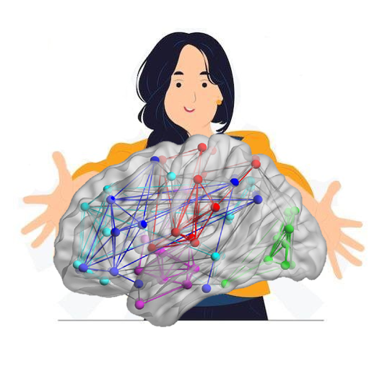
We are living in a connected world, being surrounded by complex networked systems. Blanken et al. (2021) assert that if one wants to summarize all contemporary studies on human processes and behaviors in a sentence, they would say: “It is complicated”.
The connection between neurons, interrelation of psychological states and social relations and the connection of symptoms and psychological disorders can all be considered as networks. Network analysis is not a new scientific approach but is considered as a new one in psychology (Labianca, Mehra, Brass, Borgatti, 2009). In recent studies, Borsboom (2013), has tried to apply this new approach in psychological research. The literature of applying network analysis in psychology is very extensive (For instance See Fonseca-Pedrero, E. 2018 ; Bringmann et al., 2022).

5.8. Network science in cognitive psychology and neuroscience

5.8.1. Complex system
The features of these systems are neither completely random nor completely regular, but instead indicate a rather complex organization. In our surroundings, such systems range from societies, economies, and ecosystems to infrastructure systems, data processing networks, and molecular interactions in biological organisms.
Despite recent breakthroughs in neuroscience, much remains unknown about the brain’s complex functions. Network neuroscience is an interdisciplinary branch of science aimed at better understanding these issues. There are two general procedures in this field: 1. Using new experimental tools and comprehensive maps and recording dynamic patterns in molecules, neurons, brain regions, and social systems; 2. using theoretical and computational tools of modern network science.
Nowadays, neuroscience is faced with big neural data. “Big data” typically represent networks that contain relationships or interconnections that link the many elements of large-scale neurobiological systems. These include protein interaction and genetic regulatory networks, synaptic connections and anatomical projections among brain areas, dynamic patterns of neural signaling, and communication associated with spontaneous and task-evoked brain activity and interactions among brain systems, and the environment in the functioning course of behavior. These data have different domains and types (for example, anatomical and functional connectivity, genetic patterns and disease states, and activity in distributed brain regions in relation to behavioral phenotypes) (Bullmore, E., & Sporns, O. 2009; Medaglia, et al,2015).

5.8.2. The Brain as a Complex System
The brain is the most complex network known to humans. The human brain is made up of about 100 billion (10¹¹) neurons interconnected by about 100 trillion (10¹⁴) synapses, which are anatomically organized at different spatial scales and functionally interact at different time scales. This enormous system is the biological hardware from which all our thoughts, feelings, and behavior emanate (Fornito, et al, 2016).
Network neuroscience entails the analysis of many different networks that are at different temporal and spatial scales. These studies start from the smallest elements for finding the connection between the data encoded in the relationships between genes and biomolecules and continue to higher levels. Network neuroscience is aimed at gaining a deeper insight into how neuron-level processes affect the function of large-scale circuits, neural systems, and the entire brain's structure and function. However, instead of stopping at the brain, network neuroscience asks how these patterns of interconnections in the CNS guide and interact with behavioral patterns: How perception and action are interrelated and how brain-environment interactions affect cognition. The following figure indicates these spatial and temporal scales. (Bassett, D. S., & Sporns, O. 2017).

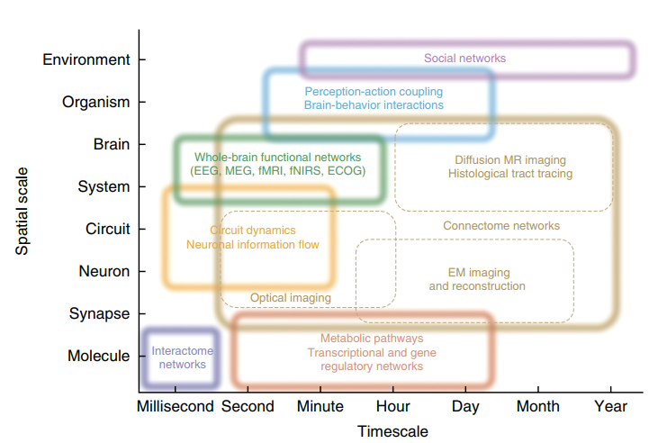

- spatial and temporal scales from (Bassett, D. S., & Sporns, O. 2017)
Research suggests that a small number of mutations or risk factors cannot fully explain the biological basics of certain psychiatric diseases. Instead, these psychiatric diseases involve disorders in biological networks.
In neuroscience, descriptive metrics of local and global features of network topology are used in structural and functional data. These analyses rely on non-random topological features such as high clustering and short path length 3,47, and network communities (modules) linked by highly connected hub nodes 48 that are in turn densely linked, forming an integrative core49 or rich club. The descriptive metrics in the graph and brain network will be examined in the following.

5.8.3. Brain Connectome
The concept of connectome was first introduced by Olaf Sporns, Giulio Tononi, and Rolf Kotter and independently in Patric Hagmann's 2005 Ph.D. project (Sporns, et al, 2005). The following figure depicts the first attempts to obtain the brain's functional matrix. The concept of connectome originally represented knowledge about the brain's cellular wiring diagram. With the developments of the last ten years, however, this has expanded to cover more general concepts. In fact, the connectome includes the matrix of anatomical connections between large-scale brain regions and between neurons, plus the functional matrix obtained through MRI (low frequency, <0.1 Hz) or EEG (high frequency, >500 Hz).
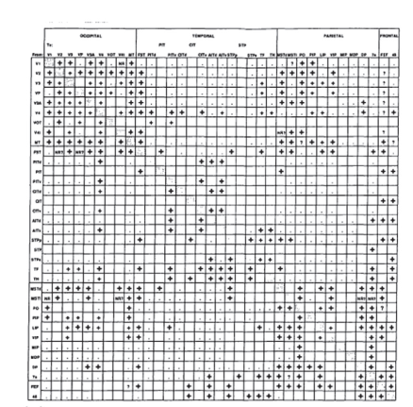
Further studies have shown that a person's connectome is unique and similar to a fingerprint. Machine learning can use these neuroimaging-based biomarkers to build diagnostic or prognostic instruments. Visualizing and interpreting these models can complement statistical analysis to provide insight into the dysfunction of resting-state patterns in brain disorders.

- One of the Early Attempts to Systematically Create a Brain Connectivity Matrix (Felleman & Van Essen 1991) shows the connection of 32 Neocortical Regions involved in Eyesight Function of the Macaque.

5.8.4. Various Scales for Network Analysis of the Brain

Unfortunately, there is no single technology to measure brain networks at all biological scales. This means that considering connectomics at multiple scales inevitably requires considering several different measurement methods. However, graph theory does not consider the scale and measurement method and presents a comprehensive language for understanding brain network topology.
Connectomics typically makes a distinction between three spatial scales to determine nodes: namely microscopic, mesoscopic, and macroscopic, and the special techniques used at each scale limit how nodes and edges can be defined.
- Microscopic: The microscopic scale refers to features that can only be detected using microscopic techniques. In other words, the network consists of neurons and synapses. Neural tissue is incredibly dense – rough estimates suggest that there are 90,000 to 100,000 neurons, about a billion synapses, and kilometers of axons and dendrites embedded within 1 square millimeter of the human cortex. Therefore, it is very difficult to find neural structures and imaging devices should have sufficient accuracy to examine this structure. From a biological perspective, this level is very significant but difficult to examine due to its tremendous complexity.
- Mesoscopy: The mesoscopic scale bridges the gap between the microscopic and the macroscopic scales and combines both methods to precisely understand the connections of the entire brain or large parts of it.
- Macroscopic: Unlike the microscopic mode, this scale does not need microscopic techniques. In fact, this scale includes analysis of structural and functional interactions in populations of neurons obtained by EEG, MRI, or MEG. In the following, macroscopic methods, graph theory, and machine learning at this scale will be examined (Fornito, et al,2016).

5.8.5. Networks in the Brain

Building a brain network requires defining nodes and edges. The method commonly used for designing predictive models based on functional connectivity has three main steps: Brain segmentation, estimation of interactions between defined segments, and finally, application of these connections between brain segments as features that enable the classifier to predict behavioral features, emotional metrics, and other variables (Fornito, et al, 2016).The defined segmentations act as network nodes and their links are considered edges.
Some segmentation techniques are based on mapping anatomical or functional atlases onto an individual's brain whereas other techniques are more data-driven and try to obtain segments based on common features within the data (Fornito, et al,2016). The first approach is known as hard segmentation, which includes the use of brain atlases, and the second approach uses statistical methods such as independent component analysis (ICA), which are unsupervised. (Unsupervised methods are discussed in the following sections.)
This method considers nodes from different brain regions and uses time series analysis to create the edges used in functional networks. This method is used widely. Then, a functional matrix is created using the correlations between their time series. There are many methods to obtain correlation or covariance between brain regions. Although the correlation matrix is easy to calculate, it is a fully correlated and dense matrix where all the nodes tend to be interconnected and this creates an overly-dense, clustered, and modular network that has dependencies with no anatomical basis. Although partial correlations can somewhat prevent this problem, ultimately, data interpretation is difficult. (Pervaiz, et al, 2020)
Typically, there are three categories of brain connectivity: namely structural connectivity, functional connectivity, and effective connectivity.

5.8.5.1. Structural connectivity

Structural connectivity refers to anatomical connections between neurons such as microscale axons and synapses or large-scale or macroscopic connections between different cortical areas, which typically employ unique methods at each level: The electron microscopy method at the micro level, axonal tract-tracing at the meso level, and diffusion MRI at the macro level. Since each axon has a source and a destination, this connection is inherently directed. (Bullmore, E., & Sporns, O. 2009).
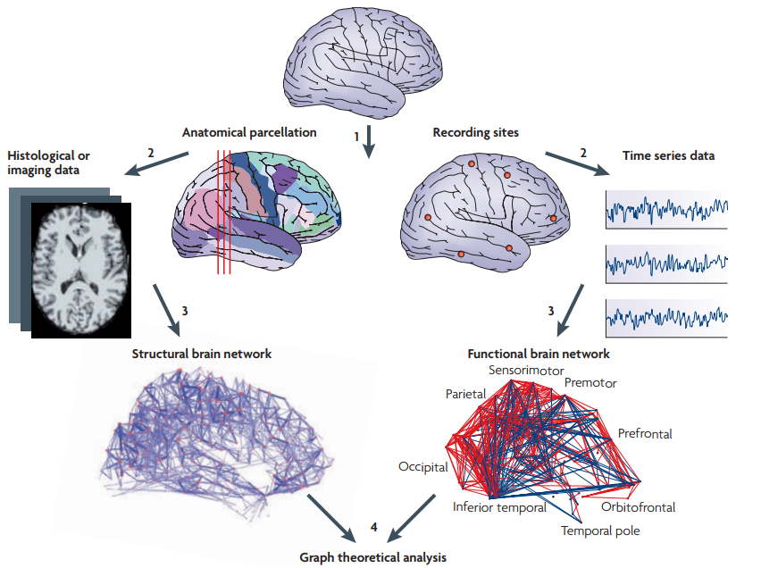

- Representation of the Stages of Creating Structural and Functional Networks of the Brain (Bullmore, E., & Sporns, O. 2009)

5.8.5.2. Functional connectivity

Functional connectivity refers to the statistical dependence between separate neural elements that determines which parts of the brain work with each other and which work independently. Their interpretation depends on the type of recordings analyzed. These connections can be directed or undirected.
Functional connectivity is measured using statistical dependence metrics between neural time series, which can be discrete or continuous.
At this level, the neuron is considered the basic element of a nervous system. It, therefore, seems reasonable to conclude that the cellular scale is a natural scale for the study of brain connections. This rationale underpinned the first attempt to reconstruct the connectome - the nervous system of the nematode C. elegans, at the neuron and synapse level. This scale of analysis produces an accurate drawing of nodes and edges, which seems very useful. However, it has disadvantages such as the computational burden, labor-intensive data acquisition and processing, and poor scalability for large neural systems.
In fact, fMRI, the brain's BOLD signals, indicate spontaneous oscillations without any external stimuli. Biswal et al. observed a high degree of correlation of spontaneous neural activity between bilateral motor areas during the resting state. Since then, cognitive neuroscience research has entered a new era of functional connectivity analysis. Due to its simple experimental design, easy operation, and easy adoption by patients with neuropsychiatric disorders, rs-fMRI has its own unique advantages in the functional study of the human brain. Functional connectivity only shows the synchrony of neural activity of spatially-separated brain regions. Researchers have proposed a series of functional connectivity analysis approaches, such as linear correlation analysis, independent component analysis (ICA), principal component analysis (PCA), coherence analysis, and cluster analysis. A node-based analysis is the most common approach to linear correlation analysis. First, regions of interest (ROIs) are selected as nodal regions according to prior knowledge, and then Pearson's correlation coefficient is calculated as a measure of functional connectivity between the period of a given nodal region and voxels in the brain. By dividing the whole brain into several regions (or defining a number of ROIs), region-to-region functional connectivity can be obtained to construct a whole-brain functional connectivity network. There is another approach that does not require considering a single node or ROI and network analysis can be achieved at the whole-brain level (Hu, & Zeng,2019).
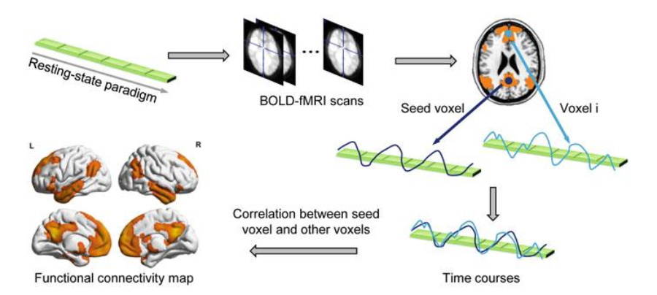

- Producing the Functional Network of the Brain (Hu, D., & Zeng, L. L. 2019)

5.8.5.3. Effective connectivity
Effective connectivity was initially used to understand the coherence in the spiking activity of neurons and was defined as the minimum neuronal circuit model that can reproduce the observed signal coherence. Effective connectivity checks if there is a flow between different components. Unlike functional connections, the direction of these connections is also specified and is consistently directed. This connectivity is mainly examined to find causal connections between different brain areas and can help researchers in finding the basic mechanisms of neuronal dynamics (Bullmore, E., & Sporns, O. 2009).

5.8.6. Definition of a Brain Graph

Network science examines the macroscopic behavior complexity of a system of interconnected elements. Given the availability of high-quality datasets, they can be considered with respect to graph theory quantities. In other words, complex systems show common macroscopic features despite having completely different microscopic features. In many studies, one of these important features, small-world, has been seen in the functional and structural networks of the brain of humans and other organisms in different dimensions.
In network science, other topological features of complex systems such as modularity, hierarchy, centrality, and the distribution of network hubs can be quantified.
The structural and functional networks of the brain can be investigated using graph theory through the following four steps:
- Defining nodes using imaging techniques
- Estimating the continuous size of the inter-node connection through spectral coherence or Granger causality measures between two magnetoencephalography sensors, the probability of connection between two regions of an individual diffusion tensor imaging data set, or inter-regional correlations in MRI measurements of the thickness or volume of the cerebral cortex.
- Linking all connections between nodes and creating a connectivity matrix where a threshold is (usually) applied to each element of this matrix to create a binary adjacency matrix or undirected graph.
- Analysis and calculation of network parameters in the brain network and comparison with the equivalent parameters of a population of random networks (Bullmore, E., & Sporns, O. 2009).

5.8.6.1. Graph Analysis Metrics in the Brain

- Node Degree, Distribution Degree, and Assortativity
The degree of a node is its number of connections with the rest of the network. This is one of the most fundamental metrics of the network that other network metrics are also related to. In random networks, all connections are equally likely, resulting in a Gaussian and symmetric degree distribution. Networks of complex systems usually have non-Gaussian degree distributions, which often have long tails towards nodes with high degrees. The degree distribution of scale-free networks follows the power law. Assortativity is the correlation between the degrees of connected nodes. Positive clustering indicates that high-degree nodes tend to connect. The following will explain assortativity and its application in more detail.
- Clustering Coefficient and Motifs
If a node’s nearest neighbors are also interconnected, a cluster is formed. The clustering coefficient is the number of connections between a node’s nearest neighbors relative to the maximum possible number of connections. Random networks have low clustering averages while complex networks have high clustering (related to high local efficiency of information transfer and robustness).
The topological motifs of a network are basic building blocks where connections between small sets of three or four nodes are repeated in the network with a frequency greater than chance.
- Path Length and Efficiency
The path length is the minimum number of edges to be skipped when going from one node to another. Random and complex networks have a short average path length (high global efficiency of parallel information transfer), while normal networks have a long average path length. Efficiency is inversely correlated with path length.
- Connection Density or Cost
Connection density is the actual number of edges in a graph as a ratio of the total number of possible edges. It is the simplest estimator of a network's physical cost. For example, in fabricating a computer chip, if each logic gate is assumed to be a node and wires to connect them, the amount of wiring between the nodes should be minimized to reduce thermal noise and additional costs (Fornito, Zalesky & Bullmore 2016).
- Hubs, Centrality, and Robustness
Hubs are nodes with a high degree or high centrality. A node's centrality measures the number of shortest paths between all pairs of nodes in the network that pass through it. Thus, a node with high centrality is essential for efficient communication. An individual node's importance for network efficiency can be evaluated by removing it and estimating the resulting network's efficiency.
Robustness either refers to the network's structural integrity after node or edge removal or the effects of disruption on local or global network states.


- Modularity
Many complex networks are made up of a number of modules. There are various algorithms for network modularity estimation, many of which are based on hierarchical clustering. Each module includes several densely interconnected nodes, and there are relatively few connections between nodes of different modules. Provincial hubs typically connect to nodes in their own modules, whereas connector hubs connect to nodes in other modules.
In most cases, correlations, coherence, and mutual information are used to create an undirected graph, and correlations, coherence, and mutual information methods are used to create directed graphs.
MRI measurements suggest that centrality and modular organization can be significant biomarkers for early diagnosis and prediction of clinical outcomes in neurology and psychiatry (Fornito, Zalesky, & Bullmore,2016 ).
- Random, Scale-Free, and Small-World Networks
In random graphs, each pair of nodes has an equal probability of p to be connected and a Gaussian distribution, but most of the descriptive graphs in the real world deviate from the random graphs model.

The "small-world" feature has high levels of local clustering among the nodes of a network and short paths that globally connect all network nodes. In fact, all nodes in a large system are connected through relatively few steps. Small-world features are between random networks and regular networks. Research on genetics, signaling, communication, computing, and the neural network has provided evidence for this feature. These studies reveal that almost all networks in natural and technological systems have non-random/irregular or small-world architectures, and this feature reflects their specific performance. (Bullmore, E., & Sporns, O. 2009)

5.8.7. Brain Network Identification and Analysis in Graph

The use of graph theory in brain network analysis dates back to the introduction of the "human connectome" (Sporns et al., 2005). Here, there is an N*N matrix (also called connectivity matrix or connection matrix) with 0 or non-zero values denoting whether or not there is a connection between the two regions. A brain network analysis of humans or other animals becomes possible upon obtaining the mentioned metrics in this network.
Generally, there are two calculation methods used in connectivity identification: functional connectivity and effective connectivity. As mentioned earlier, functional connectivity provides information about temporal coherence between distant regions, and effective connectivity is the direct effect of regions on each other.
Research on functional connectivity studies can be divided into two categories, model-based and model-free. The model-based mode employs methods such as cross-correlation, coherence analysis, and statistical parametric mapping whereas the model-free mode uses decomposition-based analysis, clustering, and mutual information methods.
The model-based mode considers as seed a region of the brain to check whether or not that region is related to other regions. This method needs background knowledge for the correct selection of seeds and related areas. In other words, there is a need for a hypothesis, which is verified based on experiments. At the same time, this method may destroy and fail to examine the useful information in the communication neglected by the researcher.
Meanwhile, the model-free mode does not select any specific region or seed and considers the whole brain and its connectivity without a hypothesis.
As mentioned, there can be two types of criteria for the examination of the brain graph: global and local criteria. (Fornito,Zalesky, & Bullmore, 2016 )
Global Criteria
The global criteria are aimed at finding functional segregation, information flow in the brain, functional integration, finding the small-world feature, and checking the network's resilience to failure (Sporns, O. 2014).
In fact, segregation means the degree to each element in the brain that is assigned to populations. In this case, the clustering coefficient and modularity criteria provide good information about segregation. In brain networking, anatomically-adjacent regions are called modules, and analysis with this mode has shown the small-world feature in the brain network. Moreover, integration provides insight into the efficiency of information connectivity throughout the brain, and the information can be measured as the length of the path between regions.
In general, the small-world feature represents a balance between segregation and integration between networks.
Regarding the resilience feature, the assortative criterion can be put against failure. In fact, inter-hub connectivity in a network leads to the coverage of a particular hub’s failures, and this criterion is also essential in examining the brain network.
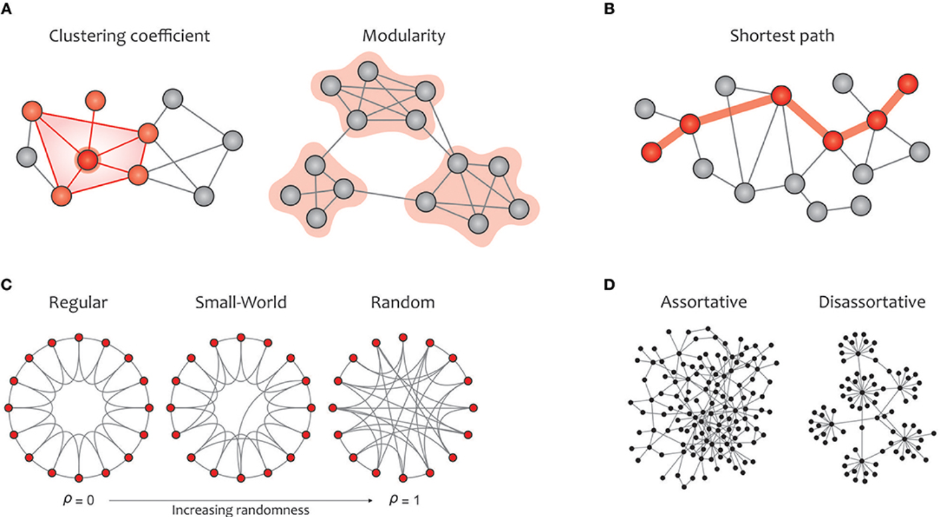
- local criteria and global criteria (Hu, D., & Zeng, L. L. 2019)

Local Criteria:
In network science, a node with high centrality that greatly affects the network is called a hub. There are two types of hubs: namely connector hubs or provincial hubs named based on their participation rate. Connector hubs have a high participation rate and the opposite is true for the provincial hubs. In other words, connector hubs are responsible for connecting different modules of the brain while provincial hubs are responsible for connectivity between modules. The network's node degree criterion is one of the easiest criteria for finding hubs. Other criteria such as centrality, betweenness, and closeness also belong to this category.

5.8.8. The Brain’s Important Networks
The first known brain network was the linguistic network discovered by Broca and Wernicke in the 19th century. The two separate parts in an interconnected network are responsible for the single activity of language. In general, many networks of different scales have been identified in the brain. There are seven basic brain networks on a large scale:

5.8. 8.1. The Sensorimotor Network
This network receives sensory information from inputs throughout the body and converts them into electrical signals in the brain. This network’s responsibilities are divided into several categories: Processing the brain’s external physical signals, internal signals, examining sensations, and producing motor responses. This network is closely related to other networks such as the auditory network, visual network, limbic network (for a sense of taste and smell), salience network, and the default mode network (DMN). It is considered a transducer in the brain (ten Donkelaar, et al, 2020).

5.8. 8.2. The Visual System
This network can be considered a spectator and is responsible for visual and vision-related processing. This system is very complex since it converts light into something recognizable. Despite the initial assumption that this task is accomplished in one area, it was later discovered that there is a system responsible for these processes. These processes include visual image enhancement and processing and detecting motion, patterns, faces, places, and more (Poggio,et al, 1988).

5.8. 8.3. Limbic System Network
As one of the oldest networks in the brain, this system regulates many brain functions such as memory, emotions, learning, and behavior. This network responds to stimuli such as smell, sound, and light. It is also responsible for behavior, reactions, and associated feelings as well as memories of experiences or any type of learning (Sullivan, 2022)

5.8. 8.4. The Central Executive Network (CEN)
Responsible for tasks and decision-making, this network operates at a high cognitive level and is considered one of the most important brain networks. Its responsibilities cover memory, processing, controlling and combining information from other areas and networks, organizing behavior based on internal motivations, mental preferences, and choices. This high-level network receives and integrates input from other networks to process a variety of information that includes flexibility, working memory, initiation, and inhibition, which were previously thought to have different networks (Dosenbach, et al, 2007).

5.8. 8.5. Default Mode Network
This is one of the most well-known brain networks that is activated when resting, daydreaming, or contemplating a new idea. This network is active during sleep and rest and becomes more active during inner thinking. These internal thoughts can be about reminiscing about childhood memories, planning for the next vacation, or hunger and bowel movements, which indicate an active DMN. Given the unconscious analysis and contemplation about oneself and the world, it is considered one of the most active and stable brain networks. Many studies on biomarkers use this network (Sambataro, et al, 2010).

5.8. 8.6. Salience Network
This network accurately considers the outside world and determines the brain’s response to stimuli. This network acts as a gear for switching from the executive network to the DMN network and back. In other words, it switches between internal and external processes. The reason for the existence of this network is that in healthy brains, the DMN and CEN networks do not activate simultaneously, the regulation is handled by SN (Elton, et al,2014).

5.8. 8.7. The Dorsal Attention Network
This network supervises human attention and is bidirectional and coherent for remaining attentive. DAN is often activated in conjunction with other active networks in the brain. DAN directs attention to whichever network (or networks) is the most salient and active. The human brain continuously receives sensory input and cannot consistently pay equal attention to all sensory signals. Instead, DAN focuses the brain's attention on the most important sensory input at a given moment (Corbetta, et al, 1995).

5.8.9. Applications of Graph in Cognitive and Behavioral Science
Cognition covers neural actions that lead to thinking, feeling, or experiencing and includes problem-solving, attention, memory, executive functions, and reasoning (Farahani, et al, 2019).
Intelligence is one area of interest in the connection between the brain network and cognition. Human intelligence refers to various functions, including logical reasoning, rapid learning, and thinking, and studies examining the structural and functional network of the brain have indicated the connection between these networks and intelligence. For instance, van den Heuvel et al. (2009), Langer et al. (2012), and Hilger et al. (2017a) mentioned the relationship between intellect and the small-world criterion in the brain's intrinsic networks. These findings reveal the correlation of intellectual performance with the shortness of the feature path and the hub centrality value in the salience and integration network between the frontal and parietal regions. Also, Wu et al. (2013) showed that IQ is positively correlated with nodal features in the attention-related network and negatively correlated with nodal features in the default mode, emotions, and language systems. Although these findings show that general intelligence is deeply influenced by the functional integration of spatially-distributed regions, they do not provide sufficient information about whether and how human IQ is related to the brain’s modular architecture.
Another field of graph study concerns brain changes during life. The human brain undergoes many functional changes from birth to adulthood. Numerous studies on this subject have shown that local efficiency and the rich club coefficient increase until adulthood in healthy people and then decrease with age. At the same time, regardless of the initial post-birth years, global efficiency remains unchanged (Gao et al., 2011). Moreover, the reverse paths between short and long connections indicate the gradual change in the brain's functional network, which likewise causes behavioral and cognitive changes in the person.
There have also been studies on the relationship between working memory and brain network. Stanley et al. (2015) showed that local efficiency is less associated with better working memory and greater global efficiency is associated with improved performance in young people and deficiency in the elderly.
Another interesting subject is the examination of changes in the person's daily functions in natural environments, on which basis brain function is measured in routine environments. For example, Petruo et al. (2018) showed that mental fatigue is associated with topological changes in the brain such as a decrease in the small-world feature and global efficiency and functional changes in the frontoparietal network and connected areas in the thalamus and the striatum.
One of the most significant applications of this science is in the diagnosis of biomarkers and mental disorders. These criteria and examination are applied to many diseases, including epilepsy, Alzheimer's disease (AD), multiple sclerosis (MS), autism spectrum disorder (ASD), attention-deficit/hyperactivity disorder (ADHD), schizophrenia, Parkinson's disease, insomnia, major depression, obsessive-compulsive disorder (OCD), borderline personality disorder (BPD), and bipolar disorder, and in many, the biomarkers of connections in brain function can be easily identified.

5.8.10. Machine Learning in Analysis of Resting-State fMRI (rs-fMRI) Data
Most applications of machine learning in the analysis of rs-fMRI data are related to unsupervised learning approaches. Contrary to task-driven studies, modeling resting-state activity is not straightforward since there is no controlled stimulus to justify and drive these fluctuations. Therefore, the analytical methods used to describe the Spatio-temporal patterns observed in task-based fMRI are typically ill-suited for rs-fMRI (Khosla, et al,2019).
Unsupervised Learning:
Given the numerous dimensions of fMRI data, it is no surprise that the primary analytical approaches are based on decomposition or clustering techniques to provide better descriptions of spatial and temporal data. Unsupervised learning approaches such as ICA accelerated the discovery of so-called resting-state networks or RSNs. It was also developed in resting-state brain mapping with the main goal of creating brain divisions, that is, the optimal grouping of voxels that functionally define coherent spatial sections in the brain. These maps help to better understand the brain's networks and connections. In addition, they serve as a feature reduction technique for statistical analysis or supervised machine learning. The literature has indicated that functional connectivity in the resting state undergoes significant changes during a typical rs-fMRI scan, which interestingly shows the dynamics of the brain network. Unsupervised learning techniques demonstrated that resting brain network patterns change between multiple states, indicating a diversity of mental processes (Khosla, et al, 2019).
The unsupervised learning approach employs k-means, Gaussian mixture models, hierarchical clustering, and graph-based clustering methods as well as latent variable models, decomposition methods, independent component analysis (ICA), PCA, and hidden Markov models.
Applications of unsupervised algorithms in rs-fMRI data include the following:
Most unsupervised learning approaches in rs-fMRI aim to segment the brain into discrete functional subunits akin to atlases. Unlike approaches that use atlases, these segmentations are driven by functional data.
The second set of these applications is an exploration of the dynamics of brain networks. Recently, unsupervised learning has been applied to the analysis of the dynamic functional connectome with promising results.
Meanwhile, as mentioned earlier, one application of machine learning in rs-fMRI is in the clinical field. These supervised machine-learning applications are used for personal-level predictions. As a sensitive biomarker in disorders, many researchers have developed an interest in "Connectome”, and many studies have further suggested that like fingerprints, these connections and connectomes are unique to each individual. Given the importance of deep learning, several new neural network-based approaches for the analysis of rs-fMRI data have also been developed. Most of these approaches extract connectomic features for individual-level prediction. Deep learning algorithms (Tzourio-Mazoyer, et al, 2002) will be explored in more detail in the following chapter.

Supervised Learning:
This approach to learning deals with problems that have features and predictions and labels with the aim of learning the mapping between the input and target. This allows the system to estimate heretofore unseen input data points. An example is the prediction of autism through rs-fMRI correlations. Since intrinsic FC reflects interactions between cognitively relevant functional networks, there is a hypothesis that systematic changes in resting state patterns could be associated with pathology or cognitive features. The promising diagnostic accuracy of supervised algorithms using rs-fMRI is strong evidence for this hypothesis. This approach also uses methods such as ridge regression, LASSO regression, elastic-net regression, logistic regression, SVM, random forest, and deep learning.
This approach is under intensive development and has been discussed in many studies. For instance, the study of brain development and aging is one application of using supervised machine learning on rs-fMRI data. In this context, Duesenbach et al. used RSFC to predict brain maturity based on the chronological age of adolescents. Hence, these activities can be introduced as a valuable tool for predicting healthy neurodevelopment. This method can also be used to identify the unusual neurodevelopmental changes associated with normal aging (Abraham, et al, 2017).
As mentioned, in this field, the machine learning method can also be used for identifying biomarkers in mental disorders. The biological basis of psychiatric disorders has been unclear and their diagnosis is currently guided entirely by behavioral assessment. rs-fMRI has emerged as a powerful imaging method for biomarker extraction for the diagnosis of psychiatric disorders. Supervised learning algorithms using RSFC have exhibited promising results for classifying or predicting symptom severity in a variety of psychiatric disorders, including schizophrenia, depression, autism spectrum disorder, attention-deficit hyperactivity disorder, social anxiety disorder, post-traumatic stress disorder, and obsessive-compulsive disorder.
It has also received a tremendous amount of attention in the field of cognitive abilities and personality traits. Analysis of functional connectivity can predict individual differences in cognition and behavior. Due to its uncontrolled nature, resting-state imaging covers a wide range of inherent cognitive states. Currently, machine learning models have been used for predicting some individual characteristics such as fluid intelligence, sustained attention, memory performance, and language scores from RSFC-based biomarkers. Also, some studies have used these models to identify personality traits such as neuroticism, extroversion, agreeableness, and openness.
Another important application concerns studies on sleep and fluctuating levels of consciousness. Nevertheless, few studies have used machine learning to predict levels of consciousness during rs-fMRI scans and have classified levels of consciousness during rs-fMRI.
Many studies have also implemented this for investigating genetics and inheritance. Understanding the influence of genetics on brain structure and function has been a long-standing goal in neuroscience. Research in genetic and environmental RSFC is also ongoing in the framework of machine learning. For instance, Miranda-Dominguez et al. applied an SVM classifier to twin FC with the remarkable result of feasibility of successfully predicting family relationships from resting-state fMRI and forming aspects of functional connectivity by unique genetic or environmental factors (Khosla, et al, 2019).

5.9. Designing Conceptual Networks
An essential first step to use a network model, or any model, involves the choice of which variables should be included in the model. The variables are called nodes in network analysis. In other words, network analysis starts with network design and network design begins with defining and describing variables (nodes) in networks (Bringmann et al., 2022).
To define the variables as nodes of a network, Bringmann et al. (2022) recommends the process of node validity, which involves two steps. The first is node selection and the second is node assessment.
Nodes can be any psychological variables, but clearly the theoretical or clinical assumptions of researchers play a key role in selecting a variable as node in a network. That is, the chosen node should be minimally complete. It means that all nodes necessary to model the intended phenomena should be contained in the network, while excluding superfluous nodes. This feature will differ across contexts. The researcher’s insight is of utmost importance. Nodes should be sufficiently distinct as well, especially if the researcher’s assumptions are casual. To be sufficiently distinct, nodes should be:
- separately identifiable (i.e., at least in theory, they can be assessed independently of one another)
- independently manipulable (i.e., at least in theory, one should be able to intervene on a node without intervening on other nodes).
More importantly, the validity and reliability of selected nodes should be assessed.
It should be born in mind that network analysis in this book is cross-sectional and most of network analysis in psychology is of this type (Robinaugh et al.,2020).
The main aim of these networks is to study between-person differences, and sometimes with the aim of generating hypotheses on within-person dynamics. We know that cross-sectional analyses do not statistically separate between-person variability (for example typically stable trait-like features) from within-person variability (for example state-like features). Thus, analyses based on cross-sectional data may result in networks with edges that reflect a mix of between and within effects. Cross-sectional data usually can be directly used to identify within-person dynamics if stationarity is yielded. This specific circumstance is called ergodicity (Molenaar ,2004). It requires that individuals are independent and that the same data generating process applies to all individuals (homogeneity). Moreover, the statistical characteristics of the data like means, variances, auto-and cross-validation do not change over time. In other words, no trends could be detected in the data.
We know that in many cases these assumptions are not met and therefore network analysis based on time-series data is carried out. This analysis is called temporal network analysis, which will not be discussed in this volume.
In sum, network science provides tools, by which the difference between people in the structure of different networks become evident. These findings lead to the formation of an assumption among artificial psychology researchers: Network processes are dynamic by nature.
Network science is quite useful in cognitive psychology particularly and in psychological sciences generally in at least three aspects. Siew et al. (2019) summarize these three aspects:

- Network science provides a quantitative approach to represent cognitive systems. Network science provides an approach to model several cognitive and psychological networks, such as language, semantic memory, traits and linguistic environment. It enables Micro-meso and macroscopic network analysis, leading to a new understanding of the structures of psychological networks.
- Network science facilitates a deeper understanding of human cognition so that researchers consider how network structure and the processes operating on the network structure interact to produce behavioral phenomena.
- Network science provides a framework to model structural changes in cognitive systems on multiple scales. Network science enables the studying of the development of cognitive and psychological systems. Thus, researchers might gain a deeper understanding of the early and late stages of human life and study the structural changes cross time. Network science helps to quantifythe structural and dynamic changes of cognitive systems.

5.10. Sample Size in Network Analysis
Advances in the accurate estimation of psychological network structures have been considered i (William & Rast, 2020). One crucial factor to accurately estimate network parameters, is the sample size (Epskamp, Borsboom et al. ,2018; Fried et al., 2018). In psychological studies with limited number of participants, and the convenience sampling method, sample size is of great importance (Shen et. al, 2011), as the number of parameters to be estimated, would be increased if nodes are increased (Ryan, O., Bringmann, L. F., & Schuurman ,2022).
Ryan, Bringmann, & Schuurman (2022) introduced a new method, based on Monte Carlo method, to determine the sample size in network analysis. They have used R software, similar to G*power software for sample size recommendations. Examples are provided in this chapter. In this context, by utilizing necessary factors, consisting of the number of nodes, assumed density, statistic value (similar to statistic power) and measure-value, one can estimate the sample size necessary for network analysis. The R package named powerly, is used here.

5.11. Moderated Psychological Network Analysis
It should be remembered that an artificial psychologist is a psychologist who deepens their analyses with AI-based methods. In psychological studies, the comparison of groups and sub-groups is significant. In other words, moderating variables are important. Many researchers are interested in studying the structure of a network to see whether nodes and edges and centrality indices, depending on the levels of moderating variable, change or not. They might also ask if cognitive parameters differ in a psychological network for men or women. Answering these questions might be of interest to cognitive and evolutionary psychologists. After estimating networks, one can compare psychological networks. These comparisons open new doors to artificial psychology. Such analysis for cross-sectional data, is called moderated psychological network analysis.
In R software there is are libraries named networktoolbox and bootnet which enable this type of analysis. An example is provided below

5.11.1 Practical example using R

Example 1
An artificial psychologist firstly tries to define three networks. This method can be considered as confirmatory mode of network analysis. We call it an ad hoc network analysis. This definition is based on theoretical foundations. He /she defines three networks:
Network A includes Nodes A1, A2, A3, and A4, which are shown in pink in the Figure 5.7 Network B includes Nodes B1, B2, B3, and B4, and Network C includes nodes C1 and C2. Network B in the output plot from the R software is marked in green and network C is marked in blue. R Codes for the ad hoc network analysis is in listing 1.

- R codes for Network analysis (Ad hoc network analysis)
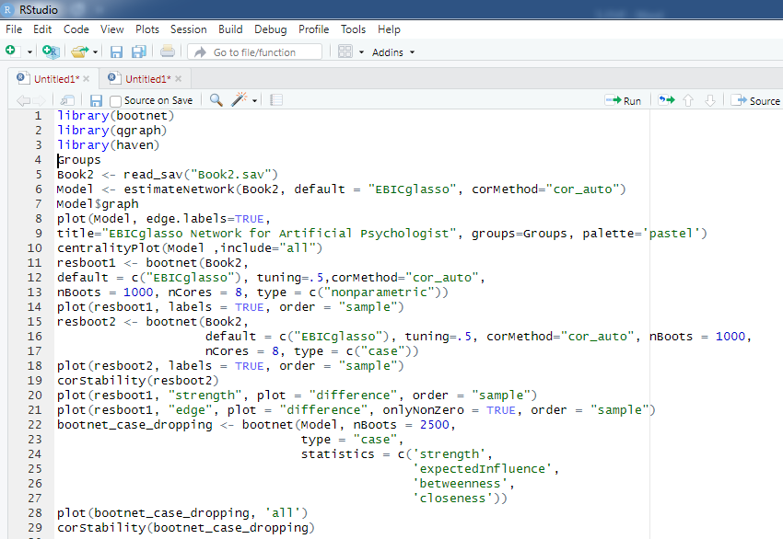

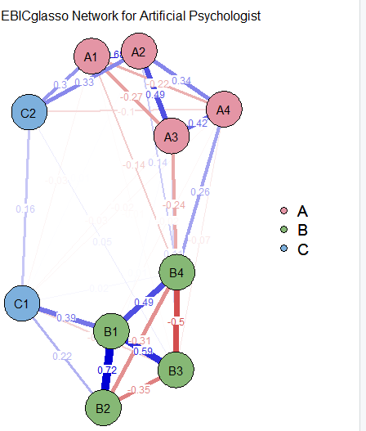

- The network plot of 3 networks (A, B, &C)

In network analysis diagrams, blue edges show positive relationships and red edges show negative relationships, and the thickness of each edge shows its strength.
The result of the analysis of this network in figure 5.8 showed that the highest strength is related to nodes B1 and B2, which have the most effect in the network and show that B4 is the bridge node between network B and network A, and also C1 is the node that links network B and C and C2 is the node that connects network C and A.
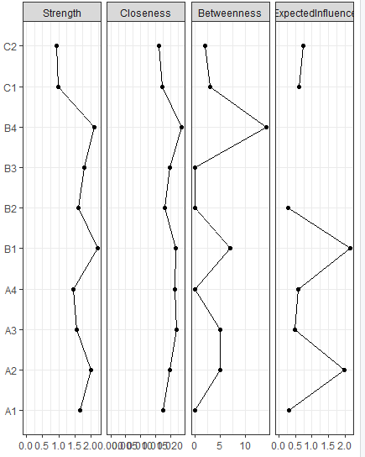
- The network plot for centrality indices

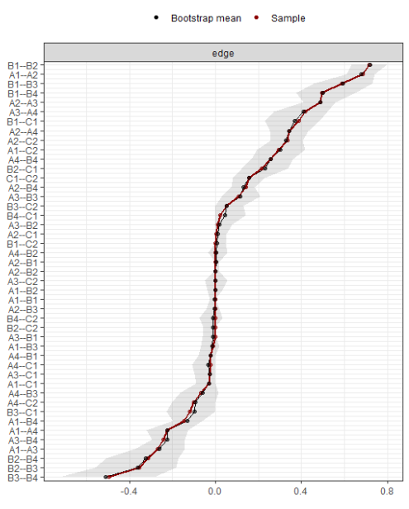

- The network stability
In Figure 5.9 the strongest positive connection in network A is between A1 and A2 and the strongest negative connection in network B between B3 and B4 and the strongest positive relationship can be seen in that network between B1 and B2.
The plot in Figure 5.9 also checks network stability. This graph shows the results of the samples obtained by the bootstrapping method from 1000 samples with the results of the main sample used in the network analysis and shows that there is stability of the edges. The path of red dots (resulting from the original sample) and black dots, which are the average edges between nodes in the bootstrapping method, correspond to a great extent, and the grey area around the two lines of the graph indicates the 95% confidence interval resulting from bootstrapping. As you can see, some edge weights, particularly those in the middle which are smaller in absolute value, are more accurate than other edges, having smaller areas of grey. Also, this diagram shows how most of the edges are close to zero, that is, most of them intersect the 0 (zero) point in the bootstrapping samples.
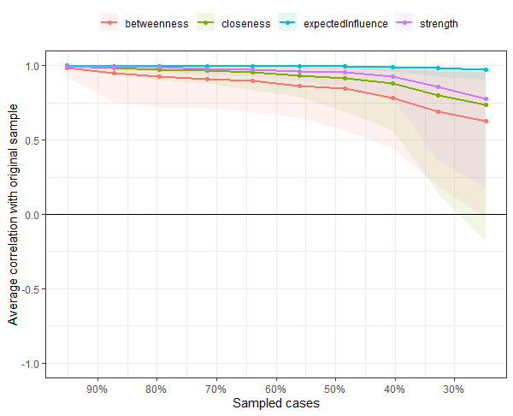
- R results for the average correlation between each of the four centrality indices and the correlation among nodes. .
Figure 5.10 shows the average correlation of the original sample with 1000 bootstrap samples between each of the four centrality indices. , This graph shows the robustness of these correlations to reduced sample size by looking to see whether the average correlation between the 4 centrality indices will be the same and will remain constant when dropping cases. This plot suggests the average correlation is robust to sample size..
Figure 5.11 shows the negative or positive connection of edges between the nodes.
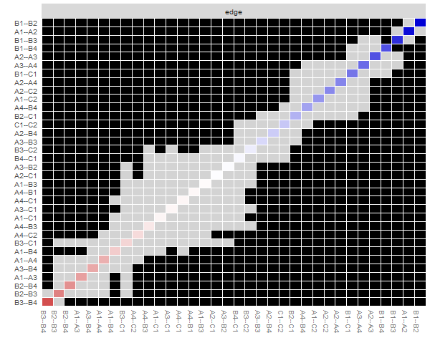
- The correlation among nodes (a red square signifies a negative node and a blue one shows a positive edge).

To avoid subjective error in viewing the graph by eye, Epskanp et al. 2018 invented a statistical index called a correlation-stability coefficient (c-s), which was explained in the previous sections of this chapter.
This index shows the average percentage of the sample that can be dropped to maintain a specified correlation of, for example, r=0.7 between the central indices of the sample and the central indices obtained from Case-dropped bootstraps. r=0.7 is not a fixed number and can be changed. If by dropping a large number of cases from the main sample, the correlation between the centrality indices is still high, it can be said that the network nodes are not affected by the characteristics of the sample and it is believed that they will show stability in the population.
This coefficient should not be below 0.25 and preferably above 0.5 (Epskanp, et al, 2018). It can be said that the result of this analysis indicates a favorable interpretation of centrality indicators, especially for expected influence and strength.
You can see Figure 5.12 which shows the adjacency matrix for each node in the output of R software. This figure represents the covariance of the node, which is considered to be the same as the adjacency matrix.

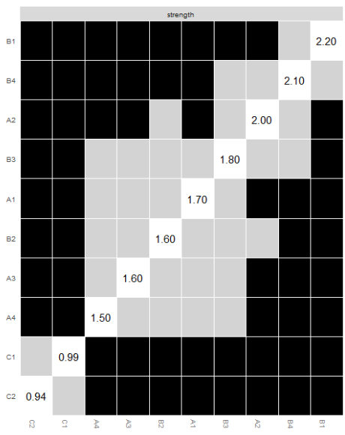
Adjacency matrix

- R results for adjacency matrix


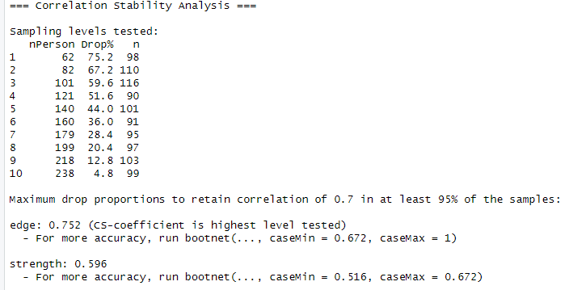

- R results for the correlation stability

The correlation shown by the correlation-stability coefficient (c-s) is higher than 0.5 in the case of the 2 indicators of Closeness and Strength, and only the case of betweenness is below 0.5. Among these indices the most important correlation-stability coefficient (c-s) is the one for Strength (Figure 5.13).
A permutation test is used to find out if there is a difference between measures obtained from a global network and one using centrality indices. For this purpose, two samples are needed. In this example, the investigated sample (n=250) is randomly divided into two parts. It is better to choose two different samples from the same community. The artificial psychologist then decides to compare the most important index under investigation, which is strength, in 2 groups using 1000 bootstrap iterations. . The p-value indicates the difference in this index between the two parts of the sample. The results show that there is no significant difference between the measure of strength in the 2 parts of the sample. In this example, the investigated network has 10 nodes named from C1 to C10.

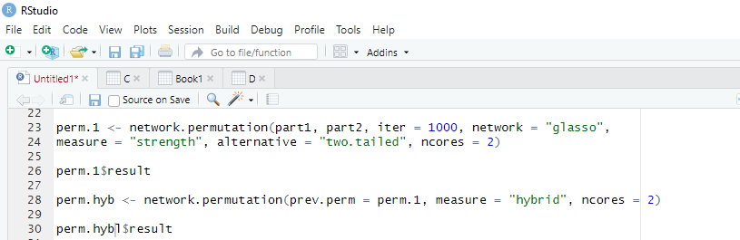
- R code for Permutation test

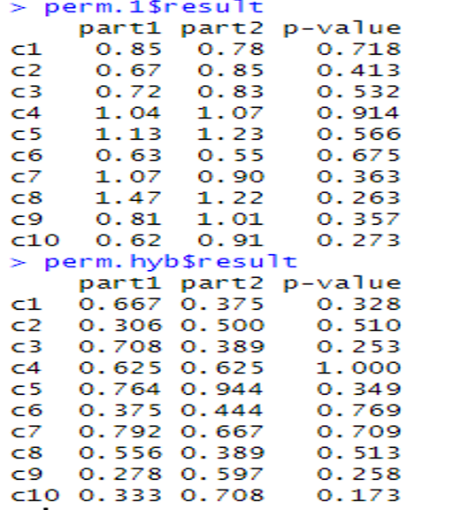

- R results for permutation test

Example2.
An artificial psychologist decides to use network analysis to examine the relationship between different nodes. She examines many cognitive variables. For this purpose, she measures the components of attention, cognitive control, and cognitive regulation of emotion in adolescents. (The data of this research is obtained from the research of Farahani, Azadfalah and Yousefi, 2022). She measures cognitive variables including attention and response speed. (Table 1) shows their abbreviations and general descriptions.

- R code for post hoc network analysis


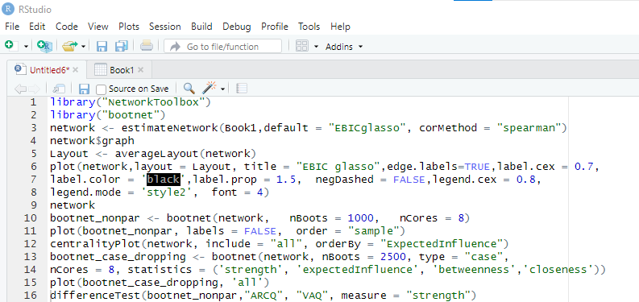

In R software there is are libraries named networktoolbox and bootnet which enable this type of analysis (listing 3). We call this exploratory network analysis a post hoc network analysis.

- Abbreviation and general description of the variables
Abbreviate | Description
AAQ | Combination of Vigilance, Focus, and Speed (Auditory)
VAQ | Combination of Vigilance, Focus, and Speed (Visual)
QVIA | Vigilance  Measure of inattention as evidenced by two different types of errors of omission(Auditory)
QVIV | Vigilance  Measure of inattention as evidenced by two different types of errors of omission (Visual)
QFOCA | Total variability of mental processing speed for all correct responses during the test (Auditory)
QFOCV | Total variability of mental processing speed for all correct responses during the test (Visual)
QMNA | Average reaction time for all correct responses (Auditory)
QMNV | Average reaction time for all correct responses (Visual)
SAAQ | Global measure of ability to respond to stimuli under low demand conditions accurately, quickly, and reliably (Auditory)
SVAQ | Global measure of ability to respond to stimuli under low demand conditions accurately, quickly, and reliably (Visual)
ARCQ | Combination of Prudence, Consistency, and Stamina (Auditory)
VRCQ | Combination of Prudence, Consistency, and Stamina (Visual)
QPRA | Measure of impulsivity (Auditory)
QPRV | Measure of impulsivity (Visual)
QCONA | Measure of ability to stay on task and sustain a reliable effort (Auditory)
QCONV | Measure of ability to stay on task and sustain a reliable effort (Visual)

She then estimates the network using the EBicglasso algorithm which uses the LASSO method to produce a parsimonious network. Figure 5.15 shows the relationship of each node with other nodes. The centrality indices are shown in Figure 5.16. The 3 columns show the Closeness, Betweenness and Expected influence of each node in the network. As seen in this Figure VAQ and AAQ have the highest strength in the network. VAQ and AAQ also have relatively large numbers of thicker edges linking them to other nodes. The lowest strength is related to qPRA.
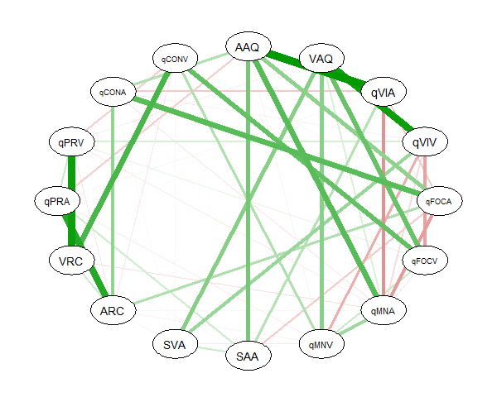

- The relationships of the nodes

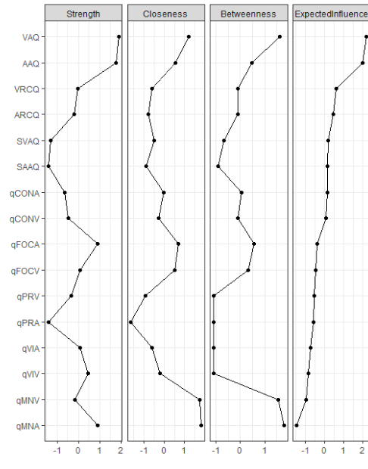

- The centrality indices for each node.

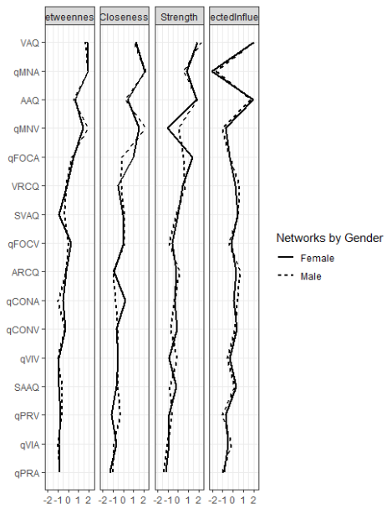
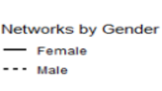

- R results for networks categorized by gender

This researcher who is interested in artificial psychology, decides to compare two networks based on the sex of teenagers. It is, therefore, necessary to design a network for male teenagers and a separate network for female teenagers. Thecentrality indices of the boys’ and girls’ networks are able to be compared using the compareCentrality command in the R code in listing 4-5. . As can be seen, there is a difference between the girls (dashed line graph) and the boys (solid line graph) (Figure 5.17).


- R code for comparing 2 network analysis

- (Continued)R codes for comparing 2 network analysis

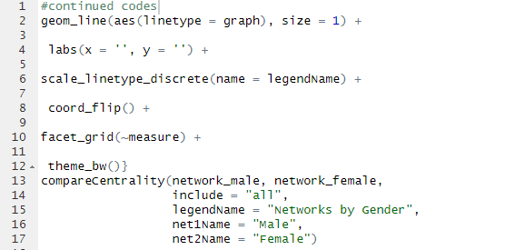

One of the interesting features of network analysis is finding communities based on the relationship between nodes. This is an exploratory method. As the output of the software shows, 3 communities have been extracted in which there are no shared nodes, which means that a number of communities are created that are independent of each other (listing 6).

Listing 6 R codes for Discovering communities using network Analysis

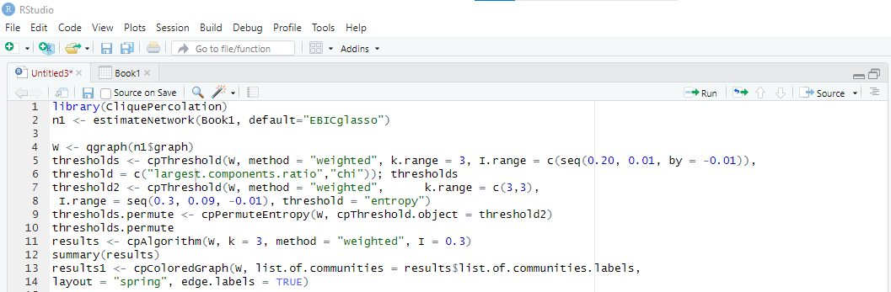

Community1: AAQ, qVSI, qFOCA ,qMNA, SAA, ARC, qCONA
Community2: VCR, qPRV,q CONV
Community3: VAQ, qVIV,qFOCA,qMNV,SVA
In this exploratory analysis, which extracts communities based on the connection of nodes, there is only one separate node from the rest, qPRA (Figure 5.18).

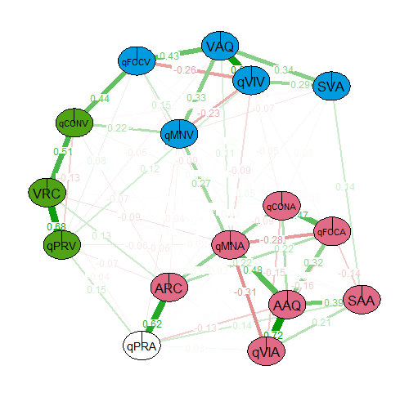
- R results for networks analysis for discovering the communities

. The first community in the network diagram, community 1, is marked in blue , community 2 is marked in green and community 3 is marked in pink with a single isolated node. It is shown in white in the diagram.

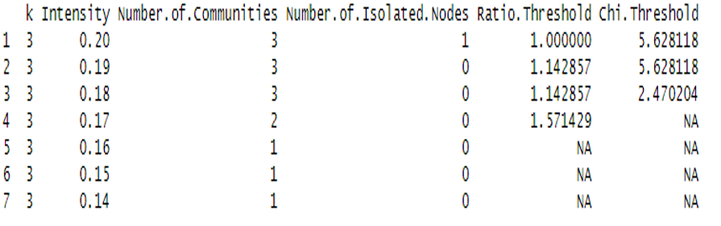

- The results of discovering the communities using the network analysis
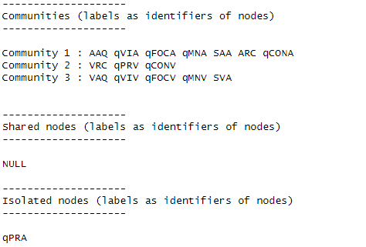

- The results of discovering the communities (K=3, I=0.2).

To run the clique percolation algorithm for weighted networks, we initially need to optimize k and I. In order to do this, the cpThreshold function can be used. By default, this function provides the communities, shared nodes, and isolated nodes with labels as identifiers of the nodes. As we can see, the results indicate that 3 communities have been discovered with qPRA as an isolated node. We run this analysis using k equal to 3 and I taking values of 0.20 to 0.01 in steps of 0.005 .There is no shared node. It is also possible to use the numbers as identifiers of the nodes or to restrict the output. The range of I values was chosen based on the mean edge weight of the network and it was set to 0.3 when generating the network. Thus, I=0.40 should allow the artificial network to find a broad range of community sizes. However, Farkas et al. (2007) recommended starting the analysis by setting the highest tested value of I to the maximum edge weight in the network.

Example 3. An artificial psychologist is going to determine the sample size for implementing network analysis. Based on the initial network, He knows the network has 10 nodes and he supposes the density is 0.4. The network density implies the proportion of present edges in the network which impact on the required sample size (Constantin, Schuurman, & Vermunt,2022). He includes the measure value equal to0.6. This measure is similar to effect size. We use a statistic value of 0.8. This measure is similar to the statistical power. Listing 7 indicates the R code for for determining the appropriate sample size to analyze a GGM network with 10 nodes and a density of 0.4.
- R codes for determining appropriate sample size to analyze a GGM network
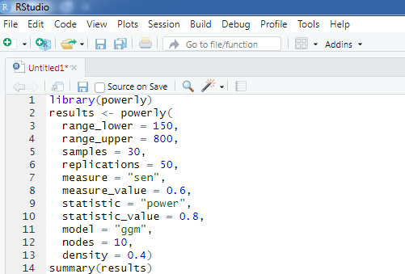

A higher density value implies that more of these pairwise connections will be present in the network. Figure 5.21 show the results.

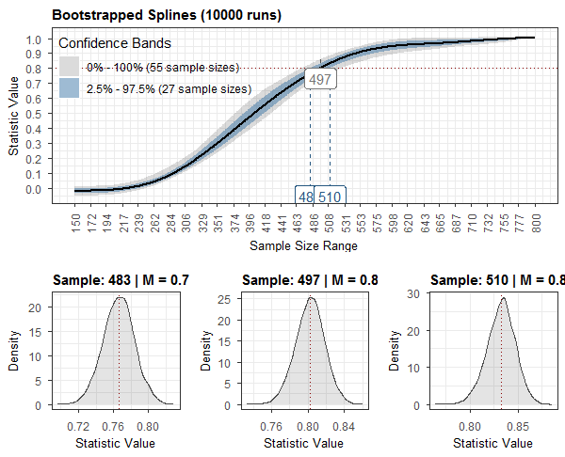

- The results of powerly package for determining appropriate sample size

The horizontal red dotted line illustrates the desired target for the statistic (0.8), and the vertical red dotted line shows the mean (0.8) of the bootstrapped statistics for the median sample size of 497. The horizontal blue dashed lines indicate the lower and upper bound sample sizes based on the 95% CI. The CI was constructed using the percentile method (Diciccio & Romano, 1988) based on 10000 bootstraps.
Box plots, provide a representation of how much the performance measure varies for each sample size based on the number of replications performed.
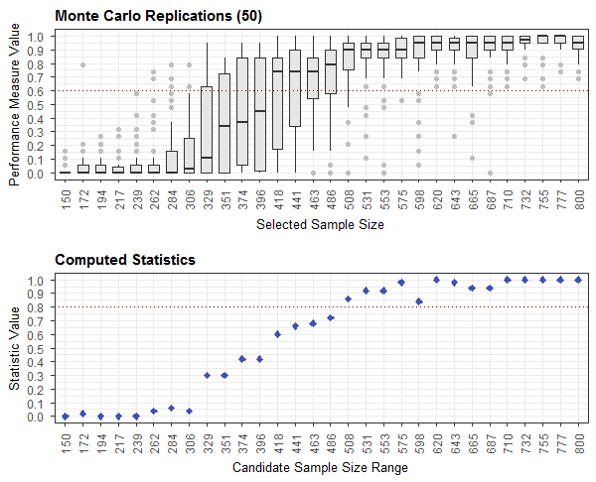
- The results of Box plot and Statistic value
Figure 5.22 indicates the performance measure values obtained from the Monte Carlo replications (Box plot) and the curve line shows the values for the statistic computed on the performance measure values and the monotone spline used to interpolate the statistic across the entire candidate range of sample sizes. A sample size of about 500 is suggested based on both of the above plots.

Paul Broca
Carl Wernicke

