Manual for Skin Conductance Response (SCR) measure in the 3T scanner at the CBU
By Iole Indovina (February 2008)

Introduction
This manual specifically describes the SCR (also named Galvanic Skin Response, GSR) setup in the 3T scanner at the CBU. For information about the theory behind the SCR technique you should refer to Barney Dunn’s manual (July 2006) which includes important references. The majority of information is duplicated from this manual, except for the differences in the scanner setup and a description of software problems in interfacing with the parallel port.
Helpful support documents are on the BIOPAC website (http://biopac.com/)

SCR setup in the scanner

- MECMRI MP150 transducer, Amplifiers (Galvanic skin response module GSR 100C, insulation module STP100C, and the ECG module, all interconnected to form a unique block and positioned in the scanning room near to computer 3 console), Biopac MECMRI-3 and MECMRI-1 leads, LEAD109A/108, dry disposable electrodes EL509, Biopac electrolyte (gel 101). To order them, FAX: 805-685-0067, 42 Aero Camino, Goleta, CA 93117, Phone assistance: 805-685-0066, Web: www.biopac.com.
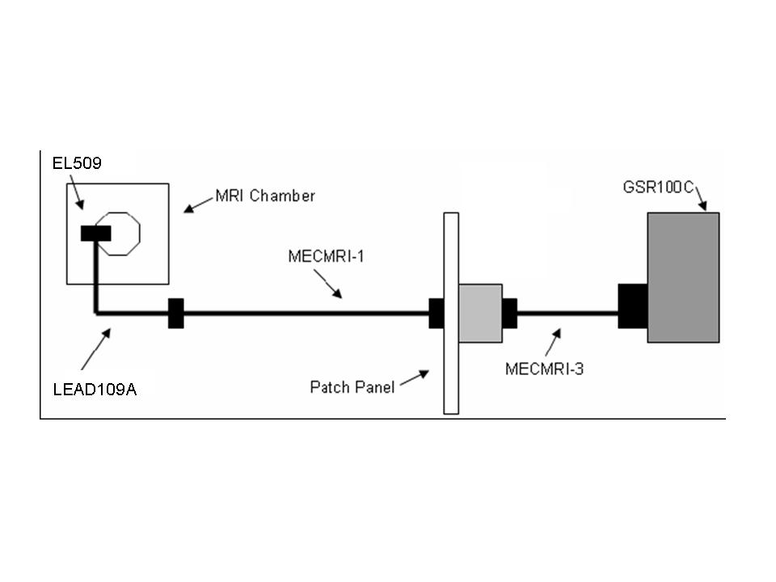

- Computer to deliver the stimuli (computer 3 in the scanning room), connected with the insulation module (STP100C) through the parallel port.

- Laptop to acquire the SCR (with the AcqKnowledge software version 3.9.1) connected to the MP150 transducer through the Ethernet cable.

SCR is measured through 2 Biopac EL509 dry disposable electrodes that must be spread with Biopac electrolyte (gel 101) and positioned on the left hand palm (so that the subject can perform the behavioural task with the right hand).
The electrodes inside the scanner room are connected though the MECMRI-3 lead to a filter box (on the left wall inside the scanner room). The connection lead MECMRI-1 on the right wall under the table in the scanner console room goes to the GSR 100C.

Digital and analogical (SCR) signals are sent to the Biopac MP150 transducer and then to the acquisition laptop (AcqKnowledge 3.9.1).
The digital and analogical channels must be setup on the AcqKnowledge template (MP150 -> setup acquisition) (see below, Setting-up the template in AcqKnowledge).
In particular the analogical channel number must correspond to the pin number selected on the top of the GSR 100C.

Before starting the measure, participants should wash their hands without soap.
We advise to wait 10-15 minutes before starting to record the SCR in order the signal stabilize.

Galvanic skin response module (GSR 100C)

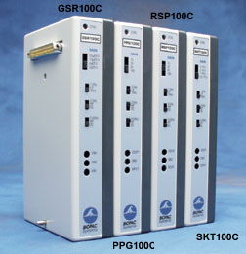

GSR 100C setup
The GSR 100C has a number on settings that allow you to adjust gain and filtering.

We usually select on the GSR 100C:
Gain = 5 micro-mho/V
Low Pass filter (LP) = 1Hz
High Pass filter (HPs) = both to DC

A gain of 5 micro-mho/V means you are interested in a signal between 0 and 50 micro-mhos, while a gain of 10 micro-mho/V means you are interested in a signal between 0 and 100 micro-mhos (the system measure 10 V maximum).

Before you start the measure you should check that these values have not been changed by other users. It is extremely important to use consistent amplifier settings.

The GSR 100C applies a constant, imperceptible voltage (0.5 V) between the two electrodes attached to the skin. Since the voltage is constant, the current flowing between the electrodes is proportional to the skin conductance (G), or inversely proportional to the skin resistance (R).
The GSR 100C is able to detect the current flowing between the electrodes and convert it to a voltage that can be recorded. Using the gain factor selected on the GSR 100C (i.e. gain=5 micro-mho/V), the recorded voltage is easily converted into micro-mho (known as microSiemens, μS) through this formula:

G (μS ) =gain (μS /V) *Vrecorded (V).

GSR 100C specifications:

Gain: | 20, 10, 5, 2 µsiemens/volt (i.e. µmhos/volt)
Low Pass Filter: | 1 Hz, 10 Hz
High Pass Filter: | DC, 0.05 Hz, 0.5 Hz
Sensitivity: | 0.7 nano-siemens (with MP System)
Constant Voltage Excitation: | Vex = 0.5 VDC
Output Range: | ±10 V (analog)
INPUT SIGNAL RANGE
Gain | Range (µmho)
20 | 0-200
10 | 0-100
5 | 0-50
2 | 0-20
Note: Normal human range is 1 20 µmho.
Unit Note—BIOPAC software calculates SCL/SCR in µmho, the traditional unit of conductance. Micromho (µmho) is interchangeable with the alternative microsiemens (µS). To use Ohm, the traditional measure of resistance, convert as 1 µmhos equals 1,000,000 ohms.

Insulation module (STP100C)

The visual-audio stimulation program must send digital markers of each events and their duration through the parallel port to the STP100C.
The STP100C is used to safely isolate digital inputs and outputs to and from the MP150 System.

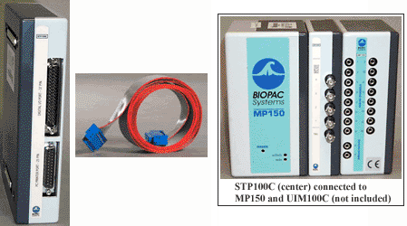

Starting the equipment

Computer 3 and the SCR equipment are turned on by the Radiographer at the beginning of the day.

Connect the laptop to the Ethernet cable coming from the wall (labelled “Biopac Socket”, on the right of the monitor of computer 3 in the scanner console room). This cable is connected through a fixed crossed Ethernet cable to the MP150.
Turn it on and start AcqKnowledge3.9.
Open your template. If the communication with the MP150 is correct a green “start” button will appear at the bottom right corner of the template.

ERRORS.
If there is a problem with the communication, restart the laptop after having verified that you connected the Ethernet cable.
On the provided laptop there are 2 version of AcqKnowledge. Be sure that you started
AcqKnowledge3.9.1 (the one interfaced with the MP150) and not the old AcqKnowledge3.7.

Running AcqKnowledge.
To start the session SCR recording, push the start green button at the bottom right corner of the template.
Use Display -> auto-scale waveform, to better visualize the signal.
Use Display -> auto-scale horizontal, to modify the time scale.

Signals are displayed in Volts, which can be converted into micro-Siemens through the conversion factor (the gain, i.e. 5 micro-mho/V). SCR should be in the range of 1-20 micro-siemens (micro-mhos).

At the end of the SCR recording period (data acquisition) push stop button at the bottom right corner of the template.
Save the data with a unique filename. Be very careful not to overwrite your data before you saved them. Save two files for each measure: one in ACQ format, and another one in txt format (useful for analysis with software different from AcqKnowledge.)

Setting-up the template in AcqKnowledge
- Open a blank AcqKnowledge file.
- Go to MP150 –> set-up channels –> analogue, and enter the physiology channel you are recording. The numbers correspond to the red switches on the top of each amplifier. Check all three boxes for each channel you wish to record and give it a sensible name (e.g. scr).
- Go to MP150 -> set-up channels –> digital and enter the digital marker signals you wish to record. The numbers correspond to the pin you are writing out to on the parallel port. Again, check all three boxes of each channel and give it a sensible name (e.g. the name of the event in your task).
- Go to MP150 -> set-up acquisition. Select ‘record once save to disk’. Enter your sampling rate (200 is sufficient for SCR; the rule is to record at a sampling rate two times higher than your maximum frequency of interest). Enter how long you want to record for (specifying units also). In general, set this much longer than your task will last – you can always stop it mid recording.

Programming your task:

Issues with the parallel port.

Issue with access to the parallel port.
A problem with Windows NT/2000 and Windows XP, is its strict control over I/O ports. Unlike Windows 9x & ME, Windows NT/2000/XP will cause an exception (Privileged Instruction) if an attempt is made to access an IO port that a user-mode program is not privileged to talk too. Actually it's not Windows that does this, but any 386 or higher processor running in protected mode.

PortTalk is installed on computer 3 in the scanning room and allow access to the parallel port.
The file PortTalk.sys is in /windows/system32/drivers (as it is on disk C, it will be deleted if the computer 3 is upgraded).
To start your stimulus presentation program (Matlab in this example) you have to use the following command on computer 3

C:\Program Files\PortTalk>AllowIO /a c:\MATLAB701\bin\matlab.exe

On computer 3 there are shortcuts on the desktop to start both Matlab (AllowIO_Matlab) and VisualBasic (AllowIO_VB) with AllowIO. If you want to use E-prime or some other programs for the stimulus delivery, you can create your own shortcut.

Issue with the parallel port and timing.
It is also necessary that you check the delay introduced in sending a signal to the parallel port by the command line in your program.
For example, using cogent (in Matlab), we found a delay of about 100 ms.
Depending on when you send signals to the parallel port (i.e whether you ‘mark’ stimulus onset, offset etc) you may end up introducing this delay into the onset or offset of your stimuli or possibly into the response time measurement.
Rhodri Cusack has written a shared Windows Component (an “ActiveX DLL”) that overcome the delay problem. It is a small tool installed on the stimulus delivery and mimic machines called “CBUParallelPortTool” that replaces the functionality of Cogent’s “outportb” but operates more quickly.

To initialise the object…
From VB: Go to Project>References and tick CBUParallelPortTool
Put at the top of your program:
Dim objPP as New CBUParallelPortTool.ParallelPort
From Matlab:
Put at the top of your program:
PPObj = actxserver('CBUParallelPortTool.ParallelPort');

There are two commands…
WriteToPort
Purpose: Writes a single value to a port
Syntax: WriteToPort([portnumber],[value])
Example from Visual basic: objPP.WriteToPort(888,123)
Example from Matlab: invoke(PPObj,'WriteToPort', uint16(888),uint16(a)); % where 888= hexadecimal 378, usually the parallel port
ReadFromPort
Purpose: Reads a single value from a port
Syntax: out=ReadFromPort([portnumber])
Example from Visual basic: myvalue=objPP.WriteToPort(888,123)
Example from Matlab: value = invoke(PPObj,’ReadFromPort’, uint16(888));

Here is an example in Matlab:

%%%%%%%%%%%%%%%%%%%%%%%%%%%%%%%%%%%%%%%%%

PPObj = actxserver('CBUParallelPortTool.ParallelPort');

tic
a=bin2dec('0001');
for i=1:10000
value = invoke(PPObj,'WriteToPort', uint16(888),uint16(a));
end;
toc

release(PPObj);

%%%%%%%%%%%%%%%%%%%%%%%%%%%%%%%%%%%%%%%%%

NOTE.
Cogent provides the program UserPort to allow access to the parallel port.
Userport behaves strangely on machines with 2 CPUs, or a dual core CPU, or even a Pentium-4 with Hyper-threading turned on in the BIOS (which emulates 2 CPUs)

It is recommended to use PortTalk instead of UserPort.

