GOGNESTIC 2022: Structural MRI analysis using Freesurfer

This document includes a subset of the Freesurfer tutorials which we will cover during GOGNESTIC. The full official Freesurfer tutorials are available here:

https://surfer.nmr.mgh.harvard.edu/fswiki/Tutorials

Before you get started
- Install freesurfer: https://surfer.nmr.mgh.harvard.edu/fswiki/DownloadAndInstall

- Download tutorial data: https://surfer.nmr.mgh.harvard.edu/fswiki/FsTutorial/Data

- From https://imaging.mrc-cbu.cam.ac.uk/methods/COGNESTIC2022 copy the scripts:
FS_check_location.sh
FS_visualising_output.sh
FS_group_analysis.sh
FS_RO_analysis.sh
to the tutorial_data root directory containing the extracted freesurfer tutorial data. To confirm you have done this correctly, navigate to the directory where you have placed the FS scripts and run FS_check_location.sh by typing the following from the command line:
./FS_check_location.sh
If all is set up correctly you should see the following directories (amongst others):
buckner_data fsfast-functional
long-tutorial diffusion_tutorial

Introduction to Freesurfer Output
In this section you will visualize and inspect correctly processed output data so that you can become familiar with what the end product should look like. The tutorial will take you through a variety of outputs, but is not necessarily the recommended procedure to take when trying to verify each subject for a real study. Some outputs are only necessary to check when troubleshooting, for example. However, it is a good idea for new users to become familiar with the variety of outputs and how to view them.

Preparations
To follow this tutorial exactly be sure you've downloaded the freesurfer tutorial data set before you begin. If you choose not to download the data set you can follow these instructions on your own data, but you will have to substitute your own data paths and subject names. These are the commands that you need to run before getting started:
<source_freesurfer>

setenv TUTORIAL_DATA <path_to_your_tutorial_data>
setenv SUBJECTS_DIR $TUTORIAL_DATA/buckner_data/tutorial_subjs
cd $SUBJECTS_DIR
The commands used for this section during the COGNESTIC live demo can be found on the script:
FS_visualising_output.sh
Information on how to source FreeSurfer is located here.

Viewing Volumes with Freeview
With one Freeview command line, you can load several output volumes, such as brainmask.mgz and wm.mgz; the surfaces, rh.white and lh.white; and the subcortical segmentation, aseg.mgz. Copy and paste the command below inside the terminal window and press enter:

freeview -v \
good_output/mri/T1.mgz \
good_output/mri/wm.mgz \
good_output/mri/brainmask.mgz \
good_output/mri/aseg.mgz:colormap=lut:opacity=0.2 \
-f good_output/surf/lh.white:edgecolor=blue \
good_output/surf/lh.pial:edgecolor=red \
good_output/surf/rh.white:edgecolor=blue \
good_output/surf/rh.pial:edgecolor=red
NOTE: The backslash allows you to copy and paste multiple lines of code as one command (otherwise, separating the command onto different lines tells Linux they are different commands to be run separately). We use the backslash throughout the tutorials to display the commands in a more easy-to-read manner, while still allowing you to copy and paste. When you are done with the course & do not need to copy and paste from the tutorials, the backslash is not necessary to make the command work.

Some notes on the above command line:
- good_output is the name of the subject
- The flag -v is used to open some of the most commonly used volumes including:
  - brainmask.mgz : skull-stripped volume primarily used for troubleshooting
  - wm.mgz : white matter mask also used for troubleshooting
  - aseg.mgz : subcortical segmentation loaded with its corresponding color table and at a low opacity. For more information on the subcortical segmentation, see here.
- The flag -f is used to load surfaces
  - white & pial surfaces are loaded for each hemisphere & with color indicated by 'edgecolor'
After hitting enter, a Freeview window should open showing you the outputs you specified:
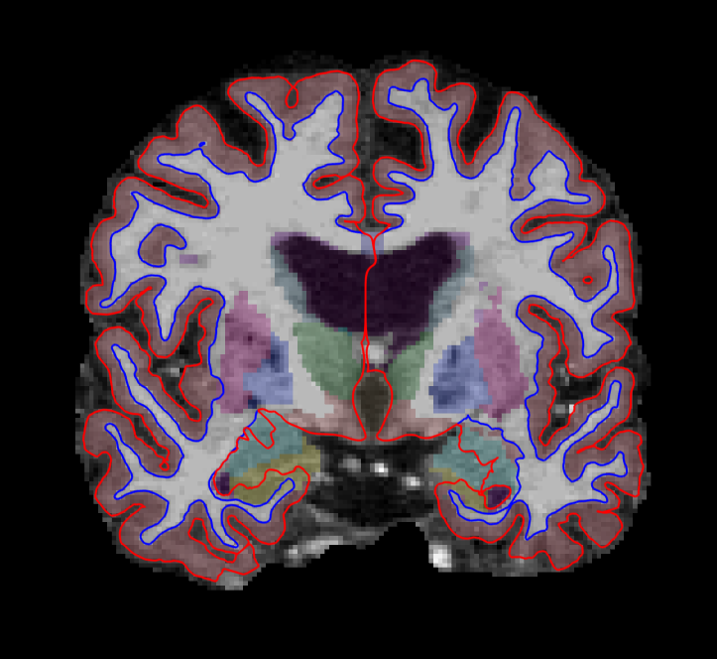
The menu on the left shows which files have been loaded.
Use the 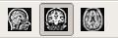buttons at the top to change which orthogonal view appears in the main viewing window. Let's go with coronal for now. You can also use the 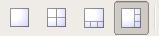buttons to change the organization of the viewing panes. To change which brain slice you are viewing, use the 'Page Up' or 'Page Down' keys on your keyboard or the up and down arrows. (Mac users: press the fn key while using the up and down arrows.)
While Freeview can load many volumes at once, you cannot necessarily see them all at once. You are able to see whichever volume is at the top of the list in the menu on the left. An exception to this are volumes such as the wm.mgz and aseg.mz which can be made translucent, allowing you to view the information they contain simultaneously with the volume directly below it on the list. For example, you are currently seeing information from both the aseg (labeled structures) and the brainmask (voxel intensities).
You can hide or turn off a layer by unchecking the check box next to the layer name. Try this out - uncheck the box next to 'aseg'. Now you can see just the brainmask. You can also use the up and down arrows (located below the menu on the left) to move the aseg down on the list, below the brainmask (try it!). Let's now move the wm volume to the top of the list but instead of using the arrows, try this shortcut: double click on where it says 'wm'. It should automatically move to the top. The menu should now look like this:
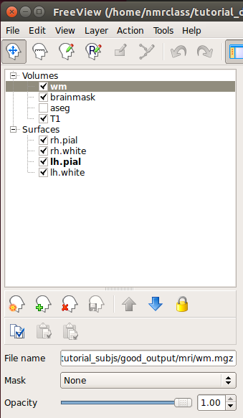
and the viewing window should look like this:
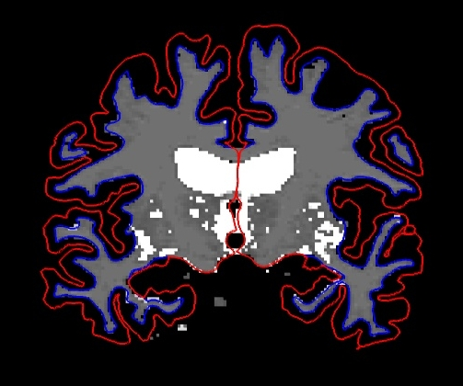
- Keyboard Shortcut: Alt+c will allow you to quickly cycle through all the layers. Every time you hit it, the volume at the top of the list will move to the bottom of the list. Mac users, all Freeview keyboard shortcuts are located here.
When the Navigation button is chosen, you can move the image in the viewing window around by holding down the middle mouse button and dragging the mouse where you want the image to go. Try it out. To zoom, scroll with the middle mouse button. In this navigation mode, notice the cursor (little red crosshair) moves to wherever you left click. When you change the orientation (to axial or sagittal), you will be viewing the slice that intersects with the cursor's location. To illustrate this point, if you are in the viewing pane selected here:
You'll notice all the planes will shift based on where you move the cursor.
One other important thing to note is that any action you do in the viewing window (i.e. erasing, changing brightness, etc.) will take place on whichever volume is currently highlighted in the left menu, regardless of which file is at the top of the list.
Now that you know the basics, you can make your way through the data. To verify that FreeSurfer did a good job, you will want to check:
- Whether the surfaces accurately follow the gray matter and white matter boundaries.
- Whether the aseg accurately follows the subcortical intensity boundaries.

Checking the Surfaces
Double click on 'brainmask' in the left menu to bring it to the top of the volume list. The white surface (blue line) is used to calculate total white matter volume and should accurately follow the boundary between white matter and gray matter. The pial surface (red line) is used to calculate cortical gray matter volume and should accurately follow the boundary between the gray matter and the CSF.
As you scroll through the slices checking the surfaces for accuracy, keep in mind that you are looking at a 2-dimensional rendering of a 3-dimensional image - be sure to look at more than just one view (i.e., sagittal, coronal and horizontal). You can turn the surfaces off and on by checking and unchecking them in the left menu under where it says 'Surfaces'. As you do this, ask yourself: would you draw the boundary in the same location?
- Keyboard Shortcut: Alt+f will turn on and off whichever surface is highlighted in the menu window.
To help verify accuracy, adjust the brightness and contrast so you can easily identify the shift in intensity between gray and white matter. To do this, left click on the image while holding down the 'Shift' key and drag your mouse. (Make sure the brainmask volume is highlighted in the left menu in order for this to work.) The other way to do this is via the 'Window' and 'Level' sliders underneath the left menu.
There are regions where the surfaces are not intended to be accurate that you should be aware of:
- Areas around the hippocampus and amygdala. The surfaces will not completely include or exclude certain subcortical regions. These inaccuracies can be ignored as subcortical regions are excluded from the cortical measures and subcortical volume is measured by the aseg, not the surfaces.
  - For an example of this, scroll to coronal slice 128 (slice numbers appear in the upper right hand corner of the viewing window).

Subcortical Segmentation
Uncheck all of the surfaces. Then check the box next to the aseg volume and double click it. The aseg volume will jump to the top of the left menu, above the brainmask volume.
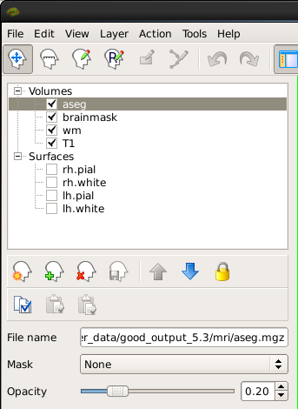
This will show the complete segmentation of the subcortical structures.
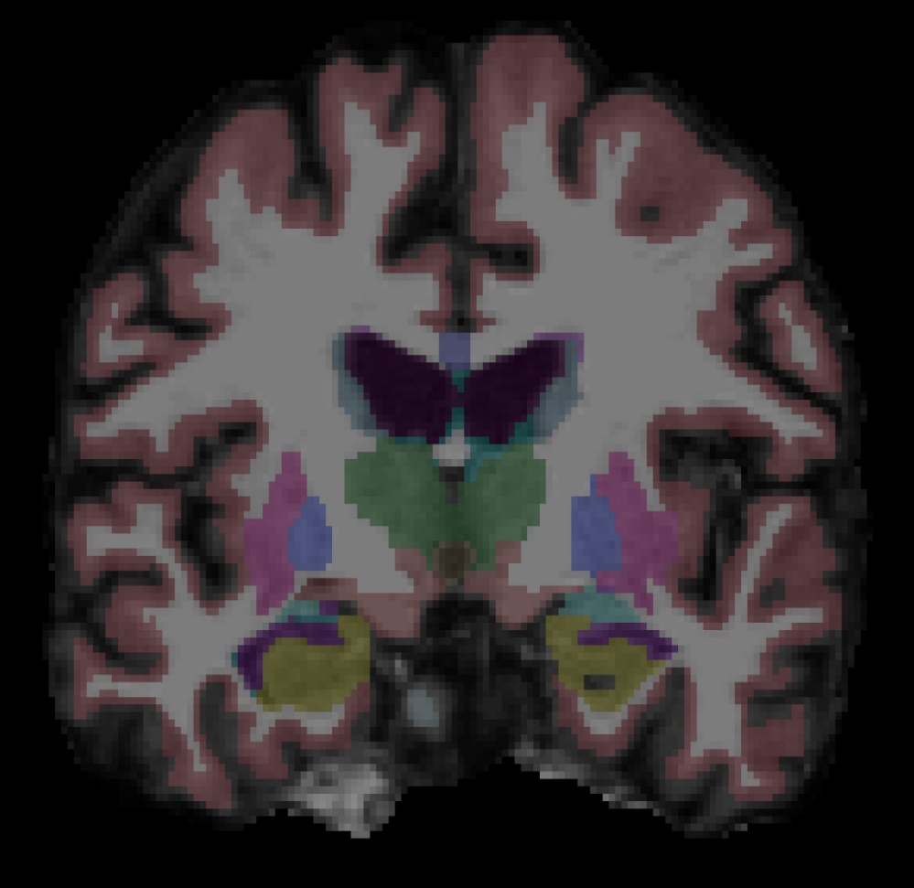
Each structure is labeled with a unique color/number distinction. If you click on a voxel the structure's name and number label will be shown in the 'Cursor' section under the viewing window next to the word, 'aseg'. If you hover over a voxel where the cursor is not located, the value of that voxel will appear under the 'Mouse' section.
- Keyboard Shortcut: Alt+v will turn on and off the layer that is currently highlighted.
Make sure 'aseg' is highlighted in the left menu and press Alt+v to turn it off and on. While doing this, make sure the aseg is accurately following the underlying intensity boundaries of each structure. You can also adjust the 'Opacity' slider to better see the underlying brainmask.
- Keyboard Shortcut: Alt+a and Alt+s will change the opacity of the layer that is currently highlighted.

Other Things To Do in Freeview
Below, we introduce you to other volumes and techniques which are good to be familiar with, especially when troubleshooting.

Skull Strip
Close the aseg. As you scroll through the brainmask volume, notice that there is no skull left in your image. You should also not see any regions of cortex or cerebellum missing from this volume. Bring the T1.mgz to the top of the volume list and toggle between it and the brainmask.mgz volume (Alt+v) to verify that the skullstrip has worked properly. In the TroubleshootingData tutorial, we'll go over what to do if there was a skull strip error.

Intensity Normalization
Scroll through the brainmask volume and notice that the intensity is uniform throughout. You should not see any very bright or very dark spots in the white matter or gray matter. If you click on a voxel in the white matter, you can see that it has been normalized to an intensity of (or close to) 110 (look under the Cursor section next to where it says 'brainmask'). When wm voxels are far from a value of 110, they may be erroneously excluded from the white surface. By "close to," we mean wm voxels have an intensity value of somewhere between 100 and 110. By "far from," we mean wm voxels are between a value of 85 and 100. In the TroubleshootingData tutorial, we'll go over what to do if there is an intensity normalization error.

WM Volume
Recheck all of the surfaces and then double click on the wm volume to bring it to the top of the list. This volume is FreeSurfer's initial segmentation of the white matter (shown in gray) with additions from the automatic topology fixer (in white). This "mask" is the starting point for the white surface which grows out from here and stops at a more accurate location using the intensity gradients in the brainmask.mgz volume as a guide. The wm.mgz can be used to add missing wm voxels or delete voxels that are not white matter but were included in the surface. In the TroubleshootingData tutorial, we'll go over how to do this and when. For now, it will be good to learn how to change the wm mask to a heat overlay for ease of editing. The "heat" setting is used for editing because it allows us to be able to see the underlying anatomy, while still being able to locate inaccuracies in the wm.mgz "mask." You can also use 'Jet' overlay, if you prefer. With wm highlighted in the left menu, take a look at the options next to Color Map and choose 'Heat' or 'Jet'. Then adjust the opacity so you can also see the brainmask underneath (down to around .25). It should look like this:
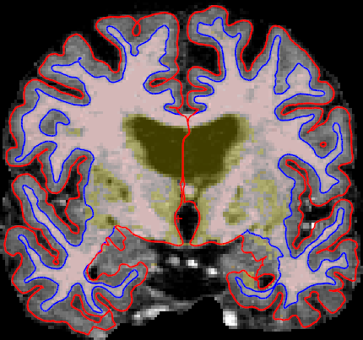
This could have also be done via commandline when first loading the wm in Freeview if we used this command: freeview -v wm.mgz:colormap=heat:opacity=0.25 brainmask.mgz (Note: You don't need to run this command.)
You can now close Freeview by hitting the X on the display window or Ctrl-q.

Viewing Surfaces in 3D using Freeview
We're now going to view several surface overlays. You could view the volumes discussed above and the overlays discussed below all in one Freeview session. They are separated in this tutorial only for simplicity. The examples below are displayed only on the left hemisphere, however, you could also view just the right hemisphere or both hemispheres at the same time. Here are some surfaces you can look at with Freeview:
- pial, white and inflated surface
- sulcal and curvature maps
- thickness maps
- cortical parcellation
You can load them all in Freeview with the command below (be patient while they all load):

freeview -f good_output/surf/lh.pial:annot=aparc.annot:name=pial_aparc:visible=0 \
good_output/surf/lh.pial:annot=aparc.a2009s.annot:name=pial_aparc_des:visible=0 \
good_output/surf/lh.inflated:overlay=lh.thickness:overlay_threshold=0.1,3::name=inflated_thickness:visible=0 \
good_output/surf/lh.inflated:visible=0 \
good_output/surf/lh.white:visible=0 \
good_output/surf/lh.pial \
--viewport 3d

Some notes on the above command line:
- lh.pial:annot=aparc.annot loads the Desikan-Killiany cortical parcellation on the pial surface. lh.pial:annot=aparc.a2009s.annot loads the Destrieux cortical parcellation on the pial surface.
  - :name=pial_aparc:visible=0 changes which name shows up in the menu display and turns off this layer
- lh.inflated:overlay=lh.thickness:overlay_threshold=0.1,3 loads the thickness overlay on top of the inflated surface and sets the min and max thresholds to display
Pial Surface
The first volume you see is the pial surface. The pial surface here is the full 3D representation of the red surface you saw on each 2D slice of the brainmask volume, earlier in the tutorial. The green regions are gyri and the red regions are sulci. With this surface, the sulci are mostly hidden. Feel free to move the inflated brain around by left clicking on it and dragging the mouse. If you would like to put the brain back to its original state, go to View > Reset View, press Ctrl+r, or click the Reset button: 
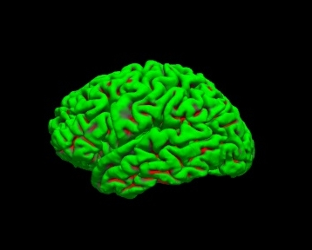
To get rid of the yellow lines being displayed on the surface (corresponding to the 3 slice views), right-click on the surface and check Hide All Slices, or hit Crtl+Shift+s.
White Surface
Press Alt+c to cycle to the white surface.
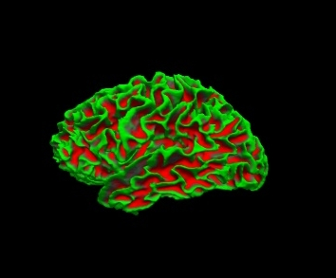
The white surface shows the boundary between white matter and gray matter. It is the 3D representation of the blue surface you saw on the 2D slices of the brainmask. With this surface, we are able to see the sulci a bit better. You can inspect this surface by rotating it around as you wish.
Inflated Surface
Press Alt+c to cycle to the curvature on the inflated surface. With the inflated surface, you can fully see the sulci. If you look at the options next to 'Curvature' in the left menu pane, you can switch it to binary to see the curvature in grayscale. Or switch it to 'off' to see the smooth inflated surface.
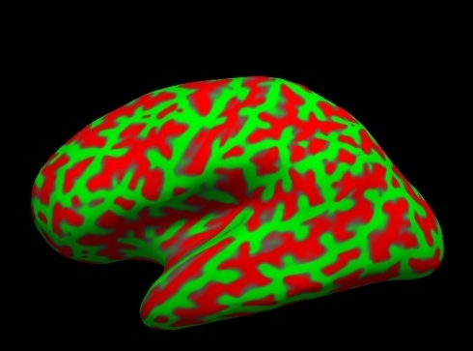
The inflated surface can be helpful to find bumps, holes, or other defects that may need to be corrected. If you click on the inflated surface, you will see the coordinates of the vertex you clicked on in the 'Cursor' window.
Thickness Map
Press Alt+c to cycle to the thickness map on the inflated surface.
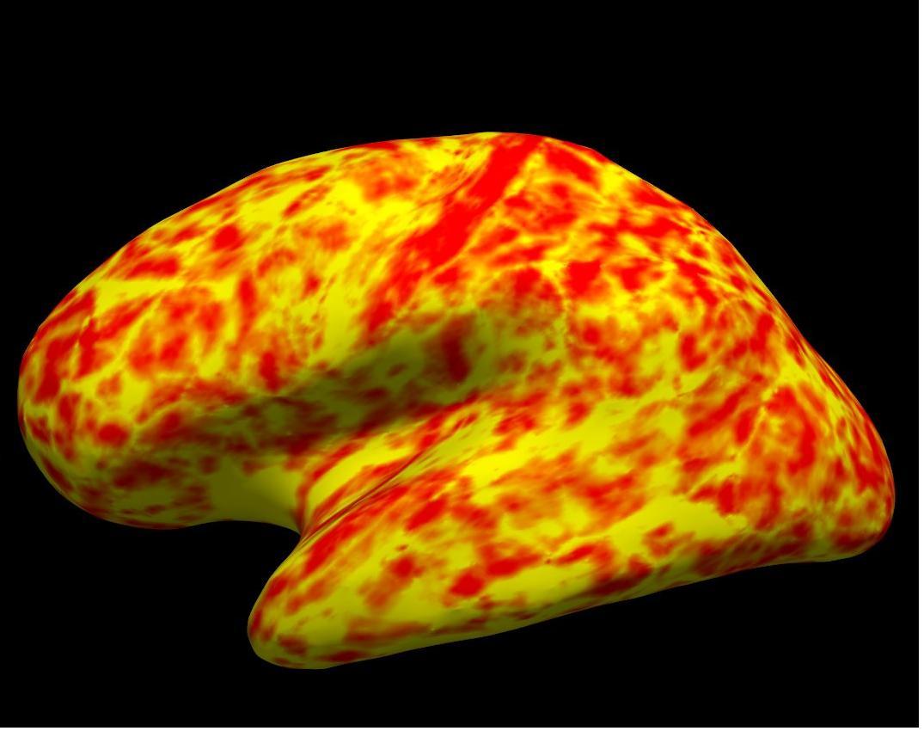
Cortical Parcellation
Press Alt+c to cycle to the cortical parcellations. On the left is the Desikan-Killiany parcellation and on the right is the Destrieux parcellation.
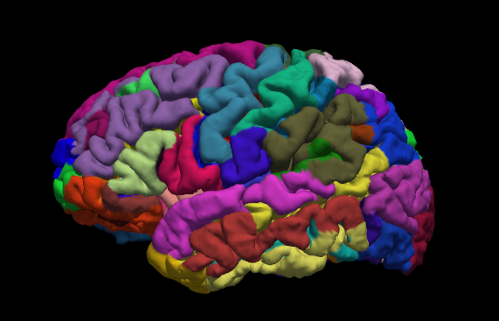
Click on a color and view the name of the cortical region in the 'Cursor' or 'Mouse' windows next to where it says 'aparc.annot'. Rotate the brain so you are looking at the medial wall. Notice that all subcortical gray matter is not a part of the surface labels (because again, those areas do not count towards the cortical surface measures).
By default there are two parcellations that are made when recon-all is run. The two parcellations are the ?h.aparc.annot, created with the Desikan-Killiany atlas, and the ?h.aparc.a2009s.annot, created with the Destrieux atlas. The difference is the number and designation of the areas that are labeled. You can load the Destrieux parcellation by clicking on the drop down box next to 'Annotation' on the left panel and choosing Load from file.... Browse to lh.aparc.a2009s.annot and hit 'Open'.

Summary
By the end of this exercise, you should know:
- How to visualize and inspect FreeSurfer data
- The command to visualize data in Freeview
- What to look for when visualizing data including that surfaces follow the gray and white matter boundaries and that the aseg.mgz accurately follows the subcortical intensity boundaries
- The regions around the hippocampus and amygdala are not intended to be accurate and these inaccuracies can be ignored as subcortical regions are excluded from cortical measures
- Surfaces can be viewed in 3D such as the pial, white, and inflated surfaces, sulcul and cortical maps, thickness maps, and cortical parcellation.
This tutorial was meant as an introduction to Freeview. For information on buttons or menu options not covered here, you can find out about them on the FreeviewGuide wiki.

Surface Based Group Analysis

Preparations
To follow this tutorial exactly be sure you've downloaded the freesurfer tutorial data set before you begin. If you choose not to download the data set, you can follow these instructions on your own data, but you will have to substitute your own specific paths and subject names. These are the commands that you need to run before getting started:
<source_freesurfer>

setenv TUTORIAL_DATA <path_to_your_tutorial_data>
setenv SUBJECTS_DIR $TUTORIAL_DATA/buckner_data/tutorial_subjs/group_analysis_tutorial
cd $SUBJECTS_DIR/glm
The commands used for this section during the COGNESTIC live demo can be found on the script:
FS_group_analysis.sh
Information on how to source FreeSurfer is located here.
If you are not using the tutorial data, you should set your SUBJECTS_DIR to the directory in which the recon(s) of the subject(s) you will use for this tutorial are located.

Introduction
This tutorial is designed to introduce you to the "command-line" group analysis stream in FreeSurfer. While this tutorial shows you how to perform a surface-based thickness study, it is important to realize that most of the concepts learned here apply to any group analysis in FreeSurfer, surface, volume, thickness or fMRI. Here are some useful Group Analysis links you might want to refer back to at a later time:
FSGD Format
FSGD Examples
DODS vs DOSS

This Data Set
The data used for this tutorial is 40 subjects from Randy Buckner's lab. It consists of males and females, ages 18 to 93. You can see the demographics here. You will perform an analysis looking for the effect of age on cortical thickness, accounting for the effects of gender in the analysis.

General Linear Model (GLM) DODS Setup

Design Matrix/FSGD File
In this tutorial, we will model the thickness as a straight line. A line has two parameters: an intercept (or offset) and a slope. For this example:
- The slope is the change of thickness with age.
- The intercept/offset is interpreted as the thickness at age=0.
Parameter estimates are also called "regression coefficients" or "betas". To account for effects of gender, we will model each sex with its own line, meaning that there will be four linear parameters:
- Intercept for Females
- Intercept for Males
- Slope for Females
- Slope for Males
In FreeSurfer, this type of design is called DODS (for "Different-Offset, Different-Slope").
You can either create your own design matrices, or, if you specify your design as a FreeSurfer Group Descriptor File (FSGD), FreeSurfer will create the design matrices for you. The FSGD file is a simple text file you create. It is not generated by FreeSurfer. See this page for the format. The demographics page also has an example FSGD file for this data.
Exercises to try on your own:
- Create an FSGD file for the above design. For the tutorial, one (gender_age.fsgd) already exists so that you can continue with the exercises.
Information on how to create/view text files can be found here.
You can open the FSGD file for this tutorial (gender_age.fsgd) in a text editor such as gedit (for Linux) or open -e (for Macs).

Contrasts
A contrast is a vector that embodies the hypothesis we want to test. In this case, we wish to test the change in thickness with age, after removing the effects of gender. To do this, create a simple text file with the following numbers (if you're using the tutorial data, this has already been done for you):
0 0 0.5 0.5
Notes:
- Remember that for an analysis between two groups each with an intercept of b and a slope of m, the contrast matrix will be in the format [b1 b2 m1 m2].
- There is one value for each parameter (so 4 values total).
- The intercept/offset values (b1, b2) are 0 (nuisance).
- The slope values (m1, m2) are 0.5 so as to average the Female and Male slopes.
- You'll find we created the contrast matrix for you already for this tutorial. It's a file called lh-Avg-thickness-age-Cor.mtx. You will need to create your own contrast matrix when testing your own hypotheses on your data. FreeSurfer doesn't automatically create this file. There are examples of FSGD files and contrast matrices for many different hypotheses here.
Open the contrast matrix file (lh-Avg-thickness-age-Cor.mtx) in a text editor. Remember, this file is located in the glm directory.

Assemble the Data (mris_preproc)
Assembling the data simply means:
- Resampling each subject's data into a common space.
- Concatenating all the subjects' into a single file.
- Spatial smoothing (can be done between 1 and 2).

Uncached Data
In the case that you have not cached the data, you can use the two commands below. The commands below only create output for unsmoothed data and data smoothed to 10mm FWHM.
Do not run this command if you're at an organized course.
It can take a while and the data has already been pre-processed for you.
mris_preproc --fsgd gender_age.fsgd \
--target fsaverage \
--hemi lh \
--meas thickness \
--out lh.gender_age.thickness.00.mgh
Notes:
- This resamples each subject's left hemisphere data to fsaverage.
- Output is lh.gender_age.thickness.00.mgh, which is unsmoothed.
mri_surf2surf --hemi lh \
--s fsaverage \
--sval lh.gender_age.thickness.00.mgh \
--fwhm 10 \
--cortex \
--tval lh.gender_age.thickness.10.mgh
- This smooths each subject's resampled data by 10mm FWHM.
- "--cortex" means only smooth areas in cortex (exclude medial wall). This is automatically done with qcache. You can also specify other labels.
- "--sval" is the name of the source subject found in the $SUBJECTS_DIR. This input data must be sampled onto this subject's surface.
- "--tval" is the name of the file where the data on the target surface will be stored.
- Output is lh.gender_age.thickness.10.mgh.

GLM Analysis (mri_glmfit)
mri_glmfit \
--y lh.gender_age.thickness.10.mgh \
--fsgd gender_age.fsgd dods \
--C lh-Avg-thickness-age-Cor.mtx \
--surf fsaverage lh \
--cortex \
--glmdir lh.gender_age.glmdir
Notes:
- Input is lh.gender_age.thickness.10.mgh.
- Same FSGD used as with mris_preproc. Maintains subject order!
- DODS is specified (it is the default).
- Only one contrast is used (lh-Avg-thickness-age-Cor.mtx), but you can specify multiple contrasts.
- "--cortex" specifies that the analysis only be done in cortex (ie, medial wall is zeroed out). Other labels can be used.
- The output directory is lh.gender_age.glmdir.
- Should only take about 1min to run.
- For more information about mri_glmfit, click here
Things to do:
When this command is finished the glm directory will contain a sub-directory called lh.gender_age.glmdir. There will be a number of output files in this directory, as well as other subdirectories. Run:
ls lh.gender_age.glmdir
and you will see the following files (descriptions are also included below, but don't show up in your terminal screen):
beta.mgh -- all parameter estimates (surface overlay)
dof.dat -- degrees of freedom (text)
fwhm.dat -- average FWHM of residual (text)
lh-Avg-thickness-age-Cor -- contrast subdirectory
mask.mgh -- binary mask (surface overlay)
mri_glmfit.log -- log file (text, send this with bug reports)
rstd.mgh -- residual standard deviation (surface overlay)
rvar.mgh -- residual variance (surface overlay)
sar1.mgh -- residual spatial AR1 (surface overlay)
surface -- the subject and hemisphere used for this analysis (text)
Xg.dat -- design matrix (text)
X.mat -- design matrix (MATLAB format)
y.fsgd -- copy of input FSGD file (text)
NOTE: You may also see some temporary directories (with names starting with tmp) or log files, which you can ignore.
Notes:
- The DOF is the degrees of freedom for the analysis which has important implications for calculating the p-value.
- The FWHM is a measure of the smoothness of the data. Part of this comes from the applied smoothing (eg, 5mm FWHM) and part of the smoothness comes from the inherent smoothness in the data. When correcting for multiple comparisons, the final FWHM must be taken into account (but this is done automatically).
There will be a subdirectory for each contrast that you specify. The name of the directory will be that of the contrast matrix file (without the .mtx extension). For example, to inspect the lh-Avg-thickness-age-Cor directory, run
ls lh.gender_age.glmdir/lh-Avg-thickness-age-Cor
and you will see the following files:
C.dat -- original contrast matrix (text)
cnr.mgh -- contrast-to-noise ratio (surface overlay)
efficiency.dat -- statistical efficiency for the contrast (text)
F.mgh -- F ratio of contrast (surface overlay)
gamma.mgh -- contrast effect size (surface overlay)
gammavar.mgh --contrast variance (surface overlay)
maxvox.dat -- voxel with the maximum statistic (text)
pcc.mgh -- partial (pearson) correlation coefficient (surface overlay)
sig.mgh -- significance, -log10(pvalue), uncorrected (surface overlay)
z.mgh -- z-stat that corresponds to the significance (surface overlay)
View the uncorrected significance map with freeview. First, make sure you are in the correct directory:
cd $SUBJECTS_DIR/glm
Then, run this command to visualize the data:
freeview -f $SUBJECTS_DIR/fsaverage/surf/lh.inflated:annot=aparc.annot:annot_outline=1:overlay=lh.gender_age.glmdir/lh-Avg-thickness-age-Cor/sig.mgh:overlay_threshold=4,5 -viewport 3d -layout 1
This command opens the left hemisphere inflated surface with the aparc annotation shown as an outline. The overlay sig.mgh is also loaded with a threshold of 4.
You should see something similar to this:
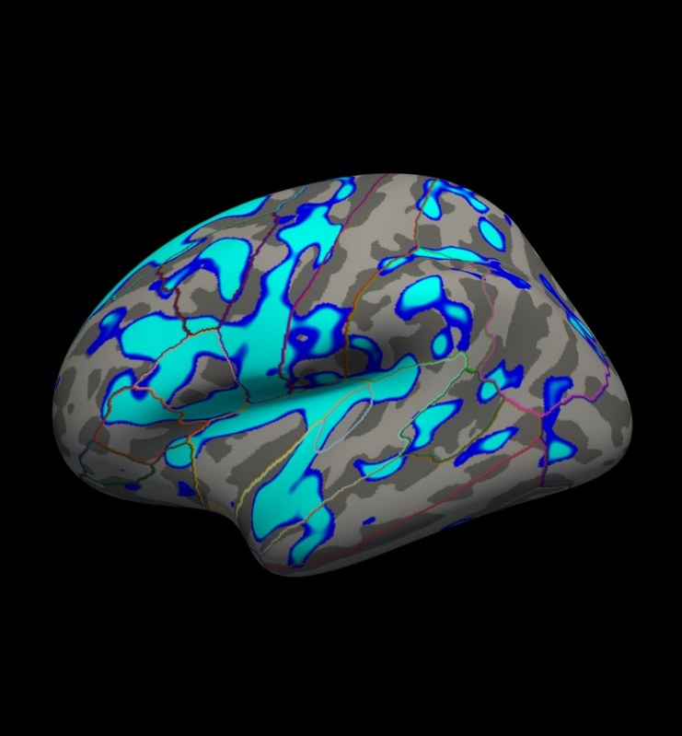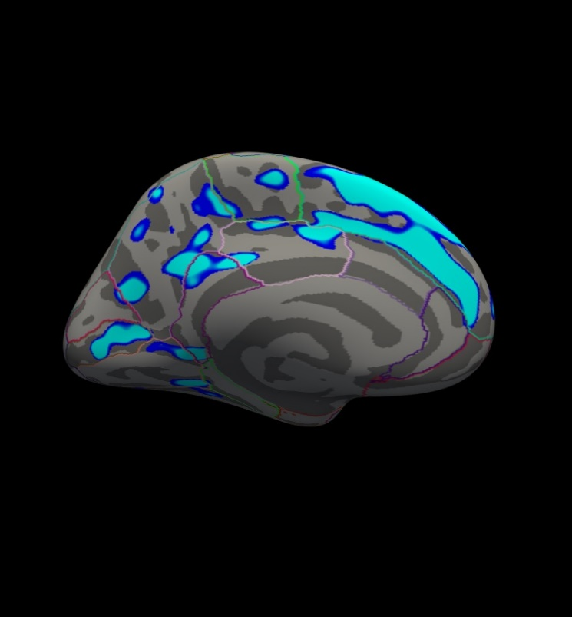

This figure displays the correlation between age and cortical thickness with a threshold of 4.
Notes:
- The threshold is set to 4, meaning vertices with p<.0001, uncorrected, will have color. This threshold is equal to the -log(p-value). In this case, any vertex with a value under 4 will not be displayed in color, however the value will still be readable in the cursor/mouse section of freeview.
- The lower threshold sets the minimum sigificance that a voxel must meet in order to be visible. It should be set such that only likely true effects will be seen. You can kind of think of it as a filter that removes voxels where no effect is present. The upper is just used for visualization purposes. If you set it very close to the min, then all voxels will appear to be the same color. If you set it higher, then you can get some gradation due to the strength of the effect. So the min removes voxels without an effect and the max allows you to see how the strength of the effect varies across the brain.
- Blue represents a negative correlation (i.e. thickness decreases with age), red represents positive correlation (i.e. thickness increases with age).
- In this example, the sig.mgh is used as the overlay and in practice this is what is normally used. However, the pcc.mgh can also be used as the overlay if it was created in the analysis.
- Click on a point in the Precentral Gyrus. What is its value? What does it mean?
Viewing the medial surface, change the overlay threshold to something very, very low (say, .01), by clicking Configure (under the Overlay dropdown menu that says sig.mgh) and set the Min value to 0.01. Click Apply, or check the Automatically apply changes checkbox.
You should see something like this:
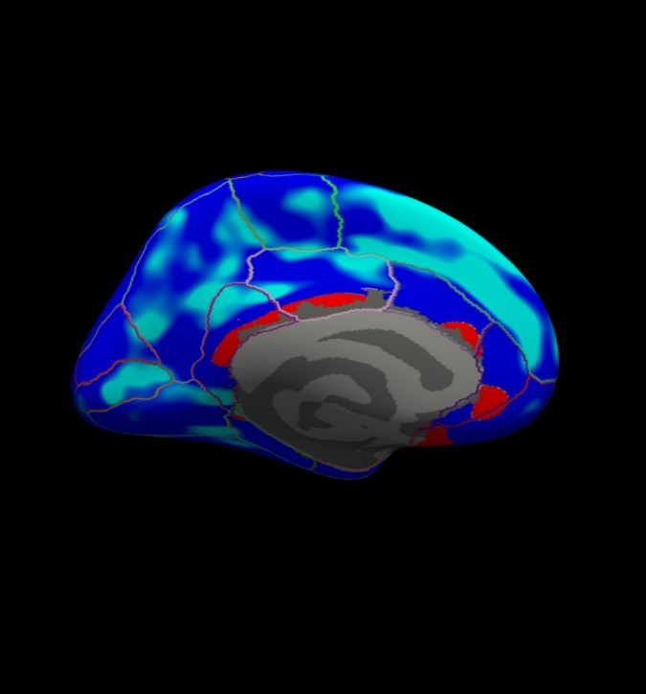
This figure displays the correlation between age and cortical thickness with a threshold of 0.01.
Notes:
- Almost all of the cortex now has color.
- The non-cortical areas are still blank (0) because they were excluded with --cortex in mri_glmfit above.
All the surface overlays created by mri_glmfit, not just the significance map, can also be inspected in freeview. Simply replace the path to the sig.mgh file in the command above to the surface overlay that you would like to see. For example, this will display the F ratio instead of the significance map:
freeview -f $SUBJECTS_DIR/fsaverage/surf/lh.inflated:annot=aparc.annot:annot_outline=1:overlay=lh.gender_age.glmdir/lh-Avg-thickness-age-Cor/F.mgh:overlay_threshold=20,50 -viewport 3d -layout 1
Text output and log files can be opened in any text editor.

Clusterwise Correction for Multiple Comparisons (Permutation)
Note: The method used is based on: False positive rates in surface-based anatomical analysis. Greve and Fischl, NeuroImage (2017).
- Contents
  - Preparations
  - Introduction
  - Run the initial analysis to get uncorrected results
  - Run the simulation
  - View the Corrected Results
  - Summary
  - Quiz

Introduction
To perform a cluster-wise correction for multiple comparisons, we will run a permutation simulation. The simulation is a way to get a measure of the distribution of the maximum cluster size under the null hypothesis. First, you run the analysis to get uncorrected maps. Then the permutation simulation is done by iterating over the following steps:
- Permute the design matrix
- Analyze the permuted data, including computing contrasts and sig maps
- Threshold sig map (cluster forming threshold (CFT) and sign).
- Find clusters in thresholded map.
- Record area of maximum cluster.
- Repeat over desired number of iterations (usually 1,000).
In FreeSurfer, this information is stored in a simple text file called a CSD (Cluster Simulation Data) file that you can find in the glmdir output folder (subfolder csd) after running mri_glmfit-sim.
Once we have the distribution of the maximum cluster size, we correct for multiple comparisons by:
- Going back to the original, uncorrected data.
- Thresholding using same level and sign.
- Finding clusters in thresholded map.
- For each cluster, p = probability of seeing a maximum cluster that size or larger during simulation.

Run the initial analysis to get uncorrected results
mri_glmfit --y lh.gender_age.thickness.10.mgh --fsgd gender_age.fsgd dods \
--C lh-Avg-thickness-age-Cor.mtx --surf fsaverage lh --cortex --glmdir lh.gender_age.glmdir \
--eres-save
This is the same command that you ran before in the Group Analysis tutorial (note the --eres-save option needed for permutation simulation).

Run the simulation
All the permutation steps above, including the final correction, are performed with the command mri_glmfit-sim below. This command can takes about 20 minute to run, and if you are in the organized course this has already been run for you.
Note: If you are not taking the FreeSurfer course: in order for this command to work you will have to install the following 6.0 patch. Version 6.0 Patch
Do not run this command if you're at an organized course.
It can take a while and the data has already been pre-processed for you.
mri_glmfit-sim \
--glmdir lh.gender_age.glmdir \
--perm 1000 4.0 abs \
--cwp 0.05\
--2spaces \
--bg 1
Notes:
- Specify the same GLM directory (--glmdir).
- Run a permuation simulation (--perm).
- Vertex-wise/cluster-forming threshold of 4 (p < .0001).
- Specify the sign ("neg" for negative, "pos" for positive, or "abs" for absolute/unsigned).
- --cwp 0.05 : Keep clusters that have cluster-wise p-values < 0.05. To see all clusters, set to .999.
- --2spaces : adjust p-values for two hemispheres (this assumes you will eventually look at the right hemisphere too).
- --bg 1 : Do not run in parallel (N=1 means single thread). If you want to run in parallel to reduce the run time use --bg N where N is the number of threads
- You can also use Permutation Analysis of Linear Models PALM

View the Corrected Results
In the contrast subdirectory, you will see several new files by running:
ls lh.gender_age.glmdir/lh-Avg-thickness-age-Cor
You will see the following new files:
perm.th40.abs.pdf.dat -- probability distribution function of clusterwise correction
perm.th40.abs.sig.cluster.mgh -- cluster-wise corrected map (overlay)
perm.th40.abs.sig.cluster.summary -- summary of clusters (text)
perm.th40.abs.sig.masked.mgh -- uncorrected sig values masked by the clusters that survive correction
perm.th40.abs.sig.ocn.annot -- output cluster number (annotation of clusters)
perm.th40.abs.sig.ocn.mgh -- output cluster number (segmentation showing where each numbered cluster is)
perm.th40.abs.sig.voxel.max.dat -- maximum voxel-wise significance
perm.th40.abs.sig.voxel.mgh -- voxel-wise map corrected for multiple comparisons at a voxel (rather than cluster) level
perm.th40.abs.y.ocn.dat -- the average value of each subject in each cluster
First, look at the cluster summary (or click here):
less lh.gender_age.glmdir/lh-Avg-thickness-age-Cor/perm.th40.abs.sig.cluster.summary
You can hit the 'Page Up' and 'Page Down' buttons or the 'Up' and 'Down' arrow keys to see the rest of the file. (To exit the less command, hit the 'q' button.)
Notes:
- This is a list of all the clusters that were found (25 of them).
- The CWP column is the cluster-wise probability (the number you are interested in). It is a simple p (ie, NOT -log10(p)) that indicates the probability of a cluster.
- For example, cluster number 1 has a CWP of p=.002.
- For explanations of the other columns in the cluster summary, click here.
Load the cluster annotation in freeview:
freeview -f $SUBJECTS_DIR/fsaverage/surf/lh.inflated:overlay=lh.gender_age.glmdir/lh-Avg-thickness-age-Cor/perm.th40.abs.sig.cluster.mgh:overlay_threshold=2,5:annot=lh.gender_age.glmdir/lh-Avg-thickness-age-Cor/perm.th40.abs.sig.ocn.annot -viewport 3d -layout 1
You should see clusters similar in shape to those pictured in the snapshots below. The color values associated with each cluster are arbitrary and may be different:
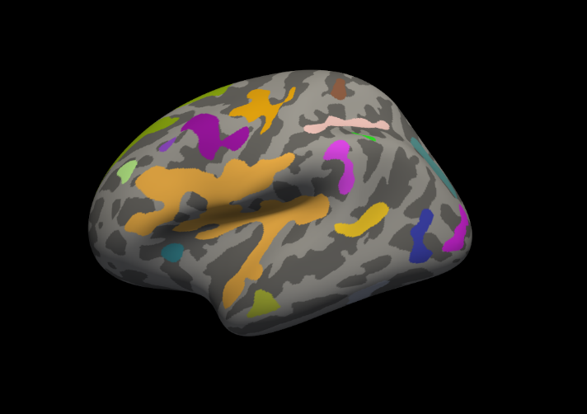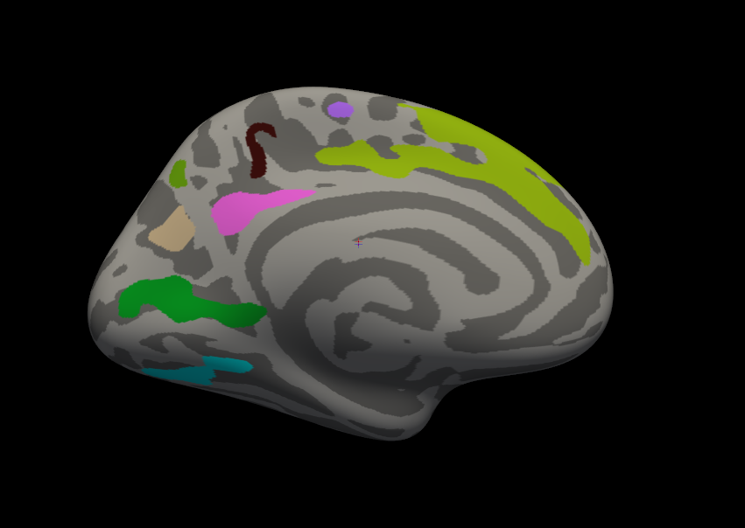
Notes:
- These are all clusters, regardless of significance.
- When you click on a cluster, the label will tell you the cluster number (eg, cluster-016) which is automatically generated.
Things to do:
- Find and click on cluster 1 (the largest cluster). It has a value of -2.69919 since this is log10(.002). The -2.69919 is because the correlation is negative.
- Find and click on cluster 24 (on the medial side of the brain). Its value is -1.52615. Note that if you turn off the annotation, the cluster 24 is not visible because its significance is worse than the threshold we set (-fthresh 2, p < .01).
- All vertices within a cluster are the same value (the p-value of the cluster).
- You can change the cluster-wise threshold by first clicking on "Show outline only" underneath the Annotation drop down menu. Then click on Configure (underneath "Overlay"), and set the Min value to your desired level. Alternatively, you can drag the red flag to adjust the cluster-wise threshold. As you do this, clusters will appear or disappear from the surface. (If your cursor is in the Min text box, the red flag won't move. Click on another text box to be able to move the flag.)

Summary
By the end of this exercise, you should know how to:
- Run the analysis to get the uncorrected maps using mri_glmfit
- Run the permutation simulations using mri_glmfit-sim
- Correct for multiple comparisons

Anatomical ROI analysis
This tutorial gives a brief introduction to anatomical ROI analysis, including understanding FreeSurfer label files, extracting ROI measures from label files, and creating individual and group statistics files for further analyses.
Contents
- Preparations
- Relationship between segmentation, parcellation and LookUp Table (LUT)
- Individual Stats files
- Group stats files

1. Preparations
To follow this tutorial exactly be sure you've downloaded the freesurfer tutorial data set before you begin. If you choose not to download the data set you can follow these instructions on your own data, but you will have to substitute your own specific paths and subject names. These are the commands that you need to run before getting started:
<source_freesurfer>
setenv TUTORIAL_DATA <path_to_your_tutorial_data>
setenv SUBJECTS_DIR=$TUTORIAL_DATA/buckner_data/tutorial_subjs/group_analysis_tutorial
cd $SUBJECTS_DIR
The commands used for this section during the COGNESTIC live demo can be found on the script:
FS_ROI_analysis.sh
Information on how to source FreeSurfer is located here.
If you are not using the tutorial data, you should set your SUBJECTS_DIR to the directory in which the recon(s) of the subject(s) you will use for this tutorial are located.

2. Relationship between segmentation, parcellation and LookUp Table (LUT)
In this exercise, you will examine a segmentation, parcellation, and color lookup table to understand how they are related. Open the subject in Freeview using the following command and select 'coronal' view at the top menu bar:
freeview -v 004/mri/orig.mgz \
004/mri/aparc+aseg.mgz:colormap=lut:opacity=0.4 \
-f 004/surf/lh.white:annot=aparc.annot

NOTE: The backslash allows you to copy and paste multiple lines of code as one command. We use this throughout the tutorials to display the commands in a more easy-to-read manner, while still allowing you to copy and paste. Whenever you are typing in your own commands, instead of copying and pasting a command written out across multiple lines, a backslash is not necessary.
The above command opens the orig and aparc+aseg segmentation volume (aparc+aseg.mgz) as well as the cortical surface parcellation (aparc.annot) on the white surface in the left hemisphere. Note that the default parcellation uses the Desikan/Killiany atlas. There is also the option to use the Destrieux atlas parcellation, where the surface is parcellated into more anatomical regions than the Desikan/Killiany atlas.
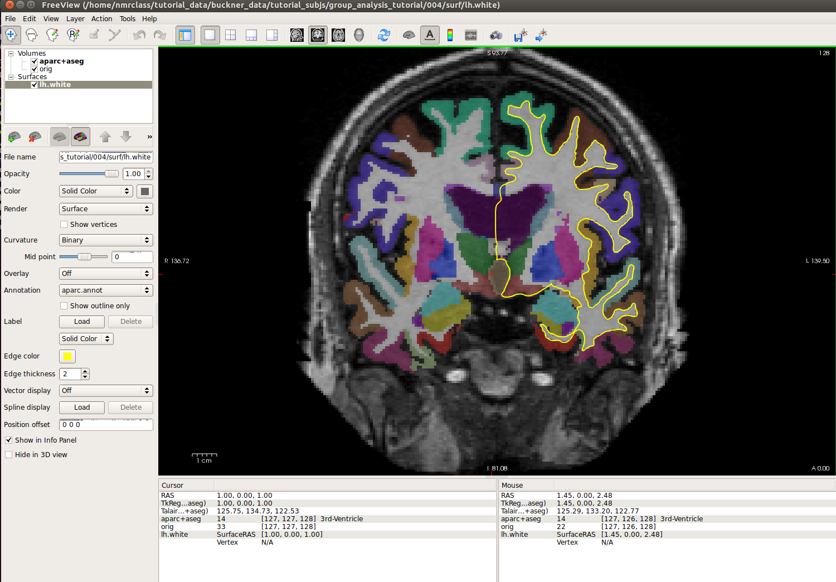
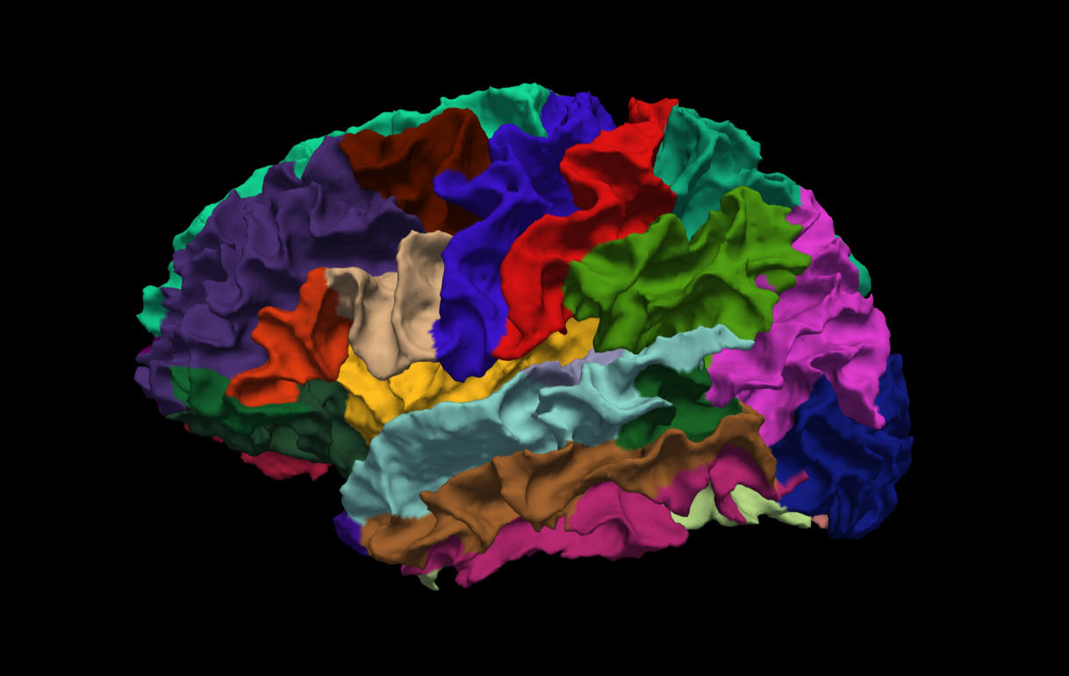
Note: The aparc+aseg.mgz file shows the parcellated cortical ribbon at the same time as the segmented subcortical structures. The colormap=lut tells Freeview to display the aparc+aseg.mgz file with colors according to the look up table (LUT). The aparc+aseg.mgz uses the Desikan-Killiany atlas. To see the Destrieux atlas, you would load fsaverage/mri/aparc.a2009s+aseg.mgz Run the following command in a new terminal window to display the contents of the LUT:
less $FREESURFER_HOME/FreeSurferColorLUT.txt
You can hit the 'Page Up' and 'Page Down' buttons on your keyboard to scroll through the text file. Or click here to view the contents of the file. (To exit the less command, hit 'q' on your keyboard.)
Things to do -- Navigating between freeview and the LUT:
- Choose the coronal view and click on a cortical structure in the brain.
- See the structure name next to 'aparc+aseg' in the Cursor section below the main viewing window. For example, it may say ctx-lh-precentral. Notice which hemisphere is specified.
- Look at the number listed immediately after the 'aparc+aseg'. For example, it may say 1024.
- Find that value in the LUT, which you have opened using the command mentioned above.
- Verify that it is the same structure you chose in freeview.
- Do the same with a subcortical structure of your choice.
You can close freeview once you are done. To get out of the less command, type 'q' for quit and hit enter.

3. Individual Stats files
During the FreeSurfer processing stream, via the recon-all script, some statistical output files are generated. They are kept in each subjects' stats/ subdirectory and are generated for the subcortical segmentation (aseg) and the cortical parcellation (aparc). These tables include information on each labeled region for the individual subject. You can view these output files via the terminal or a text editor.

3.1. aseg.stats
The statistical output from the subcortical segmentation, called aseg.stats, is a regular text file and will contain the volumes of specific structures. For example, you can obtain information such as the volume of left hippocampus and its mean intensity from this file.
cd $SUBJECTS_DIR/004/stats
less aseg.stats
At the head of the text file there will be information about the command that was run, the version used, the user who ran it and a time stamp. Following this there is information about the volume of the entire brain.
The next section of this file defines the column headers, field name, and units for the rest of the table. We can expect to see the Segmentation Id, Number of Voxels, Volume, Structure Name, Intensity normMean, Intensity normStdDev, Intensity normMin, Intensity normMax, and Intensity normRange for each entry in the table. The "norm" stats are extracted for each segmented structure from $SUBJECTS_DIR/004/mri/norm.mgz.
The remainder of the table shows this information for all the structures that are labeled in the aseg. (Remember, press 'q' if you want to quit the 'less' command).
As you may see below, the various headings don't line up perfectly in the terminal (or text editors). This is because the text file is formatted for spreadsheet programs.
# Title Segmentation Statistics
#
# generating_program mri_segstats
# cvs_version $Id: mri_segstats.c,v 1.121 2016/05/31 17:27:11 greve Exp $
# cmdline mri_segstats --seg mri/aseg.mgz --sum stats/aseg.stats --pv mri/norm.mgz --empty --brainmask mri/brainmask.mgz --brain-vol-from-seg --excludeid 0 --excl-ctxgmwm --supratent --subcortgray --in mri/norm.mgz --in-intensity-name norm --in-intensity-units MR --etiv --surf-wm-vol --surf-ctx-vol --totalgray --euler --ctab /space/freesurfer/build/pub-releases/v6.0.0/freesurfer/ASegStatsLUT.txt --subject 004
# sysname Linux
# hostname compute-0-39
# machine x86_64
# user zkaufman
# anatomy_type volume
#
# SUBJECTS_DIR /autofs/cluster/freesurfer/subjects/test/buckner_data/stable6
# subjectname 004
# Measure BrainSeg, BrainSegVol, Brain Segmentation Volume, 1262276.000000, mm^3
# Measure BrainSegNotVent, BrainSegVolNotVent, Brain Segmentation Volume Without Ventricles, 1187271.000000, mm^3
# Measure BrainSegNotVentSurf, BrainSegVolNotVentSurf, Brain Segmentation Volume Without Ventricles from Surf, 1186951.705907, mm^3
# Measure VentricleChoroidVol, VentricleChoroidVol, Volume of ventricles and choroid plexus, 69043.000000, mm^3
# Measure lhCortex, lhCortexVol, Left hemisphere cortical gray matter volume, 259221.573235, mm^3
# Measure rhCortex, rhCortexVol, Right hemisphere cortical gray matter volume, 258713.044172, mm^3
# Measure Cortex, CortexVol, Total cortical gray matter volume, 517934.617407, mm^3
# Measure lhCerebralWhiteMatter, lhCerebralWhiteMatterVol, Left hemisphere cerebral white matter volume, 239218.899217, mm^3
# Measure rhCerebralWhiteMatter, rhCerebralWhiteMatterVol, Right hemisphere cerebral white matter volume, 236617.189283, mm^3
# Measure CerebralWhiteMatter, CerebralWhiteMatterVol, Total cerebral white matter volume, 475836.088500, mm^3
# Measure SubCortGray, SubCortGrayVol, Subcortical gray matter volume, 66911.000000, mm^3
# Measure TotalGray, TotalGrayVol, Total gray matter volume, 686541.617407, mm^3
# Measure SupraTentorial, SupraTentorialVol, Supratentorial volume, 1131346.705907, mm^3
# Measure SupraTentorialNotVent, SupraTentorialVolNotVent, Supratentorial volume, 1062303.705907, mm^3
# Measure SupraTentorialNotVentVox, SupraTentorialVolNotVentVox, Supratentorial volume voxel count, 1060851.000000, mm^3
# Measure Mask, MaskVol, Mask Volume, 1740098.000000, mm^3
# Measure BrainSegVol-to-eTIV, BrainSegVol-to-eTIV, Ratio of BrainSegVol to eTIV, 0.701763, unitless
# Measure MaskVol-to-eTIV, MaskVol-to-eTIV, Ratio of MaskVol to eTIV, 0.967408, unitless
# Measure lhSurfaceHoles, lhSurfaceHoles, Number of defect holes in lh surfaces prior to fixing, 70, unitless
# Measure rhSurfaceHoles, rhSurfaceHoles, Number of defect holes in rh surfaces prior to fixing, 59, unitless
# Measure SurfaceHoles, SurfaceHoles, Total number of defect holes in surfaces prior to fixing, 129, unitless
# Measure EstimatedTotalIntraCranialVol, eTIV, Estimated Total Intracranial Volume, 1798722.304401, mm^3
# SegVolFile mri/aseg.mgz
# SegVolFileTimeStamp 2017/01/19 21:37:44
# ColorTable /space/freesurfer/build/pub-releases/v6.0.0/freesurfer/ASegStatsLUT.txt
# ColorTableTimeStamp 2017/01/18 17:00:02
# InVolFile mri/norm.mgz
# InVolFileTimeStamp 2017/01/19 04:08:57
# InVolFrame 0
# PVVolFile mri/norm.mgz
# PVVolFileTimeStamp 2017/01/19 04:08:57
# Excluding Cortical Gray and White Matter
# ExcludeSegId 0 2 3 41 42
# VoxelVolume_mm3 1
# TableCol 1 ColHeader Index
# TableCol 1 FieldName Index
# TableCol 1 Units NA
# TableCol 2 ColHeader SegId
# TableCol 2 FieldName Segmentation Id
# TableCol 2 Units NA
# TableCol 3 ColHeader NVoxels
# TableCol 3 FieldName Number of Voxels
# TableCol 3 Units unitless
# TableCol 4 ColHeader Volume_mm3
# TableCol 4 FieldName Volume
# TableCol 4 Units mm^3
# TableCol 5 ColHeader StructName
# TableCol 5 FieldName Structure Name
# TableCol 5 Units NA
# TableCol 6 ColHeader normMean
# TableCol 6 FieldName Intensity normMean
# TableCol 6 Units MR
# TableCol 7 ColHeader normStdDev
# TableCol 7 FieldName Itensity normStdDev
# TableCol 7 Units MR
# TableCol 8 ColHeader normMin
# TableCol 8 FieldName Intensity normMin
# TableCol 8 Units MR
# TableCol 9 ColHeader normMax
# TableCol 9 FieldName Intensity normMax
# TableCol 9 Units MR
# TableCol 10 ColHeader normRange
# TableCol 10 FieldName Intensity normRange
# TableCol 10 Units MR
# NRows 45
# NTableCols 10
# ColHeaders Index SegId NVoxels Volume_mm3 StructName normMean normStdDev normMin normMax normRange
1 4 33163 33215.1 Left-Lateral-Ventricle 12.6416 10.9375 0.0000 77.0000 77.0000
2 5 1200 1221.1 Left-Inf-Lat-Vent 26.6925 14.4286 0.0000 75.0000 75.0000
3 7 12677 13179.5 Left-Cerebellum-White-Matter 76.4266 8.8658 13.0000 106.0000 93.0000
4 8 51530 51612.4 Left-Cerebellum-Cortex 49.6198 11.7537 0.0000 100.0000 100.0000
5 10 7568 7259.4 Left-Thalamus-Proper 74.9564 13.4454 2.0000 126.0000 124.0000
6 11 5505 5379.5 Left-Caudate 64.2171 11.3418 30.0000 106.0000 76.0000
7 12 7815 7535.4 Left-Putamen 68.3104 10.7348 11.0000 104.0000 93.0000
-
-
-

3.2. aparc.stats
The statistical output from the cortical parcellation, called lh.aparc.stats and rh.aparc.stats, is a regular text file and will contain the thickness of specific structures. For example, you can obtain information such as, how big is left superior temporal gyrus and its average thickness from this file.
cd $SUBJECTS_DIR/004/stats
less lh.aparc.stats
This file takes the same format as the aseg.stats. The measures at the top show the number of vertices in the cortex (NumVert) and the surface area of the cortex (SurfArea). This part of the file also tells us that the lh.aparc.annot is being used as the annotation file (AnnotationFile ../label/lh.aparc.annot).
The next section of this file defines the column headers, field name, and units for the rest of the table. We can expect to see the Structure Name, Number of Vertices, Surface Area, Gray Matter Volume, Average Thickness, Thickness StDev, Integrated Rectified Mean Curvature, Integrated Rectified Gaussian Curvature, Folding Index and Intrinsic Curvature Index for each entry in the table.
The remainder of the table shows this information for all the structures that are labeled in the aparc. (Again 'q' will exit 'less').
# Table of FreeSurfer cortical parcellation anatomical statistics
#
# CreationTime 2017/01/20-02:14:03-GMT
# generating_program mris_anatomical_stats
# cvs_version $Id: mris_anatomical_stats.c,v 1.79 2016/03/14 15:15:34 greve Exp $
# mrisurf.c-cvs_version $Id: mrisurf.c,v 1.781.2.6 2016/12/27 16:47:14 zkaufman Exp $
# cmdline mris_anatomical_stats -th3 -mgz -cortex ../label/lh.cortex.label -f ../stats/lh.aparc.stats -b -a ../label/lh.aparc.annot -c ../label/aparc.annot.ctab 004 lh white
# sysname Linux
# hostname compute-0-39
# machine x86_64
# user zkaufman
#
# SUBJECTS_DIR /autofs/cluster/freesurfer/subjects/test/buckner_data/stable6
# anatomy_type surface
# subjectname 004
# hemi lh
# AnnotationFile ../label/lh.aparc.annot
# AnnotationFileTimeStamp 2017/01/19 20:15:12
# Measure Cortex, NumVert, Number of Vertices, 143669, unitless
# Measure Cortex, WhiteSurfArea, White Surface Total Area, 97596.1, mm^2
# Measure Cortex, MeanThickness, Mean Thickness, 2.34308, mm
# Measure BrainSeg, BrainSegVol, Brain Segmentation Volume, 1262276.000000, mm^3
# Measure BrainSegNotVent, BrainSegVolNotVent, Brain Segmentation Volume Without Ventricles, 1187271.000000, mm^3
# Measure BrainSegNotVentSurf, BrainSegVolNotVentSurf, Brain Segmentation Volume Without Ventricles from Surf, 1186951.705907, mm^3
# Measure Cortex, CortexVol Total cortical gray matter volume, 517934.617407, mm^3
# Measure SupraTentorial, SupraTentorialVol, Supratentorial volume, 1131346.705907, mm^3
# Measure SupraTentorialNotVent, SupraTentorialVolNotVent, Supratentorial volume, 1062303.705907, mm^3
# Measure EstimatedTotalIntraCranialVol, eTIV, Estimated Total Intracranial Volume, 1798722.304401, mm^3
# NTableCols 10
# TableCol 1 ColHeader StructName
# TableCol 1 FieldName Structure Name
# TableCol 1 Units NA
# TableCol 2 ColHeader NumVert
# TableCol 2 FieldName Number of Vertices
# TableCol 2 Units unitless
# TableCol 3 ColHeader SurfArea
# TableCol 3 FieldName Surface Area
# TableCol 3 Units mm^2
# TableCol 4 ColHeader GrayVol
# TableCol 4 FieldName Gray Matter Volume
# TableCol 4 Units mm^3
# TableCol 5 ColHeader ThickAvg
# TableCol 5 FieldName Average Thickness
# TableCol 5 Units mm
# TableCol 6 ColHeader ThickStd
# TableCol 6 FieldName Thickness StdDev
# TableCol 6 Units mm
# TableCol 7 ColHeader MeanCurv
# TableCol 7 FieldName Integrated Rectified Mean Curvature
# TableCol 7 Units mm^-1
# TableCol 8 ColHeader GausCurv
# TableCol 8 FieldName Integrated Rectified Gaussian Curvature
# TableCol 8 Units mm^-2
# TableCol 9 ColHeader FoldInd
# TableCol 9 FieldName Folding Index
# TableCol 9 Units unitless
# TableCol 10 ColHeader CurvInd
# TableCol 10 FieldName Intrinsic Curvature Index
# TableCol 10 Units unitless
# ColHeaders StructName NumVert SurfArea GrayVol ThickAvg ThickStd MeanCurv GausCurv FoldInd CurvInd
bankssts 1549 1071 2450 2.312 0.392 0.117 0.027 15 1.7
caudalanteriorcingulate 1313 872 2385 2.418 0.765 0.138 0.034 28 1.6
caudalmiddlefrontal 3199 2130 5942 2.510 0.511 0.123 0.031 36 4.1
cuneus 2562 1649 3157 1.821 0.381 0.144 0.039 40 3.8
entorhinal 563 426 1731 3.091 0.584 0.121 0.034 5 0.7
-
-
-

4. Group stats files
This section will run you through using the stats directory of the subjects to perform group stats of certain structures that may be of interest to your study. The following commands will help you combine the data of the subjects you are analyzing into one table that will be easily read into a spreadsheet program. We have considered 6 subjects as examples (004, 021, 040, 067, 080, 092) in the following sections. Set your SUBJECTS_DIR to the path where you have your subjects to be analyzed.
export SUBJECTS_DIR=$TUTORIAL_DATA/buckner_data/tutorial_subjs/group_analysis_tutorial
cd $SUBJECTS_DIR

4.1. Table of segmentation volumes
This section explains how to create a table of segmentation volumes using the 6 subjects mentioned above.
asegstats2table --subjects 004 021 040 067 080 092 \
--segno 11 17 18 \
--tablefile aseg.vol.table
The input for the --segno flag (11, 17, and 18) correspond to the segmentation label of left caudate, left hippocampus, and left amygdala, respectively. (You can create a table with all of the labels, not just these three, by omitting the --segno part.) Click here if you would like to view the list of labels and their corresponding Look Up Table ID numbers again. The file aseg.vol.table is your output - a text file consisting of the subjects mentioned in the command above and the values for the structures requested along with the measures in the header. The information in this text file is formatted so it can be easily imported into a spreadsheet program (often used as input for many statistical analysis programs). If you do the ls command, you should see that the text file aseg.vol.table has been created. To see the contents of this file in your terminal, type:
less aseg.vol.table
Press 'q' to exit.
You can also view the contents of this file in a text editing application such as gedit (linux) or some other spreadsheet application:
gedit aseg.vol.table
Note: Mac users should run
open -e aseg.vol.table
In the table, the first cell is volume indicating that the measure is a volume in mm3 for all of the cells to the right. The subject IDs can be found below volume (seen as 4, 21, 40, 67, 80, 92). You'll notice that in the examples we've considered here for asegstats2table, each subject is a 3 digit number (004, 021 etc).

4.2. Table of white matter parcellation volumes
The purpose of this section is to show how you can change which segmentation atlas you get stats from (and thus which structures):
asegstats2table \
--subjects 004 021 040 067 080 092 \
--segno 3007 3021 3022 4022 \
--stats wmparc.stats \
--tablefile wmparc.vol.table
This prints out stats on the white matter parcellation.

4.3. Table of the mean thickness of each cortical parcellation in the Desikan/Killiany atlas
This section demonstrates how to create a table of the mean thickness of each cortical parcellation in the Desikan atlas:
aparcstats2table --hemi lh \
--subjects 004 021 040 067 080 092 \
--parc aparc \
-–meas thickness \
--tablefile lh.aparc.thickness.table
Feel free to take a look at those results.

