Digitization
Once project, subject and settings have been selected for your study, you are ready to digitize the subject.
Please follow the instructions below:

- Check the grey Polhemus box is on (a small green light will be lit) if not switch it on by the large black switch on the back and wait for the green light to stop flashing.
- In the acquisition program on the computer select the final “change” button marked ‘digitize HPI’
- Ask your participant to sit in the wooden chair making sure that it is as far away from computers and other large metal components as possible
- Remove your watch
- Check the receiver is in the back of the chair, with the cable pointing downwards
- Position the goggles on the subject’s head, being careful not to cover up any electrodes or HPI coils. It is critical that the goggles are secure and do not move once digitization has begun.
- Go back to the computer and, at the top of the new window in acquistion, hit the “Coordinate frame alignment” button; you are now ready to begin digitization
- In any order, digitize the three cardinal landmarks (nasion then right and left pre-auricular points, see below) by pointing to each and simultaneously clicking the button on the stylus, wait until it has beeped and a value has appeared on the screen before moving the pen away from the head. It is a good idea to check that the two ear points are within a maximum (absolute value) distance of 3mm.

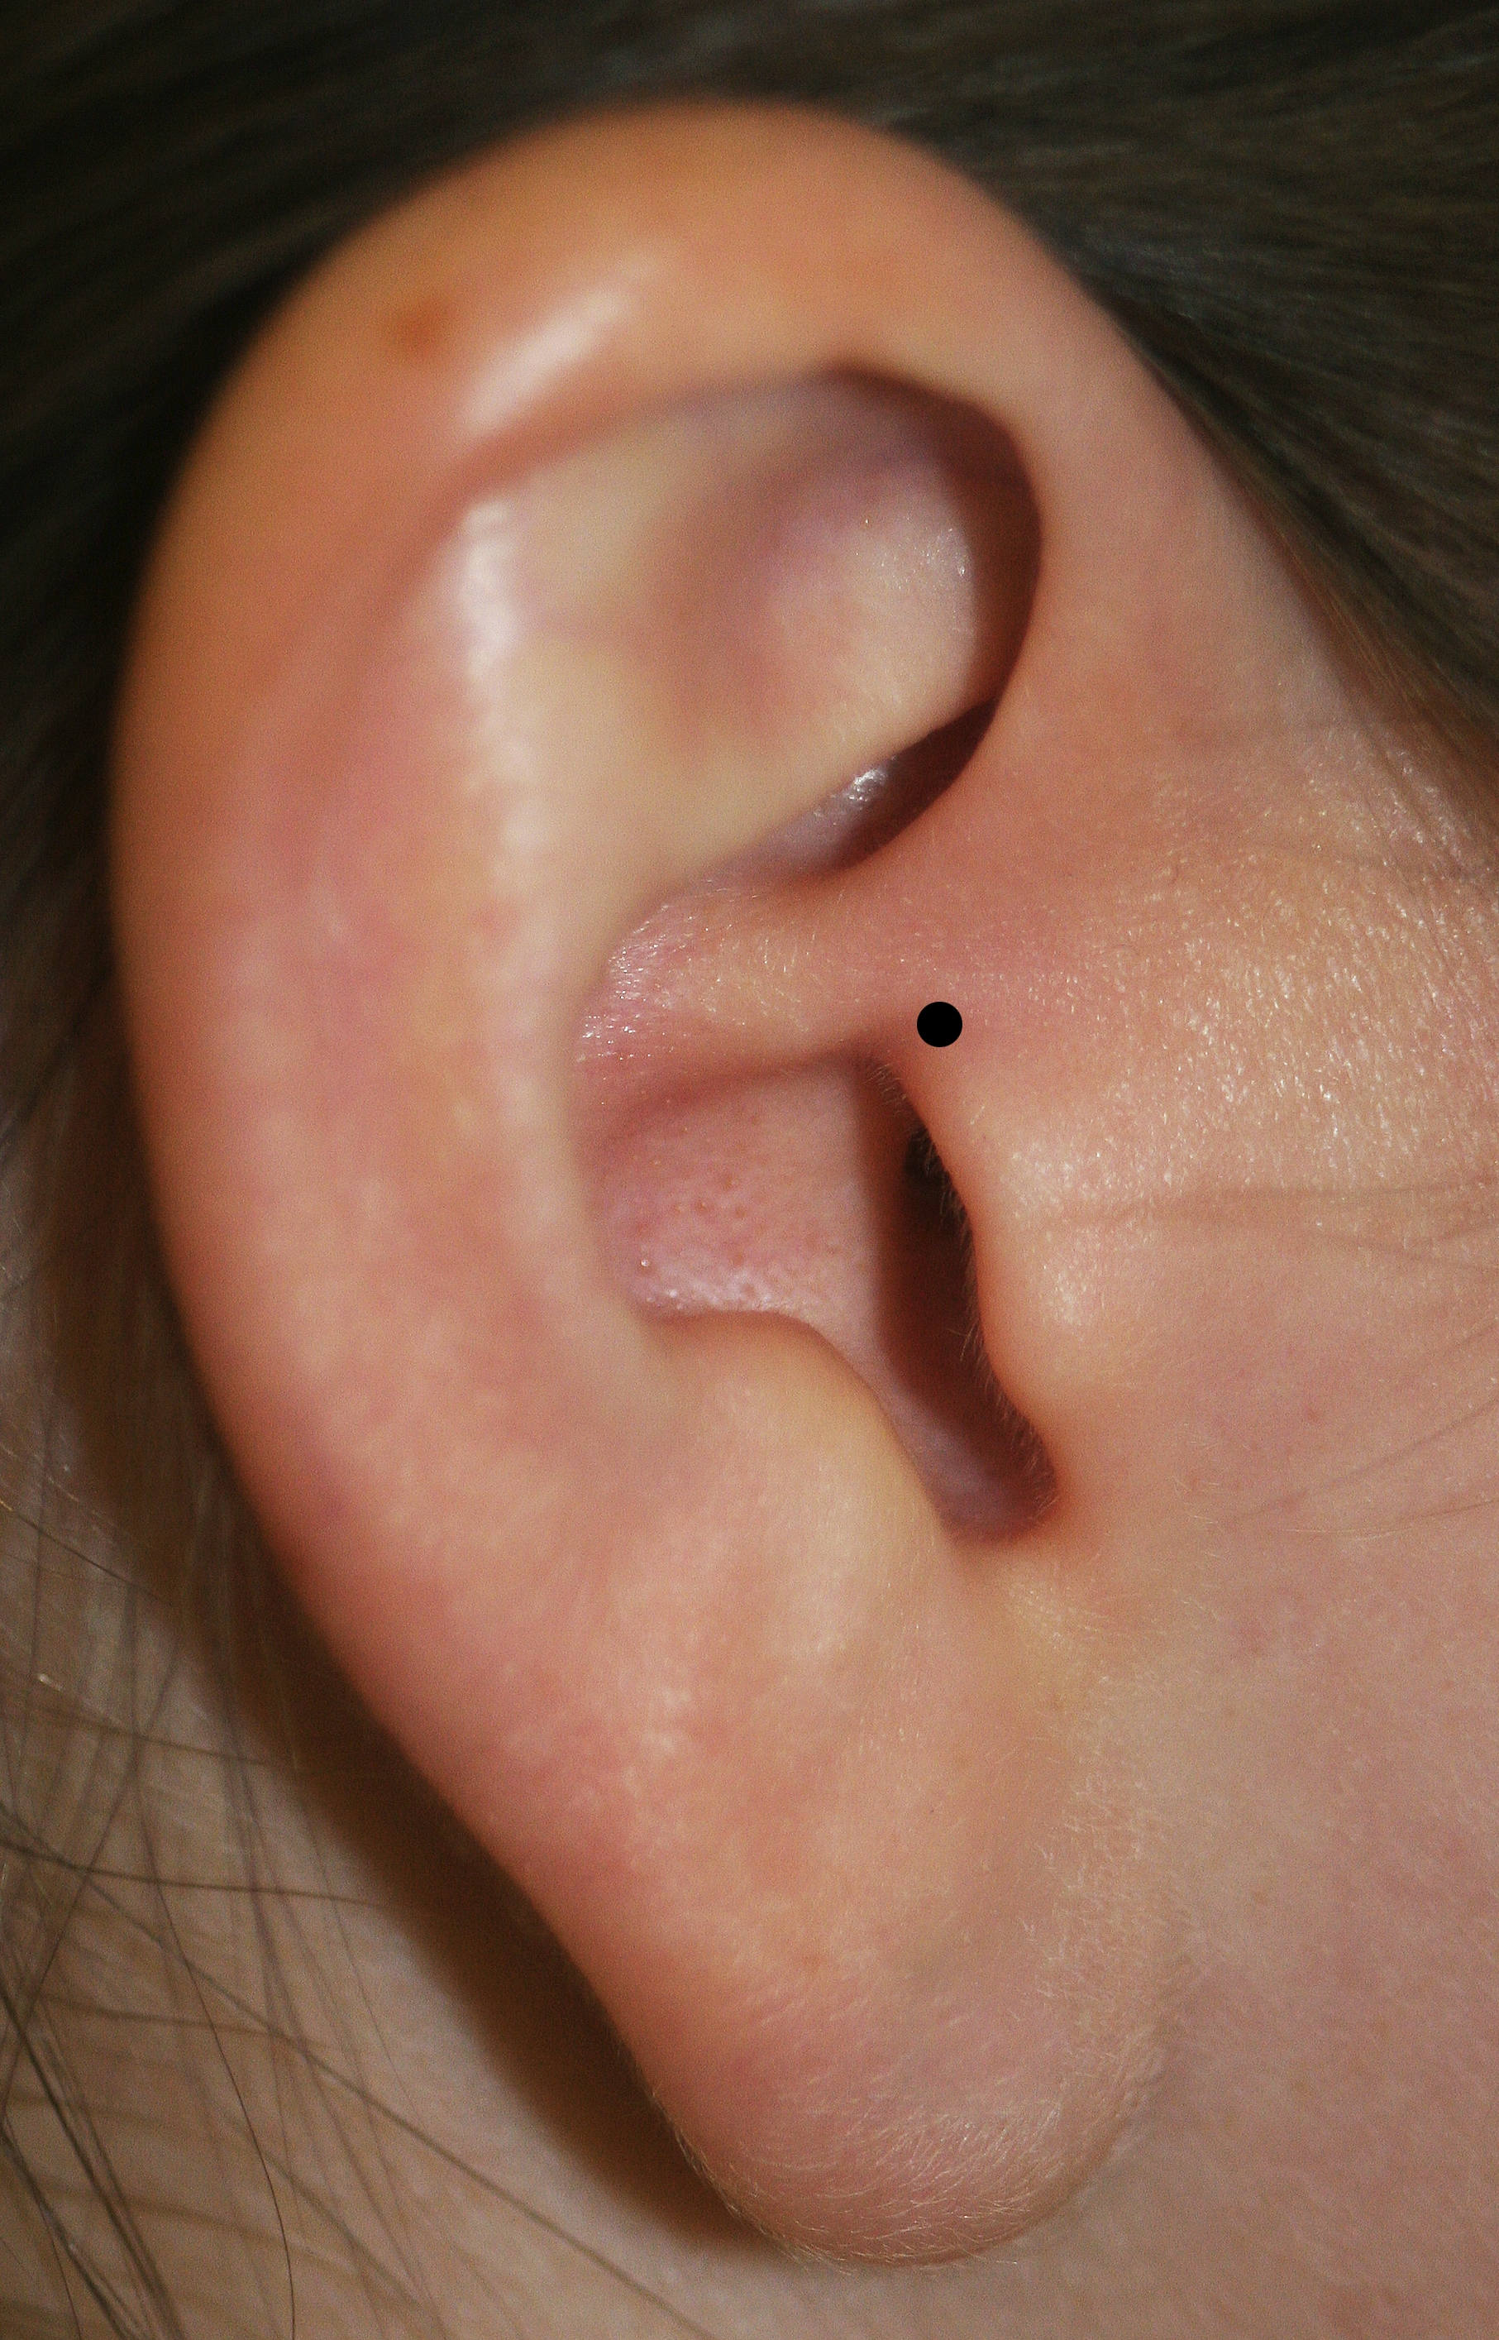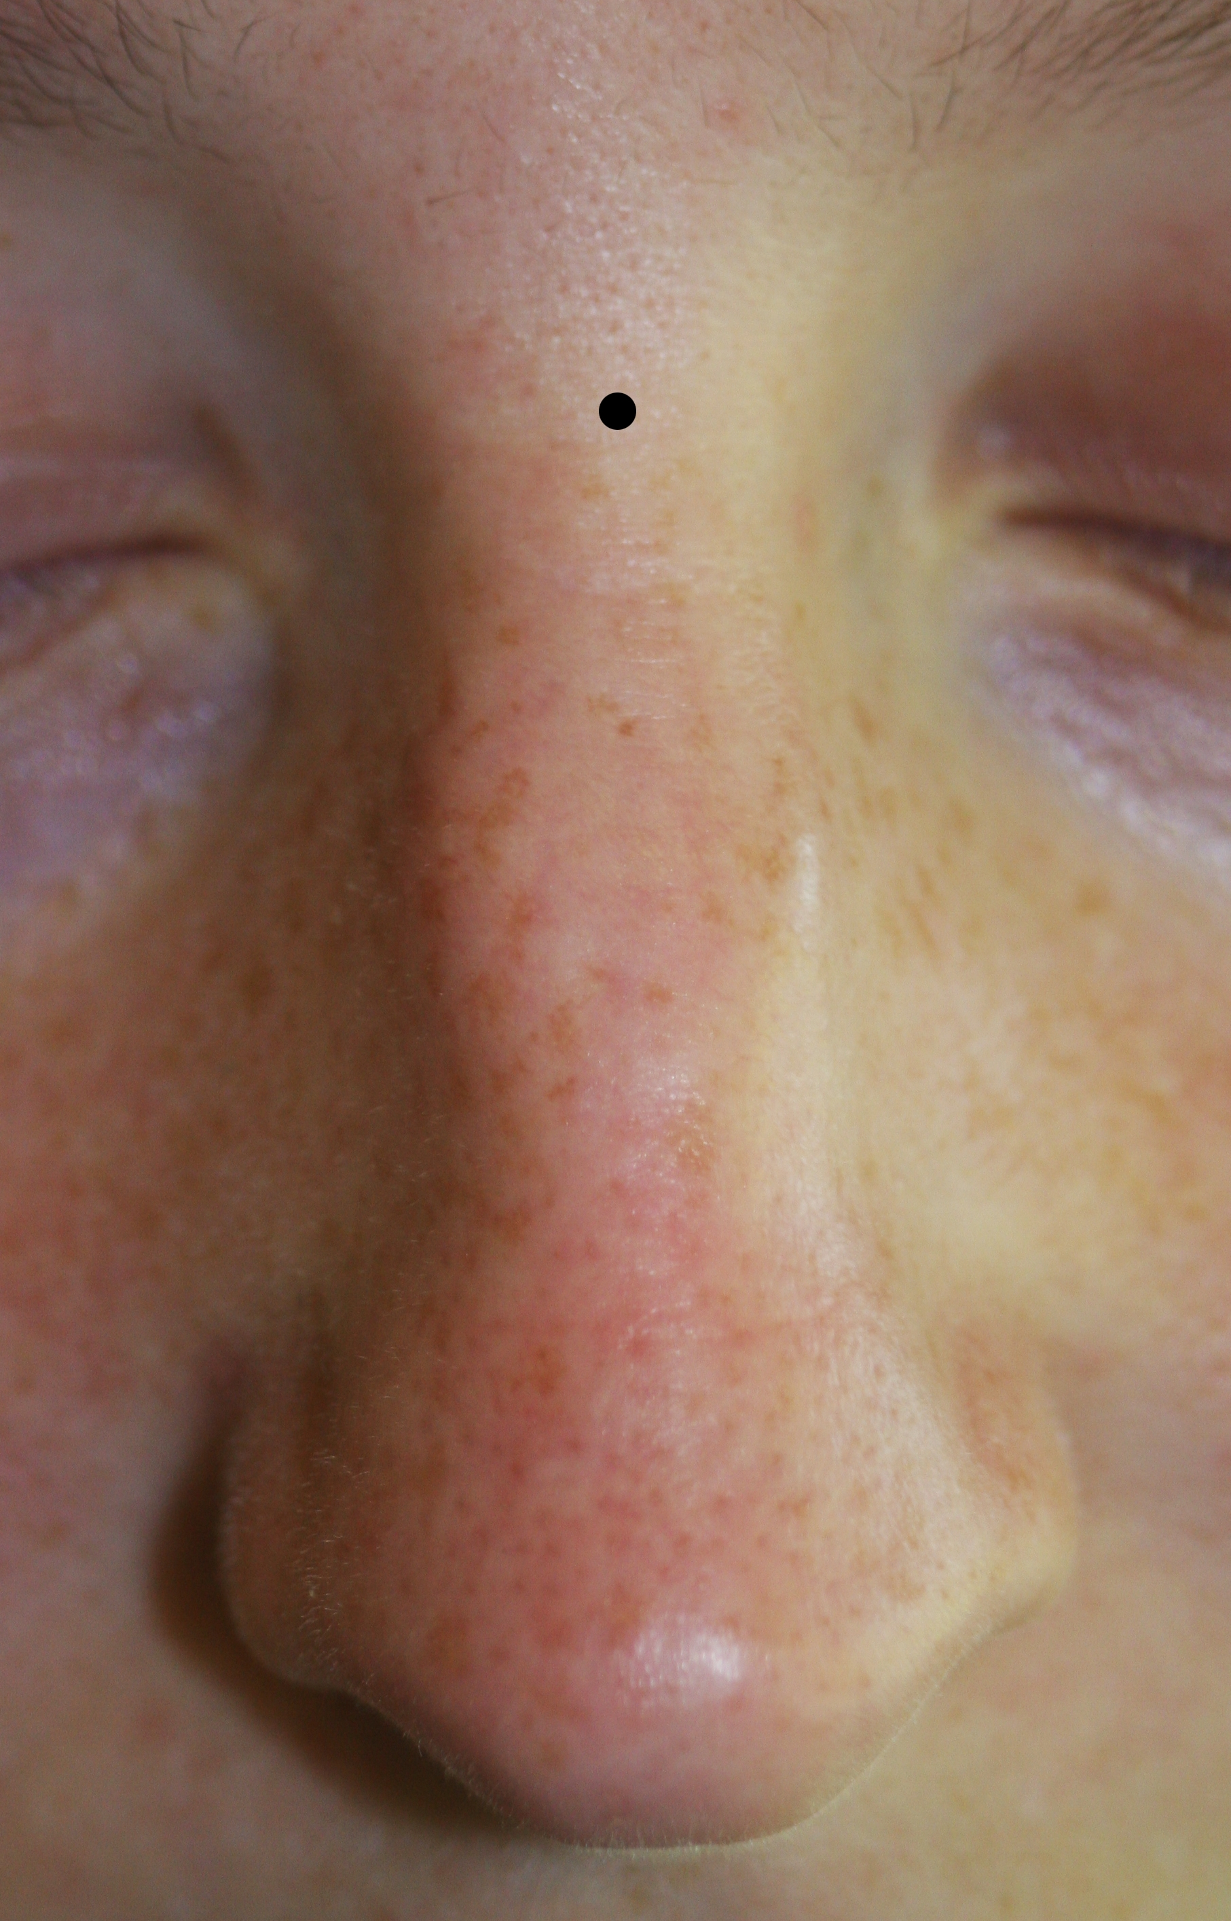
Right PA. For the Nasion mark the lowest indention above the crown on the nose as shown here.

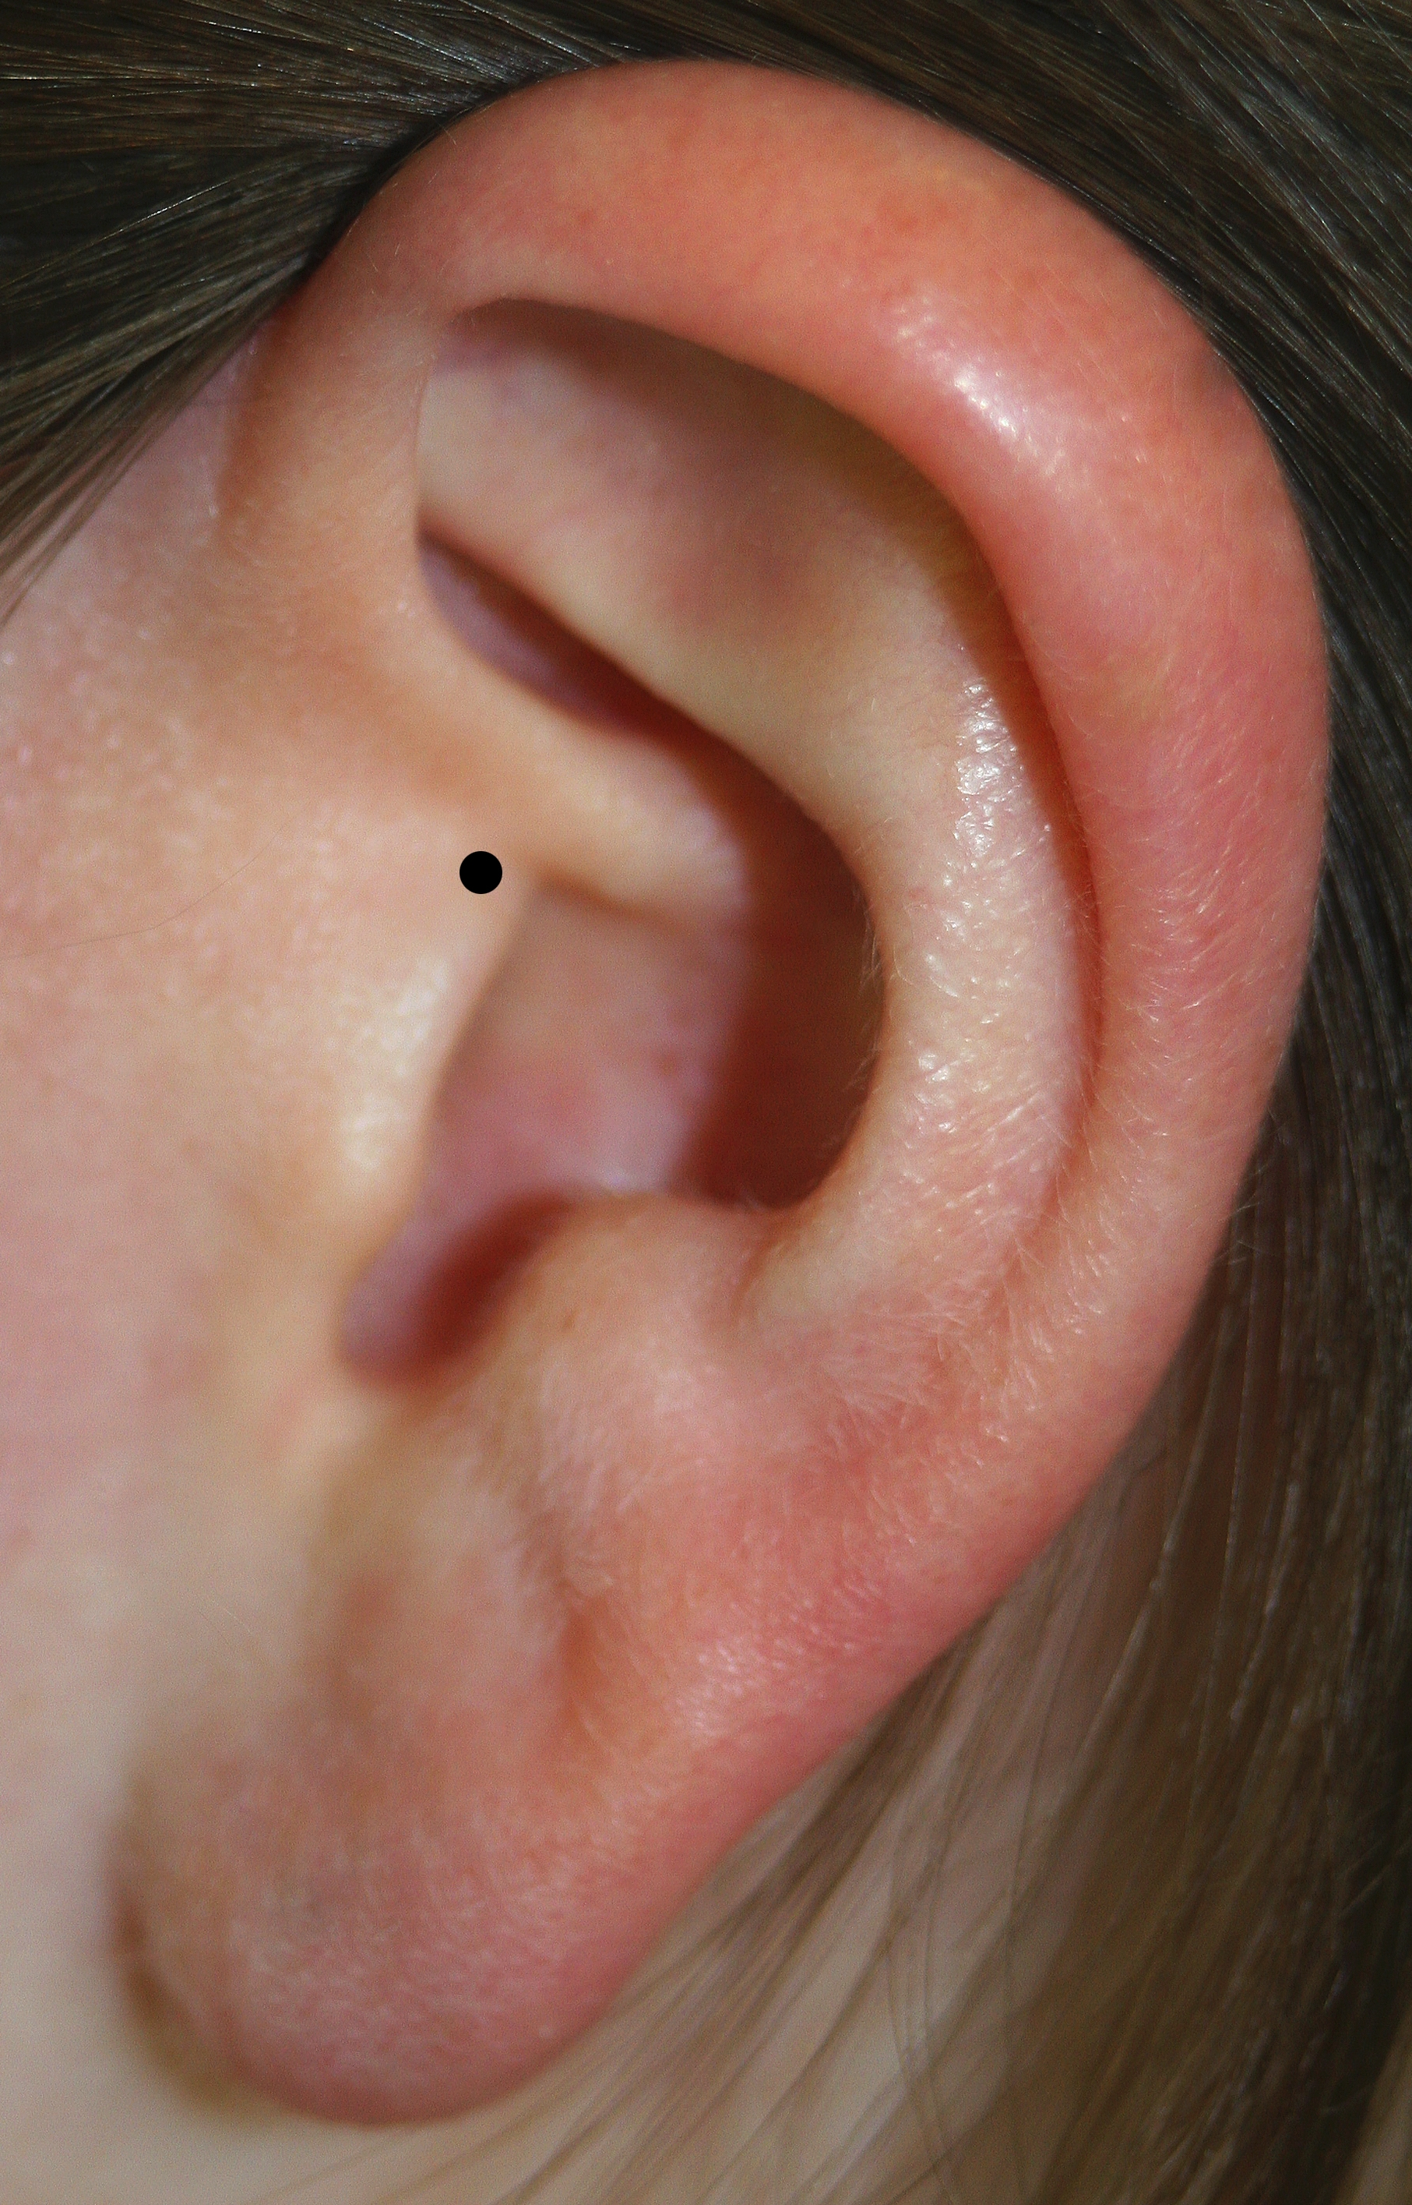

Left PA

- After the third point has been digitized, you will hear two beeps instead of one—this is simply to indicate that you are done digitizing this section. If at any point during the digitization of the different sections you hear two beeps (before the last point), you have accidentally pushed the stylus button twice and should start over. Instructions on how to do this are below.
- To move on to the next section (HPI coils), there is no need to click anything else; you will simply be prompted to begin digitizing HPI.
- Digitize the four HPI coils in any order. Be very careful when digitizing these points, as they can come back to haunt you later if not done properly the first time!
- Next, if using the EEG cap, digitize the electrodes in order, starting with the reference electrode. Place the pen into the electrode so the tip is in contact with the participant’s skin. Once completed please wipe the pen before digitizing any facial points and refill the electrodes with gel.
- If not using the cap, you will not be prompted to digitize any electrodes
- Finally, you will be asked to digitize additional head points. It is a good idea to make a straight line across the forehead and nose, as the nose is easily identifiable in the subject’s MRI. An extra 70 or so points from the head (this number is including electrode positions) should be taken by holding the button down and gently drawing the pen across the scalp; these will also be used in conjunction with the MRI. Please hold the pen at an angle as it is very pointy and may be uncomfortable for the participant if held perpendicular to the head.
- When finished, hold the stylus about a meter away from the subject and press the button.
- If at any point you should make a mistake, you can hold the stylus away, press the stylus button, and then click on the button at the top of the section you would like to do again. A selection box will appear with the choices ‘check’, ‘redo’ or ‘clear’, it is advised that you ‘check’ the position of the HPI coils at the end of your digitization and if the difference is greater than 2 mm redo the measurement.

