2D Sensor x 1D Time SPM’s

We’re using the same data set as in session 1, but with the data of all 8 subjects. To save time we’ve already run maxfilter on these files, but they still need to be pre-processed before we can generate the 2D Sensor x 1D Time SPM maps.
1) Open your VNC session

2) Start Matlab by typing: spm eeg
Starting Matlab in this way ensures that you are directed to a computing node with the lowest current load, and adds all SPM paths to your working path.

3) Open the script (located in /imaging/ms02/MasterclassDemo/ cbu_meeg_masterclass2.m ), change the working directory to your working directory (on line 11), and SAVE AS into your working directory.

4) As we’ve already maxfiltered this data set, we set the control flags for maxfiltering to 0 around line 130. This will skip the maxfiltering step and allow us to proceed through pre-processing. (NB we will not be performing source localisation in this session so set the inversion flags to zero as well).

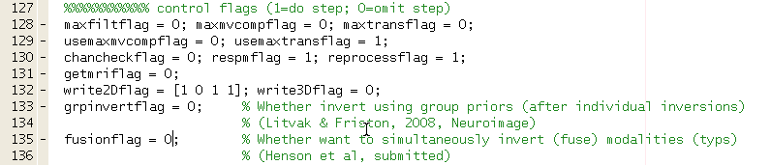
NB As we are skipping the maxfiltering step, we needed to add a few lines of code to Rik’s original script to tell Matlab where to find these files. The added code on line 16 and around lines 290 do that, but remember to remove them if you want to run the script all the way through including the maxfiltering.
fifd = '/imaging/ms02/MasterclassDemo/'; % Location of the maxfiltered files
% Extra bits for MEG masterclass as maxfiltered files not stored in own working directory and the SPM files must be stored elsewhere.
S.Fdata = fullfile(fifd, swd, S.Fdata);
if ~isempty(S.HPIfile)
S.HPIfile = fullfile(fifd, swd, S.HPIfile);
end
[path, name, ext] = fileparts(S.Fdata);
S.Pout = fullfile(wd, swd, sprintf('%s.mat', name)); % New output location
% Extra bit ends
5) Place a break point just before the 2D Sensor x 1D Time section (eg. Line 489) and run all the preprocessing to here.
The most important section of the pre-processing for what we are interested in today is shown below. This loop converts the matrix of data values (EEG, Mags, Grads or Grms) to 3D analyse format (2 dimensions of space & 1time dimension) on line 447. The files can then be treated as if they are fMRI files and the normal SPM corrections and analysis used. This loop also performs some smoothing of the data (by 5mm in space and 20ms in time) – it’s entirely up to you if you want to do this to your data or not. If not, just delete the sensor_smooth_spm variable.
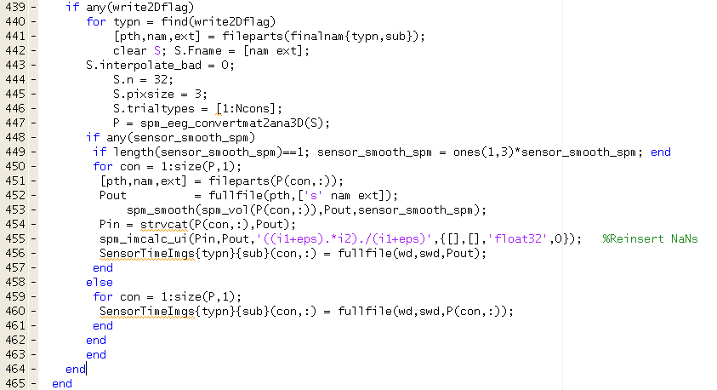
Now if you have a look in your working directory you’ll hopefully see 8 subject folders (labeled sub1 to sub8) and inside those you’ll find that SPM has generated a lot of files! Each preprocessing step appends a letter to the file name (e.g. filtering adds an f at the start, artifact rejection adds an a) and saves a new file.
The conversion from matrix to analyze format results in 3 new folders, one each for mags, grms and eeg. Inside each are folders for each of your trial types, and inside those are the analyze files themselves. Feel free to explore this to become more acquainted with what to expect to come out of an SPM analysis.
Now you need to feed all the information about where to find those files to an ANOVA to run the stats for you. To make this easy we saved the full filenames into one variable as we went through the mat2ana3D loop (see line 460). You can have a look at its contents by typing:
SensorTimeImgs{1}{1} for sensor type 1, subject 1.
SensorTimeImgs{3}{1} for sensor type 3, subject 1.
SensorTimeImgs{3}{2} for sensor type 3, subject 2.

Now we are finally ready to perform the ANOVA computation and take a look at the results.

Set another break point on the final line of code (line 524 here) and ask Matlab to run the rest of the script. The key point here is the imgfiles variable as its structure is used by meg_batch_anova to determine what the conditions are.

You first specify if you have one or more groups of data sets (line 507), then loop over subjects, selecting only those conditions you are interested in (grpcons – line 511).

Once matlab is finished you can take a look inside imgfiles to see which filenames go where by typing:
imgfiles{1}{1} for group 1, subject 1.
imgfiles{1}{3} for group 1, subject 3. Etc.

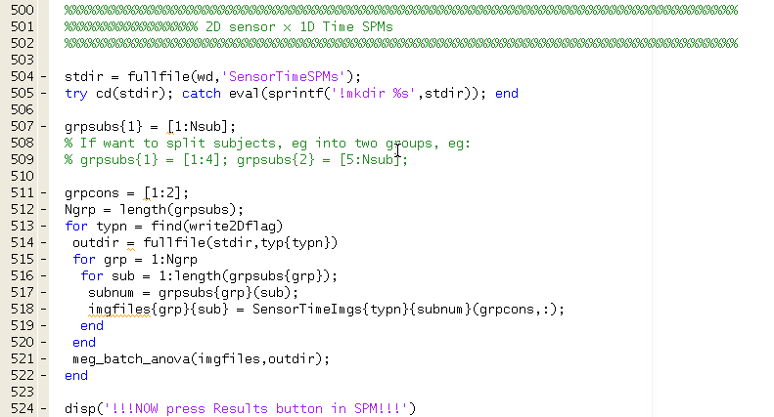

Finally we can take a look at the results!

You need to know a bit about the SPM Results interface, but press the Results button on the SPM panel (make sure SPM is in "EEG" mode) and select the SPM.mat file for one of the modalities, select the default effects of interest F-contrast (because we don't care about polarity, at least for Mags and EEG), choose 0.001 uncorrected. Then press "Whole Brain" to get table of stats (ignore brain image, see below for an example of what the Mags table looks like).

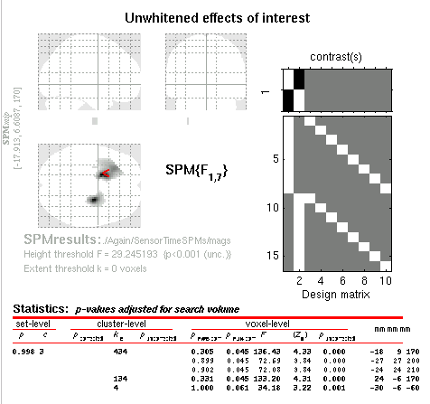

Then select a cluster (e.g. click on the -18,9,170 signifying -18mm, 9mm and 170ms), then select overlays - sections (below Display on SPM results panel), and choose mask.img to produce the 2D plot.
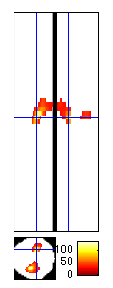
You can then use the cross-hairs to select other places in time or space and see what’s happening. For more info on interpreting these SPMs, see http://imaging.mrc-cbu.cam.ac.uk/meg/SensorSpm

You should see, at least in Mags and EEG, frontal and posterior clusters
(simply of different polarity) maximal around 170ms. Not much survives whole-
image correction because we only have 8 subjects (few df's ie. low power and RFT
conservative) - though effects around 170ms do for corrected extent-level
for Mags and EEG (using "ns" toolbox); GRMS results are very poor though. Correction for height would also be significant if you used SVC because
of an a priori timewindow of interest around 170ms (again see WIKI page below).
For an example use with EEG data, see Henson et al (2008), Neuroimage.

