Evaluation of DTI sequences - Descending vs. Interleaved acquisition

MRI data is often acquired with a gap between slices in order to avoid crosstalk artefacts, which are introduced into images by interference between adjacent slices of a scan, caused by slice profile that is not ideal due to the constraints of the measurement technology. Alternatively, crosstalk can also be avoided by acquiring interleaved slices. However, data acquired in interleaved mode can be more prone to spin history artefacts.

Spin History Artefacts

The first step of an MRI sequence is the excitation of all spins in a specific slice. Once the excitation pulse is over, the spins gradually relax back to their equilibrium state, at a rate determined by the T1 of the tissue. If the TR of the sequence is not much larger than T1 (TR < 5T1), the spins will not have relaxed completely by the time the next acquisition is initiated. In case of motion of the subject, the slice being exited might be different from the one previously excited, in which case not all spins will be in the same relaxation state, which will result in different signal intensities.

These spin history artefacts are particularly common in fMRI sequences, were the TR used is typically 1 or 2 seconds. These effects are also made worse by using interleaved acquisition, because if the subject moves up by exactly one voxel, what were the odd slices become the even ones, which results in stripping along the z direction. Bellow we show examples of this artefact for EPI images acquired with TR=1s, 2s, 4s, and 8s. The subject was asked to move his head along the slice encoding direction during the acquisition.

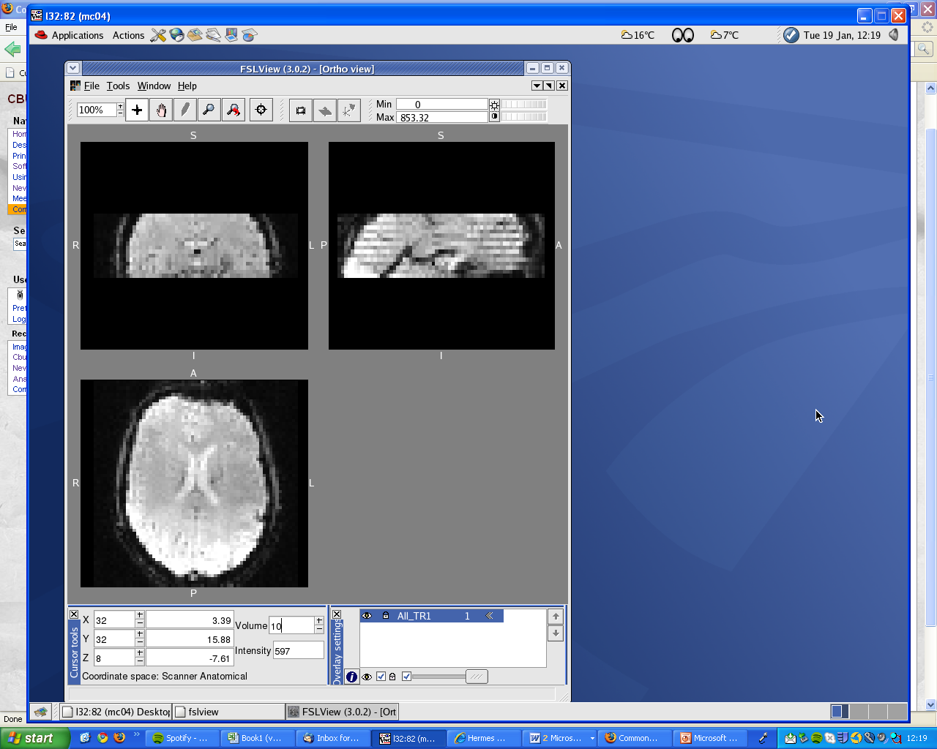
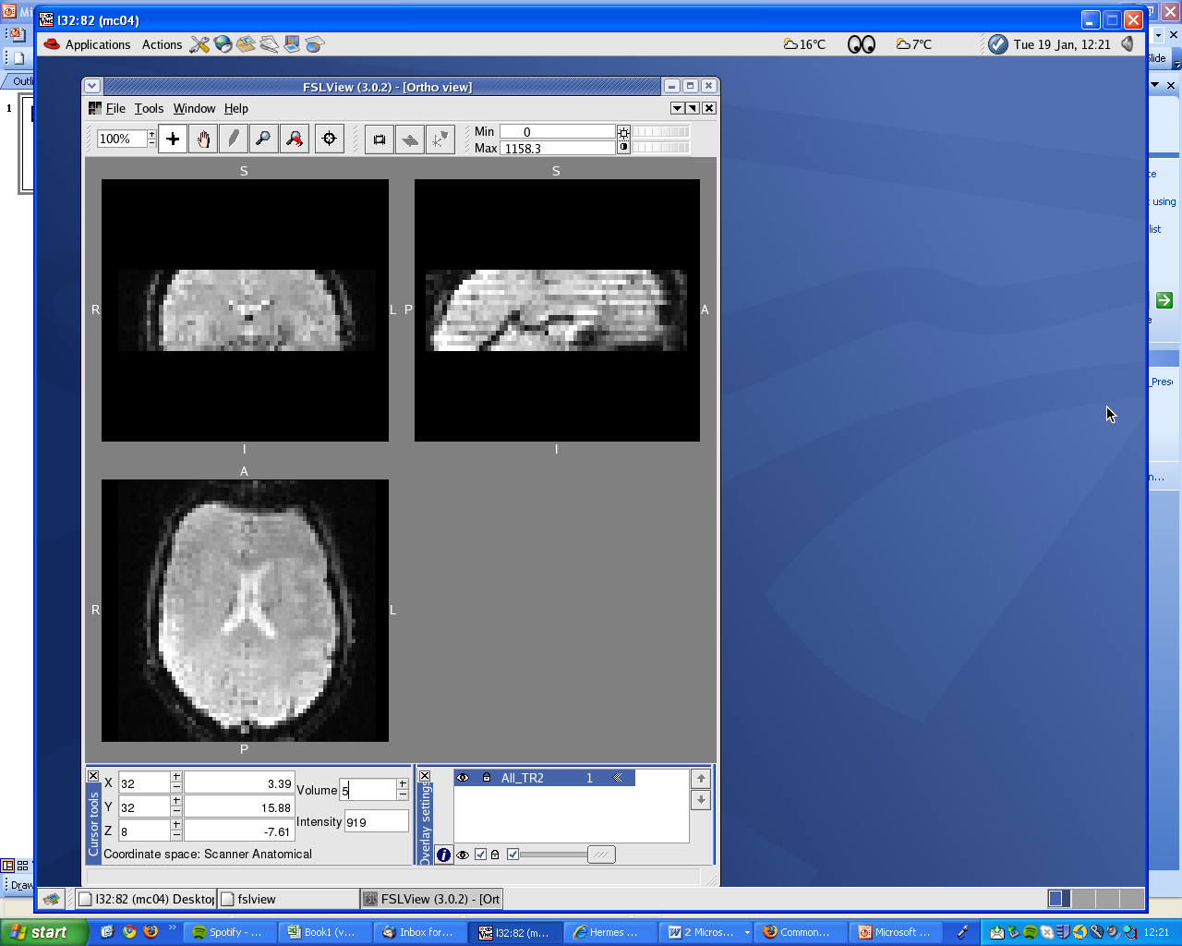
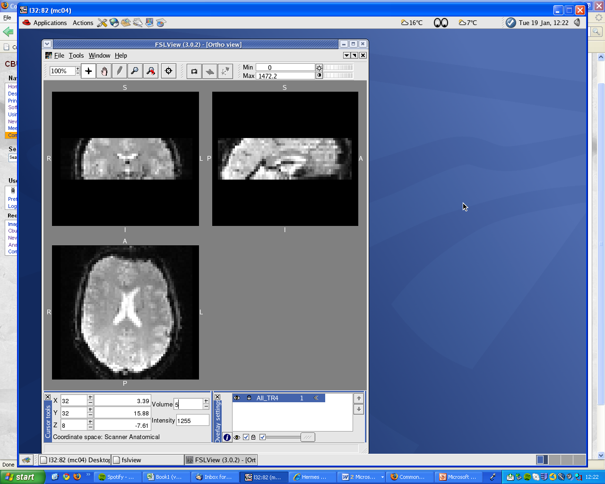
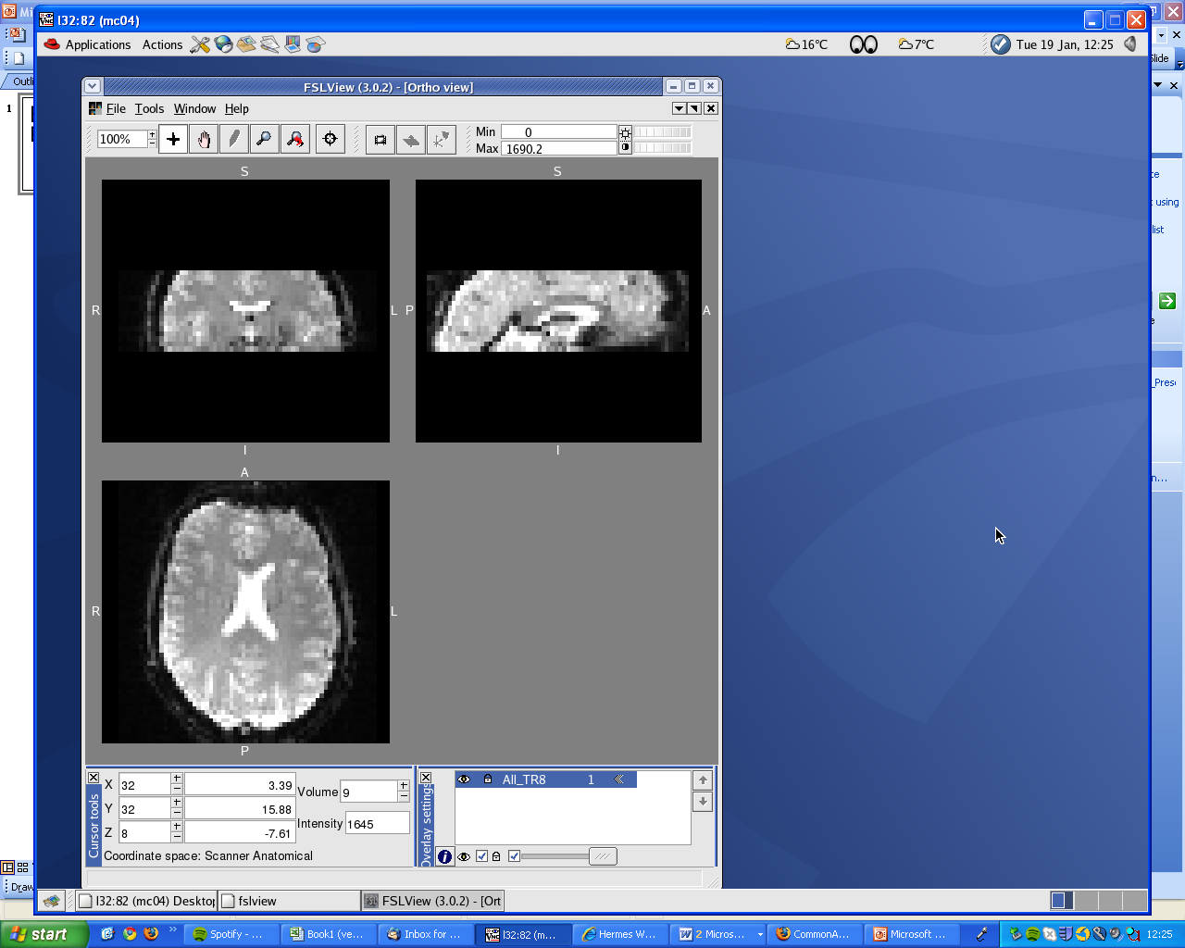
TR=1s
TR=2s
TR=4s
TR=8s

In this visible how the effects of spin history become smaller with increased TR. For Diffusion MRI sequences, the TRs used are typically greater than 7s, and therefore spin history artefacts should not be significant in these data.
Effects of Crosstalk

In order to compare the results obtained with sequential (descending) and interleaved slice acquisition, we acquired two sets of diffusion weighted data with the exact same imaging parameters, and the only difference being the slice acquisition mode. The figure below shows the FA maps obtained for Interleaved and Descending acquisition for the same axial slice:

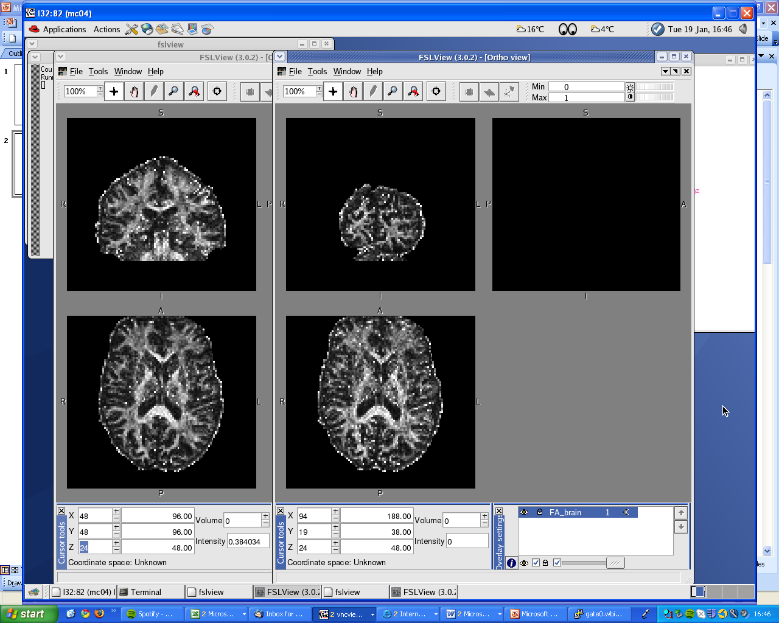
Interleaved
Descending

The FA map obtained with Interleaved acquisition appears clearer and it also shows higher signal to noise ratio (SNR) for different ROIs in white matter regions (splenium, genu, internal capsule, parasagittal white matter and thalamus):

Other diffusion tensor parameters, such as mean diffusivity, tensor eigenvalues and fibre orientation, also show higher SNR for the interleaved acquisition.

The better performance of the interleaved acquisition is also seen in the SNR relative to noise of the baseline (b=0) and diffusion-weighted images:

